Chemistry 107/108 Help Packet

Microsoft Excel 2007

Figure 1: A brief introduction to graphing with Excel 2007:
- 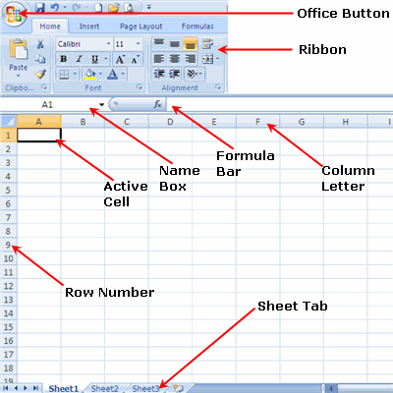The initial Excel page can be obtained by opening the Excel link located under start. Depending on your task, your necessities will be laid out as follows:
Home: Clipboard, Fonts, Alignment, Number, Styles, Cells, Editing
Insert: Tables, Illustrations, Charts, Links, Text
Page Layouts: Themes, Page Setup, Scale to Fit, Sheet Options, Arrange
Formulas: Function Library, Defined Names, Formula Auditing, Calculation
Data: Get External Data, Connections, Sort & Filter, Data Tools, Outline
Review: Proofing, Comments, Changes
View: Workbook Views, Show/Hide, Zoom, Window, Macros

Figure 2: Data entry:
- 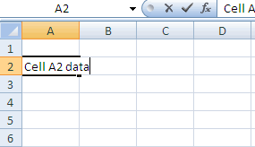Select the cell that you want your data to appear and begin typing. To enter data into another cell you can use your arrow keys, your mouse or the tab key.

Figure 3: Formatting Cells for Significant Figures:
- 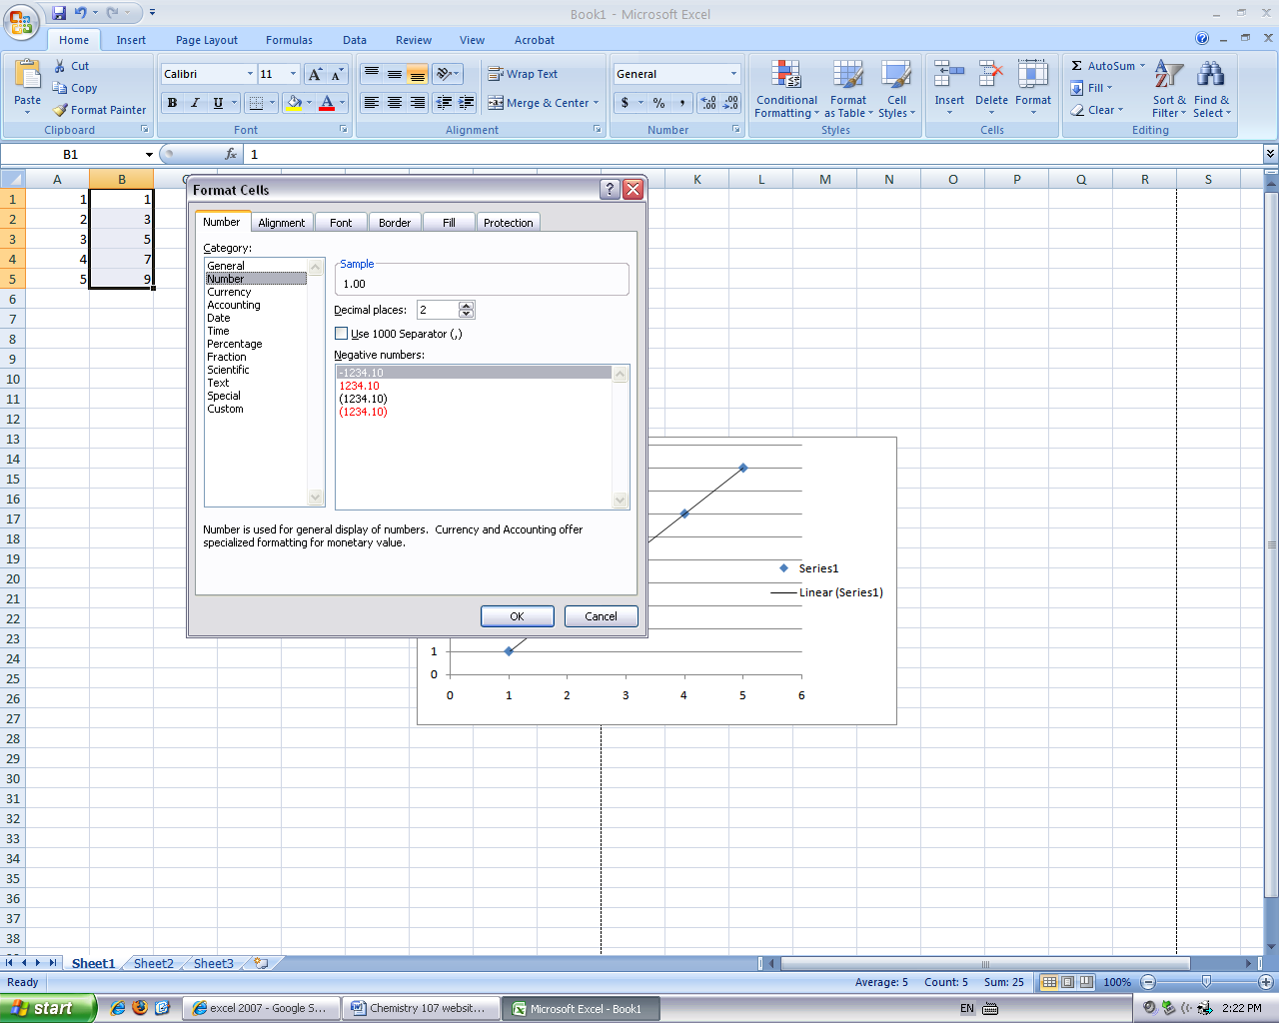To set the cells to the correct number of significant figures, right click on the letter of the column that you want your sig-figs. Go down to the format cells option and select. You can then go to number and alter the sig-figs by changing the decimal places.
Figure 4: Preparing to Graph Data:
- To graph data, put your x-coordinates in the left-hand column and your y-coordinates in the right hand column as if you were typing a coordinate pair (x,y). After filling in your data, highlight the data that you want to appear in the graph by selecting the upper left-hand corner of the first cell to be graphed. Left click and drag right and down until all cells to be graphed are highlighted. Release the left mouse button.
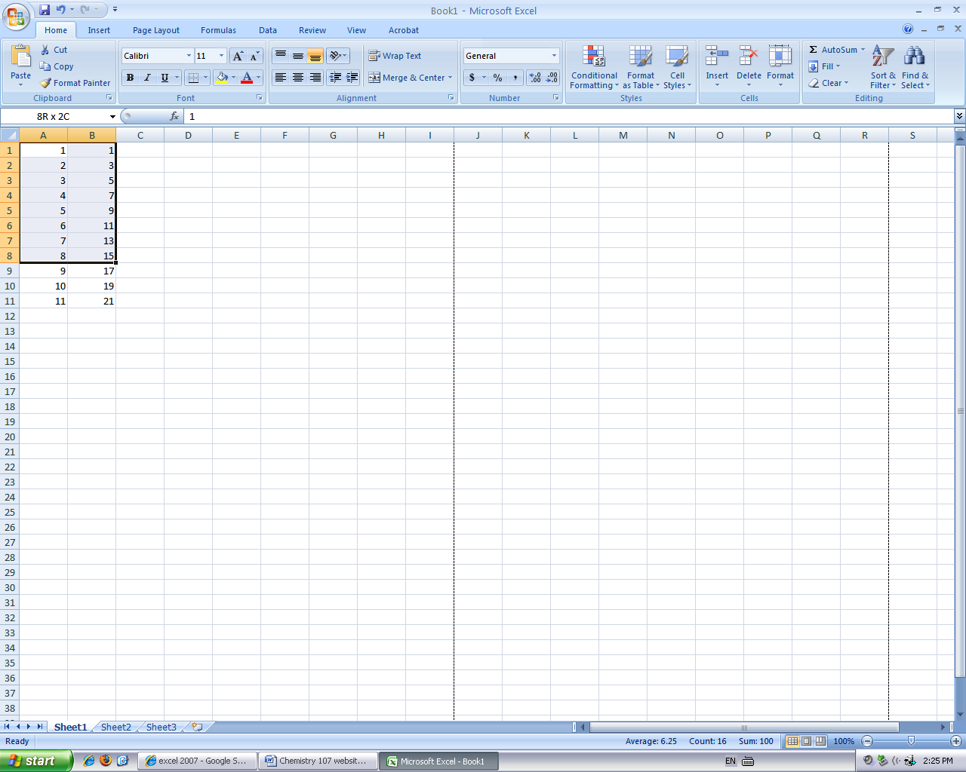

Figure 5: Graphing the Data:
- Click insert in the tool bar and notice the graph options. Under scatter, choose the option for the XY Scatter.
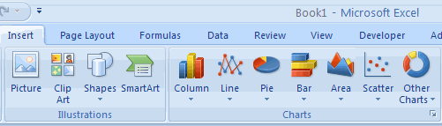

Figure 6: Changing Titles and Labels:
- Select the chart. Go to the layout tab and click chart title or data labels and from there you will be able to alter your titles.
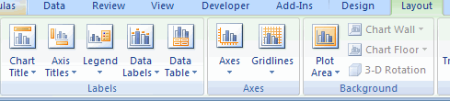

Figure 7: Adding a Trendline and an Equation to Your Graph:
- Under the layout tab, look to the right of the tool bar and you should see the trendline option. Select it and go to the bottom of the option list where more trendline options will be located. Click on it and select your trendline type which will most likely be the linear trendline. Before exiting out of the window, you can get your equation by checking on display equation on chart option located at the bottom of the window.
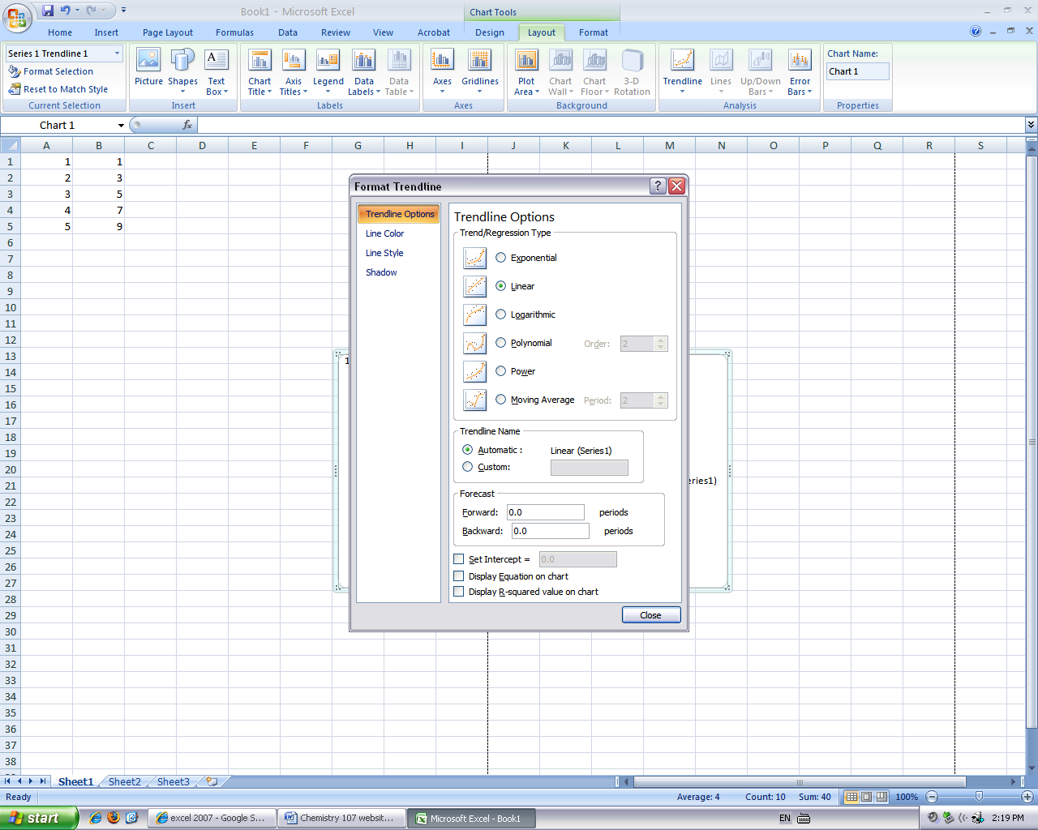
Figure 8-a: Printing Your Graph:
- 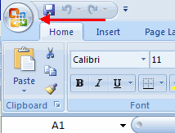If you simply hit print, your graph may come out on two pages. To prevent this, simply click the top, left-hand button, go to print preview. This will show you how your graph will print.

Figure 8-b:
- If it needs to be fixed, locate and click page setup at the top, left-hand side of the screen. Once that window is open, selecting landscape will fix the problem.
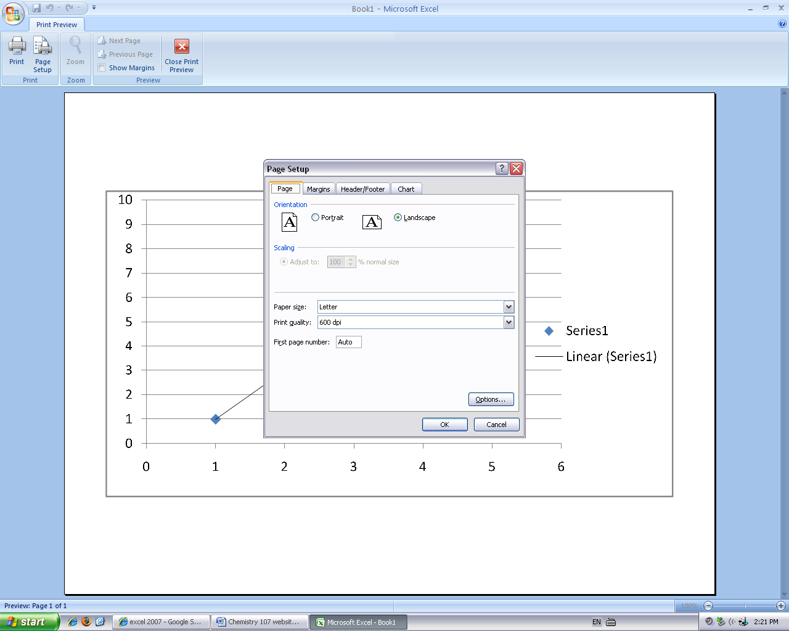
For more information see: http://www.fgcu.edu/support/office2007/Excel/index.asp

Resources:
http://www.fgcu.edu/support/office2007/Excel/index.asp
Kathie A Snyder
Terry L. McAlister
Willie Aiken

