Ohm’s Law Name:_______________________________________
Partner(s):______________________Date:______Time:_______Course:___________
Purpose: To investigate Ohm’s law, measure resistances, and study I-V characteristics.
Apparatus: DC power supply, connecting wires-5 (banana plug), 2-alligator clips, 5-ohm resistor, 10-ohm resistor, light bulb (6.3A, 0.5A), P-N junction diode (Si), and 2- digital multi meters.
Theory: Georg Simon Ohm (1787-1854), a German physicist, discovered Ohm’s law in 1826. This is an experimental law, valid for both alternating current (ac) and direct current (dc) circuits. When you pass an electric current (I) through a resistance (R) there will be an electric potential difference (V) created across the resistance as shown below.
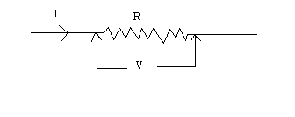
Ohm’s law says that the current (I) is directly proportional to the potential difference (V). The resistance R can be obtained using the following equation:
V = I R
Units: V------> volt (V), I------> ampere (A), R-----> ohm (Ω).
Electric power, P is given by the following equation:
Power = Voltage x Current. P = Vx I
For ohmic resistances, V versus I is a linear relationship, and they have a constant resistance. Resistance can be calculated using, R = V/I. The slope of the V versus I, line will also give the resistance, R.
For non-ohmic resistances, I versus V is a non-linear relationship, and they have a varying resistance. The resistance at a particular point can be calculated using, R = V/I, where V and I are the potential difference (or voltage) and current at that point.
In the first part of this activity, investigate the relationship between current and voltage in a standard 10-ohm and 5-ohm resistors. Then, investigate the relationship between current and voltage in the filament of a small light bulb. Finally, investigate the relationship between current and voltage in a p-n junction diode (Si).
Answer the following:
1. Electricity comes in two types. Name these two types and give an example for each.
____________________________________________________________________
2. Name five quantities and their units, used in electricity.
Terms in Electricity
Physical Quantity | Unit (unit abbreviation)

3. Go to the following simulation.
http://phet.colorado.edu/sims/ohms-law/ohms-law_en.html
a. Keep the resistance constant; change the voltage, Observe what happens. Describe the relationship between current and voltage. Also, include a plot.

b. Keep the voltage constant; change the resistance, Observe what happens. Describe the relationship between current and resistance. Also, include a plot.

Procedure:
Unknown Resistance: 10-ohm and 5-ohm
0. In the circuit shown below, identify the ammeter and voltmeter.
1. Construct the circuit shown below for the 10-ohm resistor, and call the instructor to check the circuit. (Power supply voltage = low, Voltmeter = dc 20 V, Ammeter = dc 10 A)
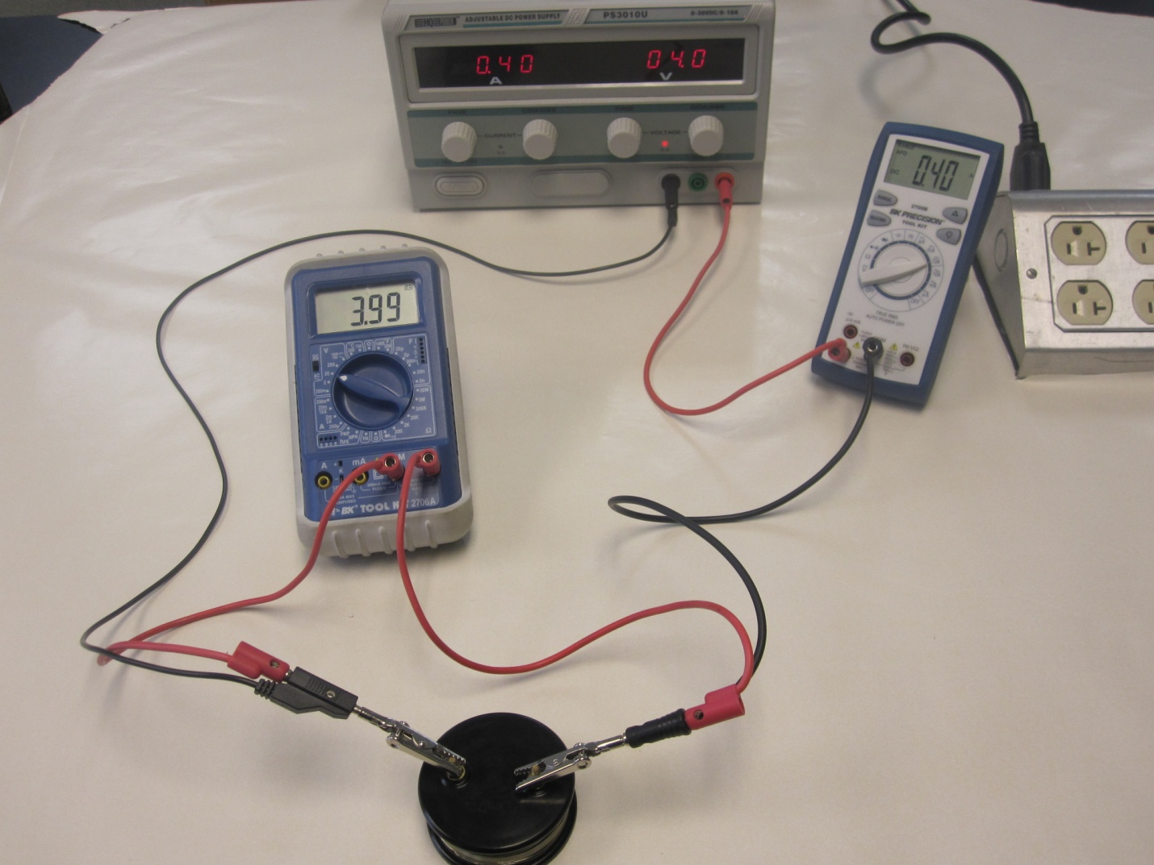
2. As you increase the voltage and current slowly, make sure the current and voltage readings are positive.
3. Set the voltage (0.5, 1.0, 1.5, 2.0, 2.5, 3.0, 3.5, 4.0 in V), measure the current, and then calculate resistance, R (resistance = voltage/current). Tabulate data in Excel.
4. Reverse the polarity of current and voltage, by reversing the connections to the power supply, and repeat procedure 3 for voltages (-0.5, -1.0, -1.5, -2.0, -2.5, -3.0, -3.5, -4.0 in V). Enter these data also in the earlier columns.
5. Turn the dial in the power supply to zero current & voltage and reverse the polarities back to positive.
6. Look at the resistance values and predict the I versus V relationship for the 10-ohm resistor.
____________________________________________________________________
7. Plot I versus V, and determine the slope. Slope = _________________________
8. Obtain the resistance from the slope. Resistance = _________________________
9. Replace the 10-ohm resistor with a 5-ohm unknown resistor, and repeat procedures 2-8.
10. Look at the resistance values and predict the I versus V relationship for the 5-ohm resistor.
____________________________________________________________________
11. Add this data to the earlier graph and determine the slope and resistance.
Slope = _____________________ Resistance = _______________________
12. Attach this graph for your report.
Unknown resistance: LIGHT BULB
13. Replace the 5-ohm resistor with the light bulb.
14. Set the voltage (0.2, 0.5, 0.8, 1.0, 1.5, 2.0, 2.5, 3.0, 3.5, 4.0 in V), measure the current, and then calculate resistance, R (resistance = voltage/current) and power, P (power = voltage x current). Tabulate data in Excel.
15. Reverse the polarity of current and voltage, by reversing the connections to the power supply, and repeat procedure 14 for voltages (-0.2, -0.5, -0.8, -1.0, -1.5, -2.0, -2.5, -3.0, -3.5, -4.0 in V). Enter these data also on the earlier columns.
16. Look at the resistance values and predict the I versus V relationship for the light bulb.
____________________________________________________________________
17. Plot the I versus V relationship, on a separate graph and attach it to your report.

Unknown resistance: P-N junction diode
18. Bring back the voltage and current to zero in the power supply.
19. Replace the light bulb with the diode. For forward bias, connect the red post to the red output of the power supply. Change the voltmeter setting to 2V and keep the ammeter setting at 10A.
20. Slowly increase the voltage (and current) until the ammeter reads about 1A. Record the voltage and current readings. Repeat the measurements for 0.90A, 0.80A, 0.70A, 0.60A, 0.50A, 0.45A, 0.40A, 0.35A, 0.30A, 0.25, 0.20A, 0.15A, 0.10A, and 0.05A.Tabulate your data in Excel.
21. Reverse the polarity of current and voltage, by reversing the connections to the power supply, and repeat procedure 20 for voltages (-0.2, -0.4, -0.6, -0.8, -0.9, and -1.0 in volt (V)). Continue to enter this data also in the Table of Procedure 20.
22. Plot I versus V, on a separate graph, attach it to your report, answer the following questions:
a. At about what forward voltage the Si-diode is conducting?____________________
b. What is the forward resistance? (Answer Low or High)____________________
c. What is the reverse resistance? (Answer Low or High)___________________
24. Write a conclusion for the entire lab.

