Speed of Sound in Air Name:_____________________________
Partner(s):___________________________ Course: ________________ Time:_______
Purpose: Determine the speed of sound in air using different methods.
A. Temperature Method
Apparatus: PC with interface and temperature sensor.
Theory: Speed of sound in air (in m/s) at temperature T (in Kelvin) is given by;
where γ = 1.40 (ratio of specific heats for air),
m = 4.8 x 10⁻²⁶ kg (average molecular mass of air), and
k = 1.38 x 10⁻²³ J/K (Boltzmann constant).
- Alternatively
R=8.314 J/(mole.K), M=28.9x10⁻³ kg/mole
- As a 3rd and simple method
V=( 331.6+.0.607tc )m/s
331.6 m/s is the speed of sound at 0⁰C
The equation says for every degree Celsius rise from 0C the sound speed icreses by .607.

Procedure:
1) Measure the room temperature using a temperature sensor, interface, and PC and calculate the speed of sound.
a. Make sure that the power for the interface is turned.
b. Plug in the temperature sensor to analog input A, white arrow on top.
c. Open PASCO Capstone software from the desktop.
d. Click Hardware Setup under Tools on the left, click on the interface input where the sensor is connected and select Temperature Sensor. Click Hardware Setup again to close it.
e. Double-Click Digits under Displays on the right, click Select Measurement, and select Temperature.
f. Click Record.
DATA:
Room temperature, t = ___________⁰C = _________K.
Speed of sound (using temperature) = V = ____________
Q: Calculate the average molecular mass of air using the three most abundant gases found in the Earth’s lower atmosphere. http://www.physicalgeography.net/fundamentals/7a.html
http://www.youtube.com/watch?v=wVu3ty2NsFM

B. Air-Column Resonance Method
Apparatus: Resonance tube apparatus, audio signal generator, speaker, stand w/clamp, and water.
Theory: In wind instruments the wind (air) is made to resonate. Resonance makes the sound audible. In this investigation a small speaker, connected to an audio signal generator, will generate sound of required frequencies. The speaker is held above the open end of the resonance tube, which has water. The water level can be changed by lowering/raising the reservoir can.
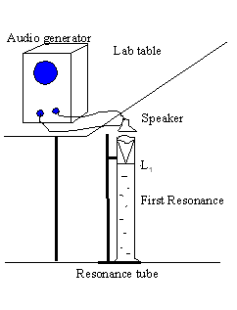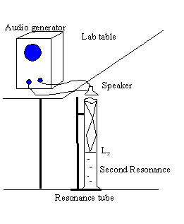
As you lower the water level, keep your ear next to the speaker and listen carefully. At the first resonance, L₁ the sound will be louder. If you keep on lowering you will hear the loud sound again at the second resonance, L₂. The wavelength, λ is given by: λ = 2 (L₂ - L₁). The speed of sound in air, V is given by: V = λ∙f, f = frequency.
Question: Approximately where will the second resonance point compared to the first resonance point. Explain your answer.
________________________________________________________________________
________________________________________________________________________
DATA
Dial  Frequency  (Hz) | First  Resonance  Point, L₁ | Second Resonance Point, L₂ | Change in Resonance Points, L₂-L₁ | Wavelength, λ | Speed of sound, V
400 | - | - | - | - | -
500 | - | - | - | - | -
600 | - | - | - | - | -
Average Speed of Sound

C. Echo Method
Apparatus: Sound sensor, interface, PC, long cardboard tube, and meter stick.

Theory:
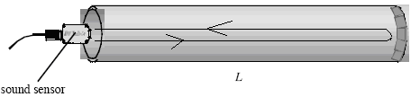

In this echo method, a sound pulse is made to travel along the tube, and the initial pulse and the reflected pulse are detected with a sound sensor.

If the length of the tube is L, then the round trip distance of travel is 2L. If the travel time is t, then the speed of sound, v is given by;

Procedure:

1. Connect the sound sensor to the interface.

2. Place the cardboard tube on the laboratory table and hold the sound sensor close to the open end as shown above.

3. Open Pasco Activity P27, Speed of sound, from the desktop.

5. Double-click Voltage Scope under Displays.
6. Move the mouse over the trigger symbol () until a hand appears, click and drag it up by about 1 division (1 volt) as shown below.
7. Click Start, and snap your fingers at the open end of the tube as shown below.
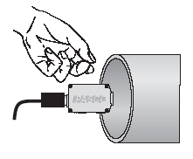
8. If the data is not captured as shown below, repeat procedure 7. The pulse should be compact and the beginning crest/trough of the initial pulse and the echo should be clearly visible.
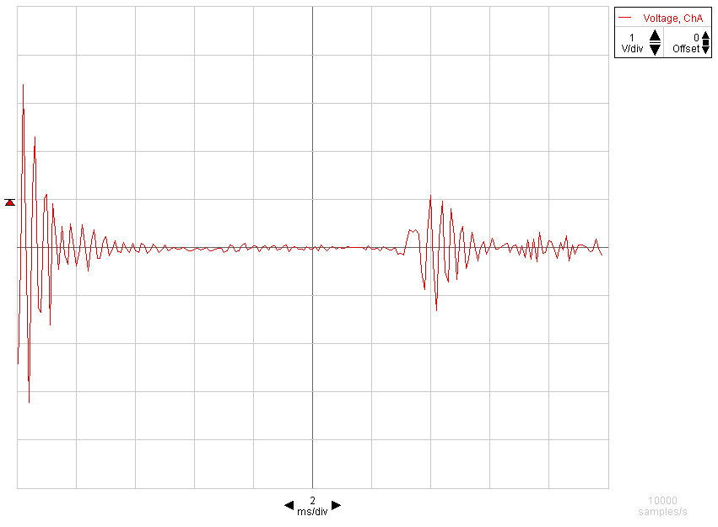
9. Click the Transfer Data button ().

10. Double-click the Graph display, click/highlight Data, and Click OK. Your transferred data should look something like as shown below.
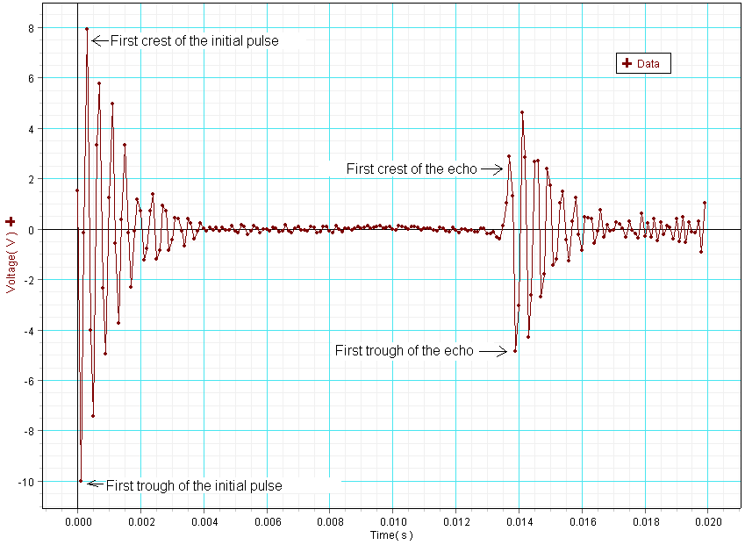
11. Use the smart tool to find the time for initial pulse, time for echo, and travel time and complete the data table below.

Length of tube  (m) | Round trip travel Distance (m) | Time for initial pulse (s) | Time for echo (s) | Travel Time  (s) | Speed of sound  (m/s)

12. Write an overall conclusion on a separate last page.

