Hooke's Law and Simple Harmonic Motion        Name:__________________________

Partner(s):__________________    Course:______________    Time:____________

1. Hooke’s Law

Purpose: To verify Hooke’s law and determine the spring constants of elastic springs.

Apparatus: 3 springs, pendulum clamp, motion sensor, plumb-line, meter stick, tall lab stand, mass set, paper-clip, meter stick, and mass hanger.

Theory: Think about stretching a spring. The more stretching force you apply, the more stretch you get. Robert Hooke (1635-1703), a British physicist, discovered this empirical relationship between the stretching force and the stretch (x), known as Hooke’s law.

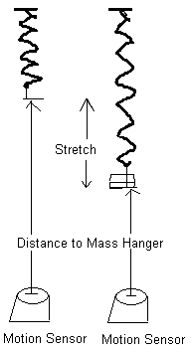

According to Hooke's law, the magnitude of the stretching force is given by:  
   
 Stretching Force = (Spring constant) X Stretch.  
  
The stretching force is provided by the added mass. You can also plot Stretching Force VERSUS Stretch. Hooke’s law is verified when there is a linear relationship between Stretching Force & Stretch.

The Spring Constant is given by the slope of the Stretching Force versus Stretch graph.

Procedure:

1. Attach the mass hanger to the hard spring and hang it from the pendulum clamp.

2. Set up the motion sensor about 50-cm below the bottom of the mass hanger.

3. Connect the motion sensor to the interface (yellow-1, black-2), set the beam to narrow.

4. Setting up the Interface for data collection:  
a. Open **PASCO Capstone** software from the desktop. If the Buy Key/ Enter Key window pops up, close it.   
b. Click **Hardware Setup** under Tools on the left, click on the interface input where the sensor is connected and select **Motion Sensor II**. Click **Hardware Setup** again to close it.   
c. Double-Click **Digits** under Displays on the right, click Select Measurement, and select **Position.**    
  
5. Click **Record** and record the distance to the bottom of mass hanger from the motion sensor. Stop the data collection.

6. Add an appropriate mass to make the spring stretch about 2 cm and measure the distance to the bottom of mass hanger, again.

7. Measure the stretches for other added masses and complete the data table.

8. Repeat 1-7 for the other two springs.

9. Enter the above data in Excel and for each spring; create two more columns for Stretch (m) and Stretching force (N). Calculate these values and make a single XY scatter Plot Stretching force VS. Stretch for all three springs, and find the spring constant for each spring.

10. Attach your data table & plot (Excel) and conclusion (Word).

|  |  |  |  |  |  |  |  |  |  |  |  |  |
| --- | --- | --- | --- | --- | --- | --- | --- | --- | --- | --- | --- | --- |
| SAMPLE DATA | | | |  | | | |  | | | |  |
|  |  |  |  |  |  | |  |  |  | |  |  |
|  |  |  |  |  | |  |  |  | |  |  | |
|  |  |  |  |  |  |  |  |  |  |  |  |  |
|  |  |  |  |  |  |  |  |  |  |  |  |  |

B. Simple Harmonic Motion

Pre-lab on Simple Harmonic Motion   
Read sections 15-2 & 15-3, p387-390 in your text (HRW) and answer the following questions.

1. Define frequency and express its unit.
2. Define period and express its unit.
3. The displacement of a simple harmonic motion is, *X(t) = xm Cos (ωt + Φ)*.

Describe the following terms in the above equation.

a. *xm  __________________* b. (*ωt + Φ) _______________*c. *ω ___________________* d*. Φ ____________________*

1. Express *ω* in terms of period, *T* and frequency, *f*.
2. Obtain the velocity of the simple harmonic motion, *v(t)* by differentiating the displacement, *X(t)* above.
3. Obtain the acceleration of the simple harmonic motion, *a(t)* by differentiating the velocity, *V(t)* above.
4. What type of force is needed for a simple harmonic motion?

Purpose: Investigate the period of a simple harmonic motion.

Apparatus: PC, interface, motion sensor, meter stick, hard spring, mass hanger, mass set, pendulum clamp, and electronic balance.

Theory:   
  
A mass, *m* is attached to the end of an elastic spring of spring constant, *k* and made to oscillate in simple harmonic motion of amplitude, *xm* and period, *T*.  
 The displacement is given by, , where .  
 The velocity is given by,.  
 The magnitude of the maximum velocity is given by,    
  or   
   
 The period (in terms of mass and spring constant) is also given by,



Procedure:

1) Connect the motion sensor to the Interface: yellow-1, black-2, and set the beam to narrow.

2) Attach 500-g mass (mass hanger + 450-g) to the hard spring and hang it from the pendulum clamp. Record the total hanging mass.

3) Place the motion sensor directly under the hanging mass, on the lab table, and leave about 30-cm between the motion sensor and the hanging mass.

4. Setting up the Interface for data collection:  
a. Open **PASCO Capstone** software from the desktop. If the Buy Key/ Enter Key window pops up, close it.   
b. Click **Hardware Setup** under Tools on the left, click on the interface input where the sensor is connected and select **Motion Sensor II**. Click **Hardware Setup** again to close it.   
c. Double-Click **Graph** under Displays on the right, click Select Measurement, and select **Position.**    
  
5)  Double click on the Position and Velocity Graphs icon under the Displays list.

6) Pull down the mass (about 5 cm) and release, and wait for the side-to-side swinging to minimize.

7) Click Record, and after about 6 seconds, stop data collection.

8) The curves should resemble sine functions. If not, delete the data and realign the motion sensor beneath the mass hanger, and try again.

9) Click on the Scale to Fit button and maximize both graphs.

10) From the Position VS. Time graph, determine the period of the simple harmonic motion, by recording the times for peak positions using the Smart Tool.

11) From the Velocity VS. Time graph, determine the period of the simple harmonic motion, by recording the times for peak velocities using the Smart Tool.

12) Determine the amplitude and magnitude of the maximum velocity of the simple harmonic motion and complete the data table.

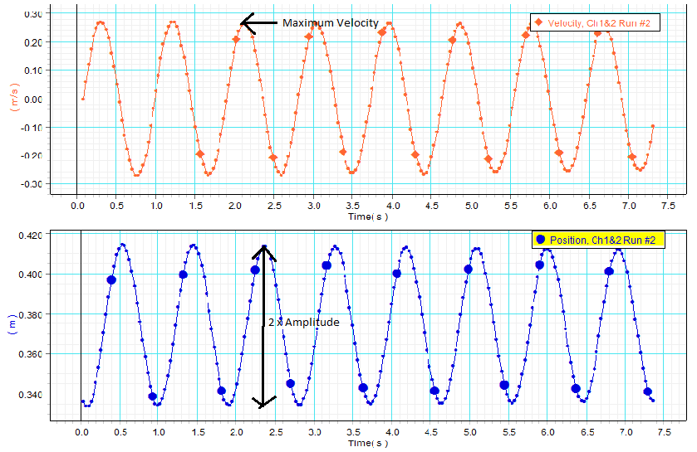

DATA (Use SI units): Spring Constant = k = ________Oscillating mass = m = _______

|  |  |  |  |  |
| --- | --- | --- | --- | --- |
| Peak | Time for peak positions | Period | Time for peak velocities | Period |
| First peak |  | XXXXXXX |  | XXXXXXX |
| Second peak |  |  |  |  |
| Third peak |  |  |  |  |
| Fourth peak |  |  |  |  |
| Fifth peak |  |  |  |  |
|  | Average Period🡪 |  | Average Period🡪 |  |

Amplitude of the simple harmonic motion = A= ________________

Magnitude of the maximum velocity of the simple harmonic motion = Vmax= ________________

Calculated Period (using amplitude and maximum velocity) = _____________

Calculated Period (using mass and spring constant) = _____________

Oscillate the mass, observe, and answer the following Questions (zero or maximum):

1. What is the net force on the mass at the equilibrium position?___________

2. What is the acceleration of the mass at the equilibrium position?__________

3. What is the acceleration with direction of the mass when the mass is at the  
 a. highest point?______________b. lowest point?___________

4: The drawing shows a graph of displacement *x* versus time *t* for simple harmonic motion of an object on a horizontal spring. State the magnitude, *v* of the velocity and the magnitude, *a* of the acceleration at points **A** and **B** in the graph?

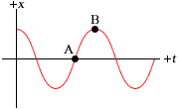

*vA* = ____________(maximum or zero)

*vB* = ____________(maximum or zero)

*aA* = ____________(maximum or zero)

*aB* = ____________(maximum or zero)