PHYS 202L Wave Phenomena Instructions

Purpose: Determine the wavelength of light using wave phenomena.

A. Diffraction Grating

Apparatus: Diffraction grating, meter stick, optics bench, and laser w/power adapter.

Theory:

One of the most useful tools in the study of light and of objects that emit and absorb light is the **diffraction grating**. This device has a number *N* of slits, often called *rulings*, perhaps as many as several thousand per millimeter. An idealized grating consisting of only five slits is represented in Fig. [36-18](http://edugen.wiley.com/edugen/courses/crs4957/halliday9118/halliday9088c36/halliday9118/halliday9088c36/halliday9088c36xlinks.xform?id=halliday9088c36-fig-0018). When monochromatic light is sent through the slits, it forms narrow interference fringes that can be analyzed to determine the wavelength of the light.

|  |  |  |  |  |  |  |  |  |  |  |  |  |  |  |
| --- | --- | --- | --- | --- | --- | --- | --- | --- | --- | --- | --- | --- | --- | --- |
| http://edugen.wiley.com/edugen/courses/crs4957/common/art/pixel.gif | |  | | --- | | http://edugen.wiley.com/edugen/courses/crs4957/common/art/pixel.gif | | |  |  |  |  | | --- | --- | --- | --- | | |  | | --- | | http://edugen.wiley.com/edugen/courses/crs4957/common/art/pixel.gif | | http://edugen.wiley.com/edugen/courses/crs4957/halliday9118/halliday9088c36/image_n/nt0020-y.gif | | http://edugen.wiley.com/edugen/courses/crs4957/common/art/pixel.gif | | | | http://edugen.wiley.com/edugen/courses/crs4957/common/art/pixel.gif | | |  |  |  | | --- | --- | --- | | [Figure zoom](http://edugen.wiley.com/edugen/courses/crs4957/halliday9118/halliday9088c36/halliday9118/halliday9088c36/halliday9088c36xlinks.xform?id=halliday9088c36-fig-0018) | **Figure 36-18** | An idealized diffraction grating, consisting of only five rulings, that produces an interference pattern on a distant viewing screen *C*. | | | http://edugen.wiley.com/edugen/courses/crs4957/common/art/pixel.gif | | http://edugen.wiley.com/edugen/courses/crs4957/common/art/pixel.gif |

With monochromatic light incident on a diffraction grating, if we gradually increase the number of slits, the intensity plot changes to a simple graph like that shown in Fig. [36-19](http://edugen.wiley.com/edugen/courses/crs4957/halliday9118/halliday9088c36/halliday9118/halliday9088c36/halliday9088c36xlinks.xform?id=halliday9088c36-fig-0019)*a*. The pattern you would see on a viewing screen using monochromatic red light from, say, a helium-neon laser is shown in Fig. [36-19](http://edugen.wiley.com/edugen/courses/crs4957/halliday9118/halliday9088c36/halliday9118/halliday9088c36/halliday9088c36xlinks.xform?id=halliday9088c36-fig-0019)*b*. The maxima are now very narrow (and so are called *lines*); they are separated by relatively wide dark regions.

|  |  |  |  |  |  |  |  |  |  |  |  |  |  |  |
| --- | --- | --- | --- | --- | --- | --- | --- | --- | --- | --- | --- | --- | --- | --- |
| http://edugen.wiley.com/edugen/courses/crs4957/common/art/pixel.gif | |  | | --- | | http://edugen.wiley.com/edugen/courses/crs4957/common/art/pixel.gif | | |  |  |  |  | | --- | --- | --- | --- | | |  | | --- | | http://edugen.wiley.com/edugen/courses/crs4957/common/art/pixel.gif | | http://edugen.wiley.com/edugen/courses/crs4957/halliday9118/halliday9088c36/image_n/nt0021-y.gif | | http://edugen.wiley.com/edugen/courses/crs4957/common/art/pixel.gif | | | | http://edugen.wiley.com/edugen/courses/crs4957/common/art/pixel.gif | | |  |  |  | | --- | --- | --- | | [Figure zoom](http://edugen.wiley.com/edugen/courses/crs4957/halliday9118/halliday9088c36/halliday9118/halliday9088c36/halliday9088c36xlinks.xform?id=halliday9088c36-fig-0019) | **Figure 36-19** | (*a*) The intensity plot produced by a diffraction grating with a great many rulings consists of narrow peaks, here labeled with their order numbers *m.(b*) The corresponding bright fringes seen on the screen are called lines and are here also labeled with order numbers *m*. | | | http://edugen.wiley.com/edugen/courses/crs4957/common/art/pixel.gif | | http://edugen.wiley.com/edugen/courses/crs4957/common/art/pixel.gif |

We use a familiar procedure to find the locations of the bright lines on the viewing screen. We first assume that the screen is far enough from the grating so that the rays reaching a particular point *P* on the screen are approximately parallel when they leave the grating (Fig. [36-20](http://edugen.wiley.com/edugen/courses/crs4957/halliday9118/halliday9088c36/halliday9118/halliday9088c36/halliday9088c36xlinks.xform?id=halliday9088c36-fig-0020)). Then we apply to each pair of adjacent rulings the same reasoning we used for double-slit interference. The separation *d* between rulings is called the *grating spacing*. (If *N* rulings occupy a total width *w*, then *d* = *w/N*.) The path length difference between adjacent rays is again *d* sin *θ* (Fig. [36-20](http://edugen.wiley.com/edugen/courses/crs4957/halliday9118/halliday9088c36/halliday9118/halliday9088c36/halliday9088c36xlinks.xform?id=halliday9088c36-fig-0020)), where *θ* is the angle from the central axis of the grating (and of the diffraction pattern) to point *P*. A line will be located at *P* if the path length difference between adjacent rays is an integer number of wavelengths—that is, if

|  |  |
| --- | --- |
| http://edugen.wiley.com/edugen/courses/crs4957/common/art/pixel.gif | |
| |  |  |  |  |  |  | | --- | --- | --- | --- | --- | --- | | http://edugen.wiley.com/edugen/courses/crs4957/common/art/pixel.gif | |  | | --- | | http://edugen.wiley.com/edugen/courses/crs4957/common/art/pixel.gif | | http://edugen.wiley.com/edugen/courses/crs4957/halliday9118/halliday9088c36/image_n/nt0060-y.gif | | http://edugen.wiley.com/edugen/courses/crs4957/common/art/pixel.gif | | http://edugen.wiley.com/edugen/courses/crs4957/common/art/pixel.gif | | (36-25) |
| http://edugen.wiley.com/edugen/courses/crs4957/common/art/pixel.gif | |

where *λ* is the wavelength of the light. Each integer *m* represents a different line; hence these integers can be used to label the lines, as in Fig. [36-19](http://edugen.wiley.com/edugen/courses/crs4957/halliday9118/halliday9088c36/halliday9118/halliday9088c36/halliday9088c36xlinks.xform?id=halliday9088c36-fig-0019). The integers are then called the *order numbers*, and the lines are called the zeroth-order line (the central line, with *m* = 0), the first-order line (*m* = 1), the second-order line (*m* = 2), and so on.

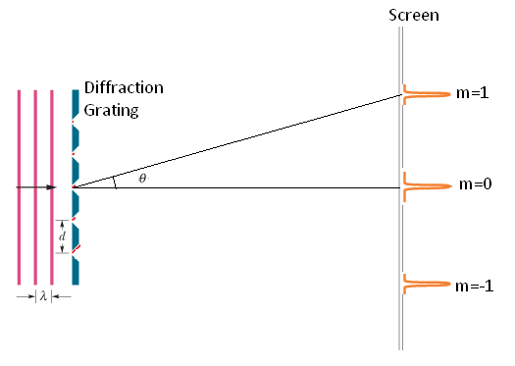

Procedure:  
1. Set up the optics bench on the lab table so that the scale is vertical.  
2. About a meter from the optics bench set up the laser.

3. Turn on the laser and adjust it until the laser beam strikes the middle of the optics bench.

4. Hold the diffraction grating in the path of the laser beam and obtain the first order diffraction spots on the scale of the optics bench.

5. Make the necessary measurements and calculate the wavelength.

B. Double-Slit Interference

Apparatus: Light sensor w/aperture bracket & cable, diode laser w/power adapter, multiple-slit set, optics bench w/linear translator, meter stick, rotary motion sensor, 850-interface, and PC.

*Instructor Notes: Attach the linear translator to the optics bench close to the 0-cm end, attach the rotary motion sensor, and set the aperture bracket to 1.*

Theory: Watch the video mini-lecture “Two-Slit Interference”, in Chapter 35, WileyPlus.

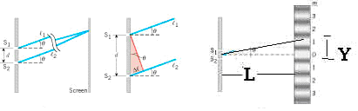

Bright fringes of a double-slit are given by (d is double-slit separation and λ is wavelength),



First bright fringe is given by,



; (Y is fringe-width),



Procedure:

1. The optics bench w/linear translator and rotary motion sensor is on the lab table.   
  
2. Attach the light sensor with aperture bracket to the rotary motion sensor as shown below.

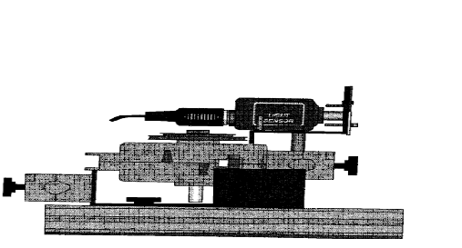

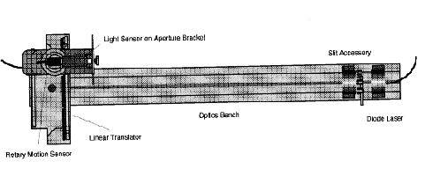

3. Mount the diode laser on the other end, at the 100-cm mark of the optics bench.  
  
4. Set the multiple slit to a double slit separation, d = 0.25 mm and a = 0.04 mm, and place the double-slit at the 90-cm mark.     
  
5. Plug in the power adapter for the laser.  
  
6. Adjust the position of the light sensor so that the laser beam strikes in the middle of the aperture bracket-1.   
  
7. Move the rotary motion sensor/light sensor so that the interference pattern is away from aperture bracket-1.   
  
8. Connect the rotary motion sensor to digital channels 1 (black) and 2 (yellow).  
  
9. Set the gain to 100 in the light sensor and connect it to analog input A.

10. Setting up the Interface:   
a. Make sure that the power for the interface is turned on.  
b. Open **PASCO Capstone** software from the desktop.   
c. Click **File** (top-left corner), click **Open Experiment**, click the drop-down menu for **Files of type**, and choose **DataStudio 1.9 files**, open **P35_Diffraction.ds** from desktop, and OK **USB 850 interface.**d. Click **Data Summary** on the left, click **Position, Ch1&2 (m)** under Rotary Motion Sensor, click on the **gear symbol** on the right, under Numerical Format change the fixed decimals to 5. Click **Data Summary** again to close it.  
  
11. Click **Record**, and slowly and smoothly move the rotary/light sensor so that the whole interference pattern passes through aperture-1 of the light sensor.   
  
12. Stop recording data and maximize the graph display.  
  
13. Measure the total width for multiple fringes using the smart tool, double-slit to screen distance (L) with a meter stick, and complete the data table.   
  
14. Print a hardcopy of the interference pattern.

C. Single-Slit Diffraction

Purpose: To observe single-slit diffraction pattern and measure the wavelength of light.

Apparatus: Light sensor with aperture bracket, diode laser, single-slit set, optics bench, rotary motion sensor, linear translator, meter stick, 850-interface, and PC.

Theory: Watch the video mini-lecture on [“Diffraction](https://www.youtube.com/watch?v=kH57Di7Sj0c)”,

|  |  |
| --- | --- |
| F27.23 | F27.24 |

Dark fringes for the single-slit diffraction are given by (w is the single-slit width and λ is wavelength),

For the first dark fringe (y is the half-width of the central dark fringe),  
    
        

Procedure:

1. Remove the double-slit and replace it with a single-slit set to slit-width, w = 0.16 mm.

2. Move the rotary motion sensor/light sensor so that the interference pattern is away from aperture bracket-1.   
  
3. Click Record, and slowly and smoothly move the rotary/light sensor so that the whole diffraction pattern passes through the sensor.

4. Stop recording data and maximize the graph display.

5. Measure the width of the central bright fringe using the Smart Tool, single-slit to screen distance (L) with a meter stick, and complete the data table.

6. Print a hardcopy of the diffraction pattern.