Nickerson Coaching 8 Iverson Road
Beverly, MA. 01915
Nickersonp@comcast.net
508-930-9327
website: nickersoncoaching.com
facebook.com/nickersoncoaching
Blog:nickersoncoaching.tumblr.com
Twitter.com/paulnickerson1

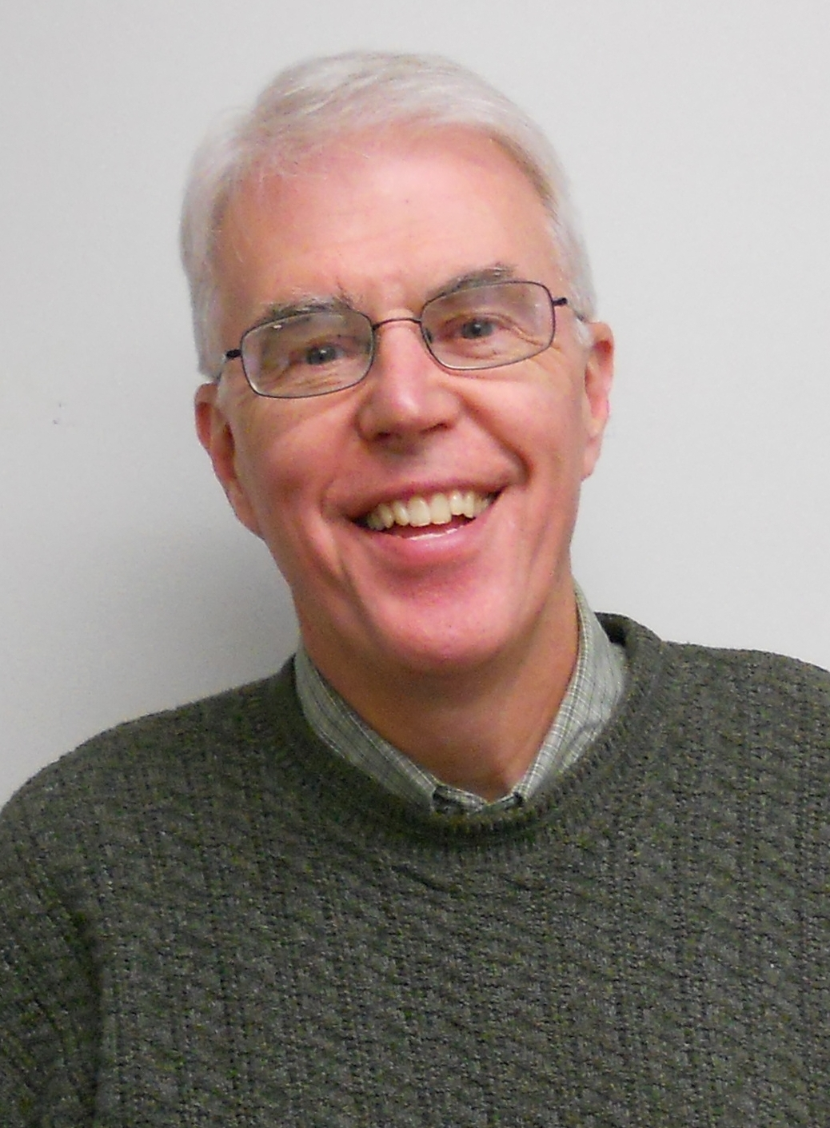

Paul Nickerson

Paul Nickerson
Getting Your Team off to a “Fast Start” in Reaching New People
Here are some helpful hints as you begin your work as a Vitality Team:
- Meet as a group out in the community (model this for the other groups in your church)
- Review your Action Plan and send a summary to the Coach
- Get dates on the church calendar: Team activities; coaching dates; Tune Up Day date.
- Pick out a few things that you can do well and build some “early success”.
- Get prayer walks started
- Do your scheduled “elbow” activities
- Get your pastor out into the community networking
- Celebrate each little success with a “mission” moment in worship, newsletter articles, email blasts, etc.
- Think strategically, about the next “few” people you can get on board with the process. Invite them to do something with you (prayer walk, town activity, join a coaching call, etc.) Add a few more with each activity.
- Begin to meet with other committees and groups, brainstorming ways they can be involved in the reaching new people process.
- Leave those who are most resistant until later (we will deal with resistance in some detail in the coaching process)
- Make sure you are praying regularly and are recruiting a prayer team to pray you through this process. Reaching new people is both “hard” work and “heart” work.

Your long-term goals are:
- For your Team to be the “catalyst” to involve all the church in reaching new people (not for you to try to do all the work for the church).
- To make reaching new people a permanent ministry of the church.
- To focus on getting out in the community, meeting people, building relationships and inviting and bringing in new folk. Note: This is slow, long-term “culture” change in your church. Most churches have been in the old “attraction” model for decades.
- To see lives changed and communities transformed.

