Remote lab on Oscilloscope Name:_____________________________
A. Pre-Lab on Oscilloscope
1. Look at the four AC signals and find out a distinguishing feature of alternating waves.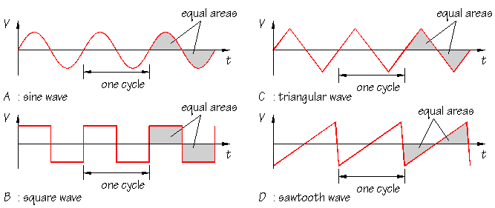
_____________________________________________________________________
_____________________________________________________________________
2. What is the average voltage for the above signals?______________________
3. Watch this video and define period and frequency of a wave and express
Frequency in terms of period.
Period:
Frequency:
Frequency in terms of period:
4. Now we will concentrate on sine wave ac signals. A sketch of V versus t graph of a sine wave AC signal is shown below. Also shown are the following:
1. peak amplitude 2. peak-to-peak amplitude, 3. rms amplitude, and 4. period.
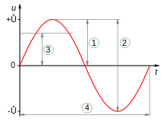
$$rms amplitude= \frac{peak amplitude}{\sqrt{2}}$$

5. Oscilloscope allows one to see signals, for example an ac signal. An ac signal can be described with three properties; waveform, amplitude, and frequency. Instead of amplitude, peak-to-peak value or rms (root-mean-square) value can also be used.
Describe the above three properties of the US wall-outlet signal below:
a. ___________________ b. ____________________ c. ______________________
6. For the waves shown below, determine peak-to-peak value, amplitude, period, and frequency.
Peak-to-peak value: Measure the vertical divisions from trough to crest and multiply it by the VOLTS/DIV setting. Peak value is half the peak-to-peak value.
Period: Measure the horizontal divisions from one crest (or trough) to the next and multiply it by the TIME/DIV setting.
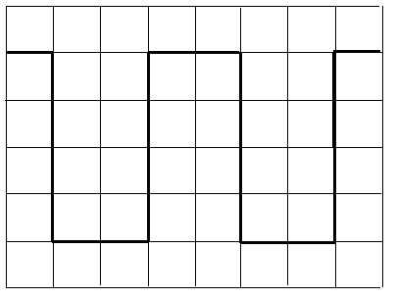 | 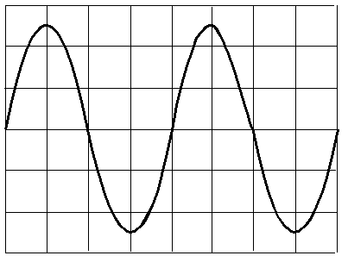
volt/div = 0.5V, time/div = 2 ms | volt/div = 2V, time/div = 1 µs
 | Sq. Wave | Sine Wave
1. The peak-to-peak amplitude of the signal
2. The peak amplitude of the signal
3. The period of the signal in second
4. The frequency of the signal in Hz

B. To measure the period and hence the frequency and voltage (peak or peak to peak) of sine wave signals in an oscilloscope simulator.
Procedure:
- Open the following simulation and click “Begin”:
http://thephysicsaviary.com/Physics/Programs/Games/ReadTheOscilloscope/

- Something similar to the following will be displayed.
- Position knobs are used for moving the signal up/down or left/right. Bigger knobs (Volts/div and Time/div) need to be adjusted to obtain a nice sine wave curve. Click on the knobs to change the settings to obtain a display something similar to as displayed below. In this example, period can be read, and then it is used to find the frequency. Measure the quantity and enter your results in the simulation.
- Repeat the above measurements until you are very familiar with reading an oscilloscope.
C. Measuring the ac signal from an ac-adapter and a function generator:
Procedure:
1. Open the following simulation and click “Begin”:
https://www.thephysicsaviary.com/Physics/Programs/Labs/FrequencyVoltageACPowerSupplyLab/
2. Record the output voltage and frequency displayed in the ac adapter in the data table.
3. Click on the adapter to plug it to the wall outlet.
4. Click on the multimeter to connect the adapter to the multimeter. A multimeter with the readings will appear below. Record the voltage reading of the multimeter. Click on the frequency dial of the multimeter and read the frequency.
5. Click on the oscilloscope to connect the adapter to the scope, and measure the signal properties and complete the data table.
6. Connect the function generator, by clicking on it. The frequency is set to 500 Hz.
7. Set the amplitude to min.
8. Measure the peak-to-peak value and determine the peak amplitude.
9. Repeat the above measurements for ¼, ½, ¾, and max amplitudes and complete the data table.
10. For the max amplitude and frequency of 500 Hz, measure the period and determine the frequency.
11. Repeat the above measurements for other frequencies and complete the data table.
Data Table for C
I. ac-adapter:
Listed values: Output voltage = ____________________ Frequency = __________
Measured values with a DMM: Output voltage = _______Frequency = _________
Oscilloscope readings:
The peak-to-peak amplitude of the signal
The peak-amplitude of the signal
The rms value of the signal
The period of the signal in second
The frequency of the signal in Hz
Digital multimeters measure which one of the following amplitudes?________
a. peak amplitude b. peak-to-peak amplitude c. rms amplitude
IIa. Function Generator: Change the amplitude for a constant frequency.
Frequency = 500 Hz, Sine wave.
Amplitude from front dial of the function generator | From scope display readings
 | peak-to-peak amplitude | Peak-amplitude
min
1/4
1/2
3/4
max
IIb. Change the frequency for constant amplitude. Amplitude = max, Sine wave.
Frequency from the function generator display (Hz) | From Scope Display Readings
 | Period | Period (sec) | Frequency (Hz)
500
5000
50,000
500,000
5000,000

D. Purpose: To measure the inductance (L) of an inductor coil using the resonance of R-L-C circuit.
Theory: Read about RLC resonance in this online textbook.
For a series R-L-C circuit, the resonance frequency (f) is given by, where L = inductance and C = capacitance; (SI unit for capacitance is farad (F) and for inductance is henry (H))
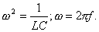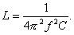

Procedure:
- Open the following simulation:
https://www.thephysicsaviary.com/Physics/Programs/Labs/RLCinACLab/
Series RLC circuit is shown. Also displayed are the current, total potential difference, and potential differences across the R, L, C. During the resonance the potential difference across the capacitor is exactly opposite to the potential difference across the inductance, and they cancel each other. This will be used to find the resonance frequency.
- Set the resistance to 100 Ω (Brown, Black, Brown), inductance to 25 mH (0.025H), and capacitance to 5.0 μF.
- In the display turn on only the capacitor and inductor potentials.
- Adjust the frequency until the potential difference across the capacitor is exactly opposite to the potential difference across the inductance, record this resonance frequency, and calculate the inductance.
- Repeat the above measurements for other capacitance values and complete the data table.

DATA Table for D1
Capacitance, C (µF) | Resonance frequency, f (Hz) | Inductance, L (H)
5.0
4.5
4.0
3.5
3.0
2.5
2.0
1.5
1.0
0.5
Average Inductance, L from Resonance
Simulation value of the inductance
% Difference
- Keep C = 0.5 µF. In the display turn on only the resistor potential.
- Measure the peak voltage across the resistance, as a function of frequency, for the frequencies shown in the data table.

DATA Table for D2
Frequency (Hz) | Peak Voltage, V_{p} (volt)
250
500
750
1000
1250
1500
1750
2000
2250
2500
2750
3000
6. Tabulate your data in excel and make an X-Y scatter plot V_{p} versus f, with a smooth line connecting data points, and see whether the resonance peak agrees with the data from Procedure-4 above.
________________________________________________________
Resonance peak frequency from V_{p} versus f plot: =_________________
Attach your plot and write a conclusion for D.

