PHYS 202L RESISTANCE Name:________________________
I. Purpose: To investigate the resistance of a metal wire using a digital multi meter (DMM).
Apparatus: DMM, one long metal (nichrome) wire (≈100 cm), connector box, micrometer, and meter stick.
Theory: Resistance, R of a metal wire of length L and cross-sectional area A is given by:
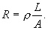
The plot of R versus L will yield a slope of ρ/A. Knowing A, the resistivity (ρ) can be determined.
Open the following simulation and see how the resistance depends on the above variables: https://phet.colorado.edu/sims/html/resistance-in-a-wire/latest/resistance-in-a-wire_en.html
Procedure:
Variation of resistance with length:
- DMM is set to measure resistances and connected to the connector box.
- One end of the long metal wire will be connected to one terminal of the connector box.
- A length of 10 cm of wire will be measured and connected to the other terminal so that there is exactly 10 cm of wire between the terminals.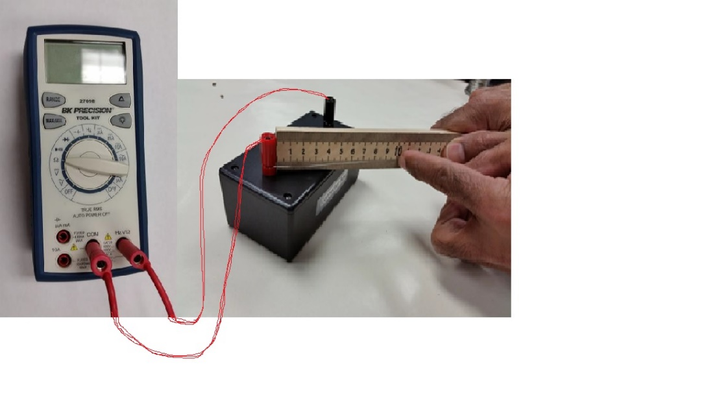
- Record the resistance value and repeat the above procedure for other lengths: 20, 30, 40, 50, 60, 70, 80, 90, 100 cm; by watching this video.
- Plot a graph, R versus L, determine its slope, and insert it below.
- Measure the diameter of the wire with a micrometer, calculate the cross-sectional area, and calculate the resistivity of the metal.
Variation of resistance with diameter: Data Collection Video
- Fold the wire into half and then again half to make 4 equal pieces.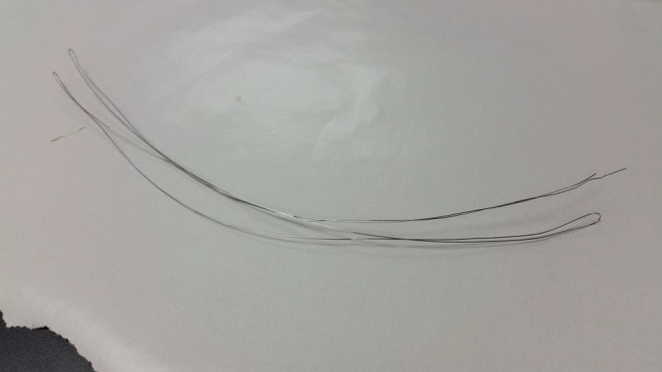 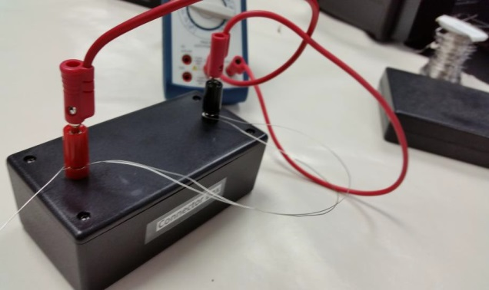
- Measure the resistance of one fold, two folds, three folds, and four folds.
- Tabulate your data, plot an appropriate graph, and see what happens.
- Add an appropriate trend line, and obtain resistivity from your fit.
- Insert your graph.
DATA
Variation of resistance with length:
Slope of R versus L, graph:_________________
Diameter of wire = __________________ Cross-Sectional area of wire =________________
Experimental resistivity of wire = _________________
Accepted resistivity of wire = 1.00 x 10⁻⁴ ohm.cm. % Error = __________________
Variation of resistance with diameter:
Slope or Coefficient of the fit = _________________
Length of wire = __________________ Cross-Sectional area (for 1-fold) =_______________
Experimental resistivity of wire = _________________
Accepted resistivity of wire = 1.00 x 10⁻⁴ ohm.cm.
% Error = __________________
Write a Conclusion for I.

II. In this section you will go through few activities with resistors and circuits.
Go to the following simulation and click “Intro”:
https://phet.colorado.edu/sims/html/circuit-construction-kit-dc/latest/circuit-construction-kit-dc_en.html
A. Constructing a simple circuit
- What you see is a PhET circuit construction kit with various circuit elements.
- Move the light bulb to the center. Move the battery below the light bulb. Use the wire(s) to connect the light bulb to battery so that it will light up. Flow of electrons are also displayed.
- Draw the constructed circuit diagram below, showing the polarities of the battery and the flow of electrons. Click “Conventional current” to display the flow of current, and show this in a circuit diagram below.
Circuit Diagram showing the flow of electrons and battery polarities | Circuit Diagram showing the flow of conventional current and battery polarities
- Clicking on the battery will display its voltage and clicking on the bulb will display its resistance. Calculate the current using Voltage/Resistance, and compare this with the measured value using the ammeter.
Voltage = V = ________ Resistance = R = ________ Current = V/R = _________
Measured current with the ammeter = ___________
B. Measuring the resistance
- Reset the simulation, click on the battery symbol (), next to the battery on the right, to display circuit schematics.
- Move the resistor to the center. Move the battery below the resistor. Use the wire(s) to connect the resistor to battery and observe the flow of electrons. Click “Conventional” current and observe the flow of conventional current.
1. Flow of Electrons | 2. Flow of conventional current | 3. Measuring current
- Click on the battery to display the battery voltage, measure the current with the ammeter as shown above (Figure 3), calculate the resistance using voltage/current, and click on the resistance to display its value.
Battery voltage = ______________
Measured current =_____________
Resistance calculated = __________
Resistance value = ______________
- The above method can be used to measure any resistor combination, which you will do in the next activity.
C. To investigate various combinations of resistors.
Theory: When two or more resistances are connected in series the equivalent resistance, R_{S} is given by;
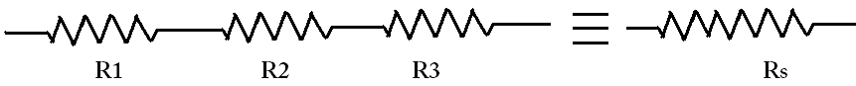
When two or more resistances are connected in parallel the equivalent resistance, R_{P} is given by:
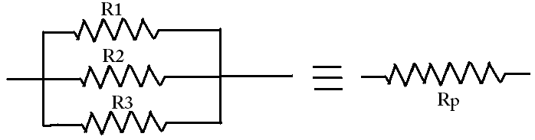
Procedure:
Open the following simulation and click “Intro”:
https://phet.colorado.edu/sims/html/circuit-construction-kit-dc/latest/circuit-construction-kit-dc_en.html
1. Connect R₁ (10 ohm) and R₂ (20 ohm) in series, connect the battery (V = 9 volt), measure the current, and complete the data table below.
2. Connect R₁ (10 ohm) and R₂ (20 ohm) in parallel, connect the battery (V = 9 volt), measure the current, and complete the data table below.

Resistor combination Diagram | Current, I (A) | Equivalent Resistance (Ω)
 |  | Measured=V/I=9/I | Calculated
R₁ (10 Ω) and R₂ (20 Ω)in series:
R₁ (10 Ω) and R₂ (20 Ω)in parallel:

3. Connect the three resistors in various combinations and obtain various values of resistances. Measure the equivalent resistances. Also calculate the equivalent resistances using the values for R₁ = 10 ohm, R₂ = 20 ohm, and R₃ =30 ohm.
Battery voltage = V = 9 volt
Resistor combination diagram | Current, I (A) | Equivalent Resistance (Ω)
 |  | Measured=V/I=9/I | Calculated
All in series
All in parallel
2 in parallel + 1 in series
Resistor combination diagram | Current, I (A) | Equivalent Resistance (Ω)
 |  | Measured=V/I=9/I | Calculated
2 in parallel + 1 in series
2 in parallel + 1 in series
2 in series + 1 in parallel
2 in series + 1 in parallel
2 in series + 1 in parallel

