PHYS 202L Reflection and Refraction Remote lab Name:________________________
A. Reflection: Plane Mirror
1. Determining the number of images for two plane mirrors kept at a particular angle (θ) between them.
a. When you stand in front of a plane mirror, you see yourself in the
mirror. There will be only one image.
θ (degrees) | # of images
180
(use one mirror)
120
90
72
60
51.4
45

b. For θ = 90⁰ is shown below, how many images you see?
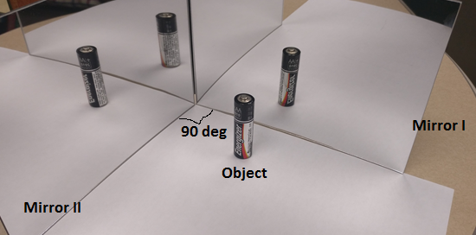
c. Watch this video:
https://www.youtube.com/watch?v=ra1SozRvrhE
Write down a formula for the number of images in terms of the angle (θ) between two plane mirrors: # of images = _____________________________
2. Determining the image properties for a plane mirror.
Using a plane mirror in your home determine the following:
- Stand in front of it and find out the size of your image. Is it the same or different? Also, is it upright?
- How far is the image behind the mirror? Observe what happens when you move closer to and away from the mirror.

- Is the image virtual or real? https://www.youtube.com/watch?v=g_5_4Ktamf8
3. Plane mirror size and object size relationship: (Image from OpenStax, College Physics).
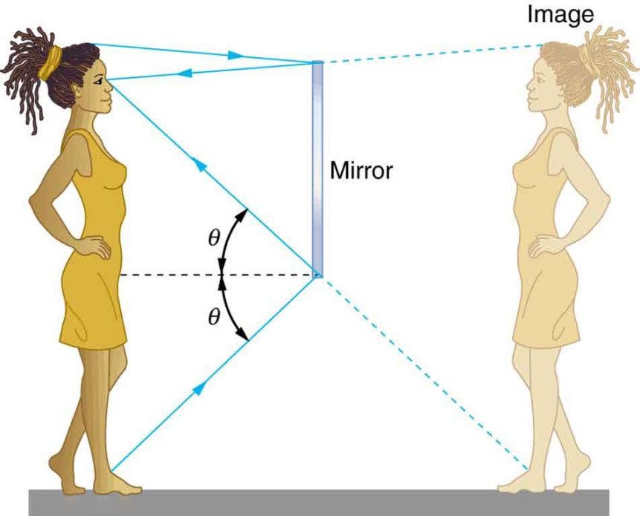
a. Take a piece of paper and cut a square hole inside. Side of the square can have any length as long as it is less than the width of the paper. Tape this cut paper on the mirror, at your eyesight, so that one of the sides of the square is horizontal.
b. Look at the square hole and see how much of your face is inside the square. Measure the size (length or width) of your face as seen inside the square hole of the mirror.
Size of the side of the square hole =_____________
Size of your face as seen in the square hole of the mirror = ________________
Ratio of size of your face/size of mirror =_________
c. Repeat the above measurements, for a closer or further distance from the mirror.
Size of the side of the square hole =_____________
Size of your face as seen in the square hole of the mirror = ________________
Ratio of size of your face/size of mirror =_________
d. Predict a relationship between size of object and minimum size of mirror to see the entire object in the mirror.
___________________________________________________________________________
e. What minimum height of mirror is necessary to see the entire body of a person whose height is 6 feet. ________________

4. The law of reflection: (Image from OpenStax, College Physics).
The law of reflection says that the angle of incidence is equal to the angle of reflection.
θ_{i} = θ_{r}.
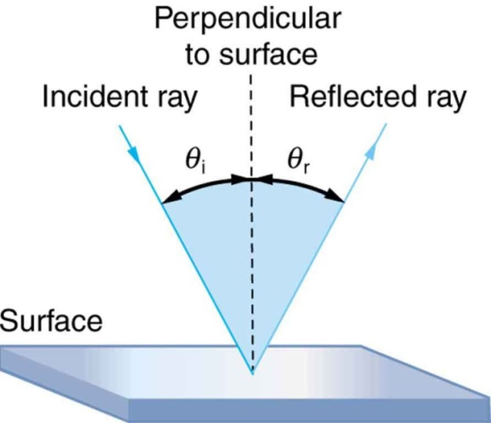
Go to this Phet simulation: (We will use this for the rest of the lab)
https://phet.colorado.edu/sims/html/bending-light/latest/bending-light_en.html
- Click the first simulation, Intro.
- Turn on the laser beam by clicking the red button.
- For this activity you will consider the reflection from the air-water boundary.
- Click and move the center of the protractor to the reflection point.
- Move the laser until the angle of incidence is 20⁰.
- Measure the angle of reflection, and enter the data in the data table.
- Repeat the measurements for other angles of incidence and complete the data table.
- Look at your data and explain whether the

θ_{i} (degree) | θ_{r} (degree)
20
30
40
50
60
70
80

law of reflection is verified or not, below.

B. Law of Refraction (Snell’s Law):
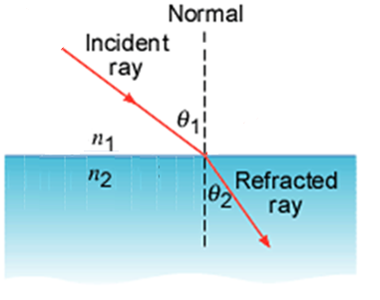
When light travels from a material with refractive index n₁ into a material with refractive index n₂ the refracted ray, the incident ray, and the normal lie in the same plane. The angle of refraction θ₂ is related to the angle of incidence θ₁ by:
n₁ sin θ₁ = n₂ sin θ₂
B1. Go to this Phet simulation:
https://phet.colorado.edu/sims/html/bending-light/latest/bending-light_en.html
- Click the first simulation, Intro.
- Turn on the laser beam by clicking the red button.
- For this activity you will consider the refraction from air into water.
- Click and move the center of the protractor to the refraction point.
- Move the laser until the angle of incidence is 10⁰.
- Measure the angle of refraction and enter the data in the data table in excel.
- Repeat the measurements for other angles of incidence and complete the data table in excel.
- Plot a graph and obtain the index of refraction of water from the graph.
θ₁ (degree) | θ₂ (degree) | $$Sin θ_{1}$$ | $$Sin θ_{2}$$
10
20
30
40
50
60
70
80
Index of refraction of water from graph = _________________
Accepted index of refraction of water = ___________________
% Error =_____________________
B2. Index of refraction of glass:
1. Change the refraction medium to glass, by clicking the up arrow for materials (bottom right) and choosing glass.
2. For this activity you will consider the refraction from air into glass.
3. Move the laser until the angle of incidence is 10⁰.
4. Measure the angle of refraction and enter the data in the data table in excel.
5. Repeat the measurements for other angles of incidence and complete the data table in excel.
6. Plot a graph and obtain the index of refraction of glass from the graph.
θ₁ (degree) | θ₂ (degree) | $$Sin θ_{1}$$ | $$Sin θ_{2}$$
10
20
30
40
50
60
70
80
Index of refraction of glass from graph = _________________
Accepted index of refraction of glass = ___________________
% Error =____________________
B3. Index of refraction of Mystery A:
1. Change the refraction medium to Mystery A, by clicking the up arrow for materials (bottom right) and choosing Mystery A.
2. For this activity you will consider the refraction from air into Mystery A.
3. Move the laser until the angle of incidence is 10⁰.
4. Measure the angle of refraction and enter the data in the data table in excel.
5. Repeat the measurements for other angles of incidence and complete the data table in excel.
6. Plot a graph and obtain the index of refraction of Mystery A from the graph.
θ₁ (degree) | θ₂ (degree) | $$Sin θ_{1}$$ | $$Sin θ_{2}$$
10
20
30
40
50
60
70
80
Index of refraction of Mystery A from graph = _________________
C. Total Internal Reflection and Critical Angle
1. Watch the following video and get an understanding of Total Internal Reflection:
https://www.youtube.com/watch?v=QFYWPamx9F8
2. Go to the simulation. Change the first medium to water, by clicking the up arrow for materials (top right) and choosing Water. Change the second medium to air, by clicking the up arrow for materials (bottom right) and choosing Air.
3. First you will consider the refraction from water to air.
4. Change the angle incidence by moving the laser and make the refracted ray to grace the boundary. In this case θ₂ = 90⁰ and θ₁ = θ_{C}.
5. Record the critical angle, θ_{C} for the water-air boundary.
6. Calculate the critical angle, θ_{C} for the water-air boundary.
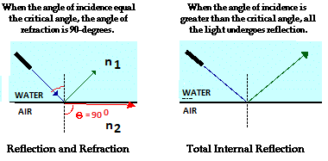
Applying the Snell’s law gives: $n_{1}Sinθ_{C}=n_{2}Sin(90)=n_{2}$, Since Sin 90⁰ = 1.
$θ_{C}=\sin^{-1}{\frac{n_{2}}{n_{1}}}$
Boundary | Critical Angle θ_{C} (degree) |  | % Error
 | Measured | Calculated
Water(n=1.33)-Air(n=1)
Glass(n=1.50)-Air(n=1)
Glass(n=1.50)-Water(n=1.33)
7. Change the first medium to Glass, by clicking the up arrow for materials (top right) and choosing Glass. Change the second medium to Air, by clicking the up arrow for materials (bottom right) and choosing Air. Repeat the measurements and calculations for Glass-Air boundary and complete the data table.
8. Change the first medium to Glass, by clicking the up arrow for materials (top right) and choosing Glass. Change the second medium to Water, by clicking the up arrow for materials (bottom right) and choosing Water. Repeat the measurements and calculations for Glass-Water boundary and complete the data table.
9. Write an overall conclusion for the entire lab.

