Reflection of Light

Standard 8-6.4: Summarize the behaviors of waves (including refraction, reflection, transmission, and absorption).

Purpose: To investigate the reflective property of light, an electromagnetic wave.

Materials: plane mirror attached to wood block cardboard
blank sheet of white paper three pins
thumbtacks
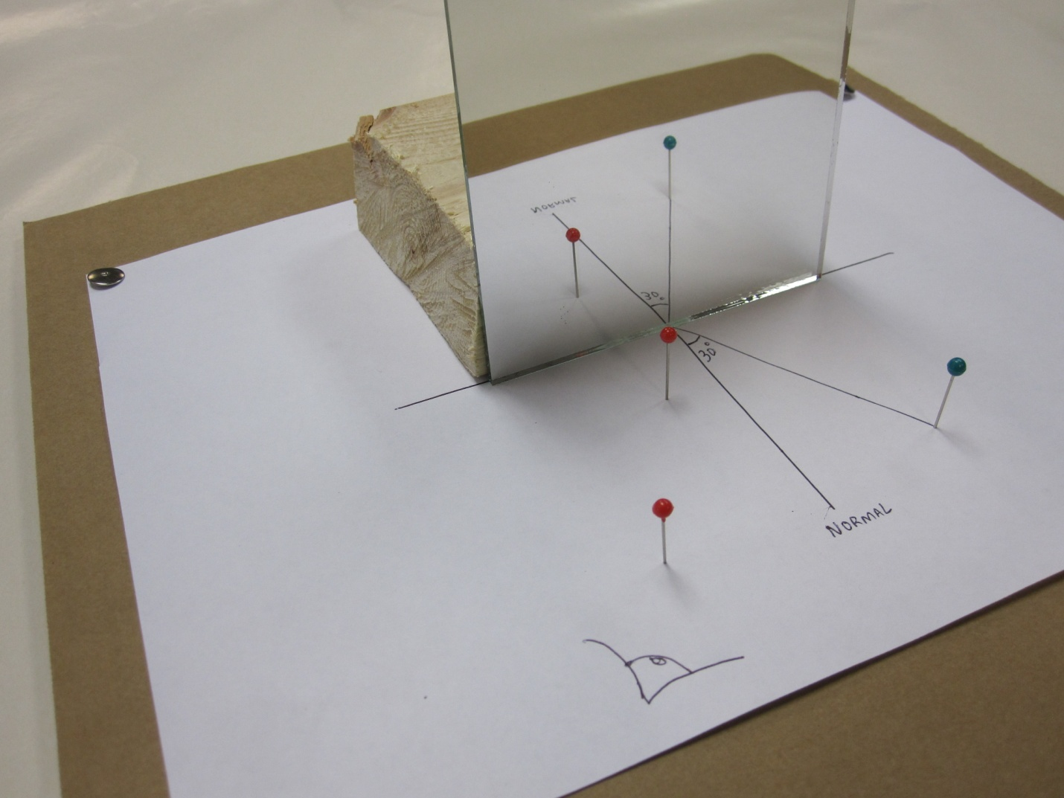

Procedure:
- First, secure a blank sheet of white paper on a piece of cardboard with thumbtacks. Trace an outline of a protractor in the middle of the paper. Find the midpoint of the straight edge of the protractor tracing, and draw a line perpendicular from that point and past the curve of the tracing. This is called the normal.
- The purpose of this lab is to investigate the reflective property of light, so a mirror would be useful, and the mirror needs to be in one position throughout the experiment. To make sure of this, attach a plane mirror to a small block of wood.
- Draw five lines from the midpoint, each with different angles measured from the normal line and all to one side of the normal line, as well. The angles between each line and the normal line are called the angles of incidence—the angles at which light approaches a reflective surface. The theory is that light reflects off a surface at the same angle as it approaches the surface. This means that the angle of incidence of light is the same as the angle of reflection. Enter the angles of incidence and expected angles of reflection in the data table.
- Place one pin along one of the lines and set the mirror’s back edge against the straight edge of the protractor tracing. Notice how the image of the pin appears in the mirror. Look at the mirror from the other side of the normal line and position two pins on the paper so that they line up with the reflected image of the first pin. Draw a line from the midpoint to the two pins, and measure the angle that line forms from the normal line. Enter the measured angle of reflection in the data table.
- Repeat step 4 for the remaining four angles of incidence.

Data:
Angle of Incidence θ₁ ( º ) | Expected Angle of Reflection θ₂ ( º ) | Measured Angle of Reflection θ₂ ( º )

Questions:
- Why must the two pins form a straight line with the reflected image of the first pin?

- What do you notice about the expected angles of reflection and the measured angles of reflection?

- If there are any differences between the expected angles of reflection and the measured angles of reflection, what could the reason(s) be?

Written by: Andrew Niswander, Winthrop Student

