PHYS 202L Remote lab on Heat

Name

Date

Period

Purpose: To verify the mechanical equivalent of heat and measure the specific heat of metals.
Find the Lab

- In your web browser, go to www.gigaphysics.com, then click Virtual Labs, and finally
Mechanical Equivalent of Heat.
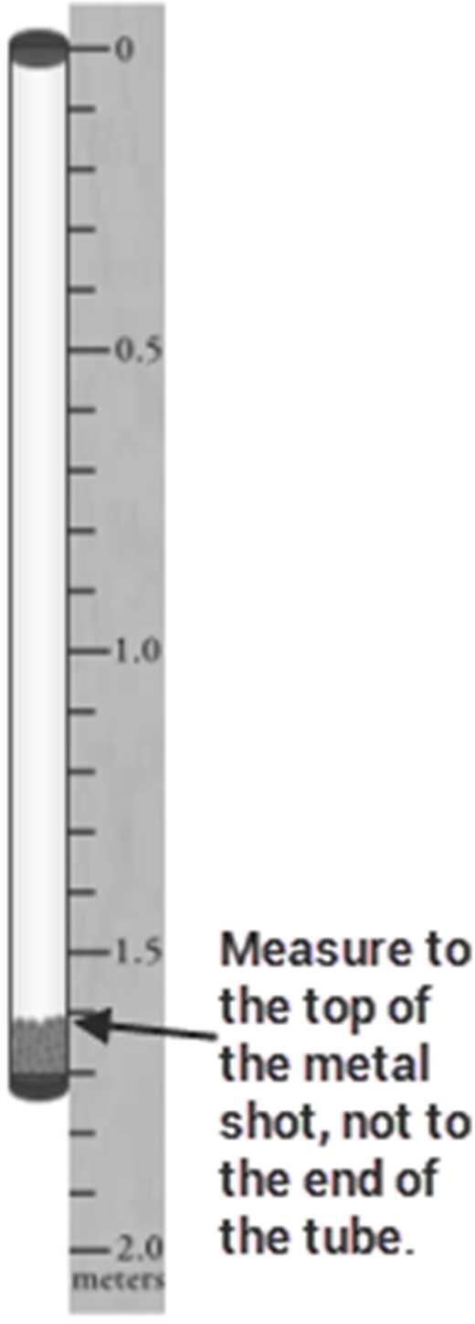
- If someone else used the computer for this lab before you, click Reset Experiment. This will ensure that you have your own unique data when you do the experiment.

Part I: Proof of Concept

- Use the Choose a metal menu to select copper.
- One of the measurements you will need throughout this lab is the distance the shot will fall. To find this distance, use your mouse to drag the ruler next to the tube. Measure from the top of the tube to the top of the copper shot. Record this length in the table below.
- You will also need the mass of the shot. Click Open Tube, then drag the shot to the electronic balance. The balance will display the mass in grams.
- Convert this mass to the SI unit of kilograms, and record it in the data table.
- You’ll need the shot’s initial temperature as well, so drag the shot onto the red laser dot in front of the infrared thermometer (it’s under the balance). The thermometer will display the temperature in °C; add this to the data table as well.

Length of tube | Mass of copper shot | Initial temperature of shot

- To start turning the gravitational potential energy into heat, you need to flip the tube over. Click Close Tube to put the shot back in the tube, and click Flip Tube about 30–40 times. Notice the on-screen flip counter so you don’t have to worry about losing count.
- Click Open Tube and drag the shot back to the infrared thermometer to get the final temperature. Record your data below.

Number of times flipped | Final temperature of shot

- Use the formula E = mgh to calculate the gravitational potential energy. Be sure to take into account the number of times the tube was flipped to get the total height the shot fell.

Total height the shot fell | Gravitational potential energy

- Now use the formula Q = mc∆T to calculate the heat generated as the shot hit the bottom of
the tube. The specific heat capacity of copper is 390 J/(kg.C⁰).

Change in temperature of shot | Heat energy gained by shot

- If you have performed the calculations correctly, you should find that the heat energy gained by the copper shot equals the gravitational potential energy that was available. (Small differences due to rounding are OK.) If your numbers are not the same, you should find out what went wrong before you continue.

Part II: Specific Heat Capacity of Lead
- Change the Choose a metal selection from copper to lead.
- Click Open Tube and drag the shot to the infrared thermometer to get the initial temperature.
- If you want, you can drag the shot to the balance to get the mass as well.
- The length should be the same as it was in part I, unless you have clicked the reset button since then. If you have reset the experiment, you will need to use the ruler again to obtain a new length measurement.

Length of tube | Mass of lead shot (optional) | Initial temperature of shot

- Click Close Tube and flip the tube again. For lead, you should get good results with about 20–30 flips.
- Click Open Tube and get your new final temperature reading.

Number of times flipped | Final temperature of shot

- In Part I, you demonstrated that the gravitational potential energy before the shot falls is equal to the heat gained at the end of the fall. Use this concept to set up an equation and solve it for the specific heat capacity of lead. Show your work in the space provided.

Specific heat capacity of lead

Part III: Specific Heat Capacity of Aluminum
- Change the type of shot from lead to aluminum.
- Repeat the previous procedure, but you will probably need to flip the tube about 40–50 times to get good results for aluminum.

Length of tube | Mass of aluminum (optional) | Initial temperature of shot
Number of times flipped | Final temperature of shot

Specific heat capacity of aluminum

Part IV: Additional Questions
In parts II and III, you didn’t actually have to find the mass of the metal to calculate its specific heat capacity, even though mass appears in the relevant formulas. Why didn’t you need the mass?

Iron has a specific heat capacity of 450 J/(kg.C⁰). Would an iron nail heat up more or less than an aluminum nail while being pounded into a board with a hammer? Explain your answer.

Conclusion:

Learning physics? Teaching physics? Check out www.gigaphysics.com.
© 2016, Donovan Harshbarger. All rights reserved. This activity guide may be reproduced for non-profit educational use.

