PHYS 211L Remote Lab on Friction

Name: ____________________________Date: __________Time: _________

**Part A: Forces**

Watch the following video:

<https://www.youtube.com/watch?v=kKKM8Y-u7ds>

Answer the following questions:

1. What is Newton’s first law?
2. What is Newton’s second law?
3. What is a net Force?
4. What is the difference between the mass and the force the gravity?
5. What is a normal force?
6. What is a tension force?
7. What is a free body diagram? Give an example.

**Simulation**

Use the *Forces and Motion* simulation from

<http://phet.colorado.edu/sims/html/forces-and-motion-basics/latest/forces-and-motion-basics_en.html>

Your screen should look like the following. **Click on motion.**

**Explore the simulation for 5 minutes**

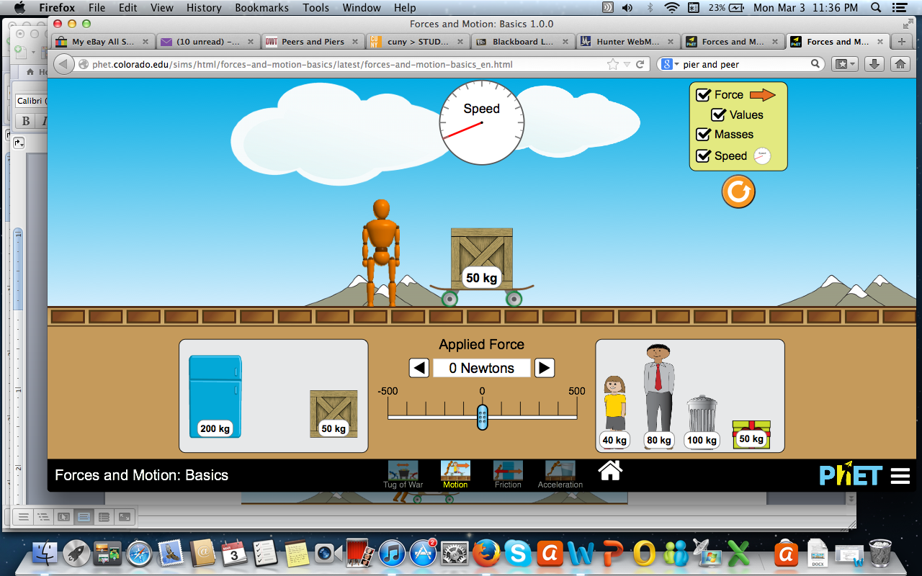

1. What do you think the wooden man and arrow represent?
2. Before you begin to further explore, select the Forces, Values, Masses, and Speed checkboxes in the yellow box on the top right.

Box is on the skateboard. Pause the simulation and set the applied force to 50 N. Use your phone as a timer and set it to 10 s. Start the timer and the simulation simultaneously. At the end of 10 s, remove the applied force, and record the final speed in the data table below.

1. Now place both boxes on the skateboard and repeat the above procedure.

1. Repeat the measurements for other masses and predict a relationship between an object’s mass and its ability to pick up speed, or accelerate?

Force = 50 N, Time interval for which the force is applied = 10 s

|  |  |  |  |
| --- | --- | --- | --- |
| Mass (kg) | Final speed (m/s) | Determine acceleration using | |
| Kinematic Equation | Newton’s 2nd law |
| 50 |  |  |  |
| 100 |  |  |  |
| 150 |  |  |  |
| 200 |  |  |  |
| 250 |  |  |  |

1. Now, investigate the effect of force on the box. Start with 50 N force, and increase it in 50 N increment, and complete the data table below:

Mass = 50 kg, Time interval for which the force is applied = 10 s

|  |  |  |  |
| --- | --- | --- | --- |
| Force (N) | Final speed (m/s) | Determine acceleration using | |
| Kinematic Equation | Newton’s 2nd law |
| 50 |  |  |  |
| 100 |  |  |  |
| 150 |  |  |  |
| 200 |  |  |  |
| 250 |  |  |  |

1. In your own words how would you describe the relationship between the amount of applied force and an object’s ability to pick up speed, or accelerate?
2. Draw the free body diagram of all the forces on the box, and calculate the acceleration for a box of mass m=50kg, an applied force of Fa=210N, and a friction force of 110N.

**Part B.** **Friction**

Watch the following video:

<https://www.youtube.com/watch?v=fo_pmp5rtzo>

Answer the following questions:

1. Why is it hard to move an object sometimes?
2. What are the different types of friction forces?
3. Define kinetic friction
4. Define static friction
5. Calculate the friction force for an object of mass of 40kg, and an applied force of 30N, and an acceleration of 2.3m/s2. Draw the free body diagram and write your equations

**Part C: Frictional Forces**

**Purpose:** To study the frictional forces and determine the coefficients of static and kinetic friction for various surfaces in contact using a simulation.

**Theory:  
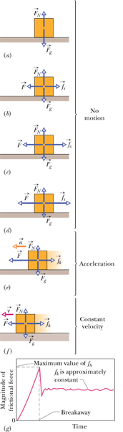**

Consider a box of weight ***Fg*** sitting on a lab table. The free-body diagram is shown in figure (a), where ***FN*** is the normal force. If a force, ***F*** is applied horizontally, to pull the object to the left, the object won’t move due the static frictional force, ***fs*** appearing to the right, as shown in figure (b).

As the pulling force is increased the frictional force will also increase, as shown in figures (c) and (d), until it reaches its maximum value, ***fs, max***., shown in figure (g). Beyond this the object will start to move and reaches the kinetic region.

If the applied force is greater than the kinetic frictional force, ***fk*** the box will accelerate, as shown in figure (e). If the applied force is almost equal to the kinetic frictional force, ***fk*** the box will move with a constant velocity, as shown in figure (f), which can be used to determine the kinetic frictional force.

Magnitude of the maximum static frictional force is given by:



$f_{s}=μ_{s}F_{N}$

Magnitude of the kinetic frictional force is given by:

$$f_{k}=μ_{k}F_{N}$$

Normal force = $F_{N}=mg$,

Where *m* = mass and   
 g = acceleration due to gravity

**Simulation:**

1. Go to the following simulation.

[**https://www.thephysicsaviary.com/Physics/Programs/Labs/ForceFriction/**](https://www.thephysicsaviary.com/Physics/Programs/Labs/ForceFriction/)

2. Click “Begin”, record the mass, and click “Start”.

3. Force VS. Time graph will be displayed for the pulling force. From this graph obtain the static (highest value) and kinetic (flat line value) frictional forces and calculate the static and kinetic coefficients of friction to 2 decimal places.

4. Repeat the simulation for other surfaces and complete the data table.

|  |  |  |  |  |  |  |  |
| --- | --- | --- | --- | --- | --- | --- | --- |
|  | Mass (g) | Mass (kg) | Normal  Force (N) | Frictional Force (N) | | Coefficient of Friction | |
| Static | Kinetic | Static | Kinetic |
| Rubber on Ice |  |  |  |  |  |  |  |
| Al on  steel |  |  |  |  |  |  |  |
| Glass on Glass |  |  |  |  |  |  |  |
| Graphite on Graphite |  |  |  |  |  |  |  |
| Rubber on concrete |  |  |  |  |  |  |  |
| Wood on Lab table |  |  |  |  |  |  |  |

Write an overall conclusion: