Purpose: Determine the wavelength of light using wave phenomena.
Diffraction Grating
Apparatus: Diffraction grating (500 lines/mm), meter stick-2, and laser w/power adapter.
Theory: (From Halliday, Resnick, and Walker, 9th Ed, Chapter 36-8)
One of the most useful tools in the study of light and of objects that emit and absorb light is the diffraction grating. This device has a number N of slits, often called rulings, perhaps as many as several thousand per millimeter. An idealized grating consisting of only five slits is represented in Fig. 36-18. When monochromatic light is sent through the slits, it forms narrow interference fringes that can be analyzed to determine the wavelength of the light.
 | Figure 36-18 | An idealized diffraction grating, consisting of only five rulings, that produces an interference pattern on a distant viewing screen C.

With monochromatic light incident on a diffraction grating, if we gradually increase the number of slits, the intensity plot changes to a simple graph like that shown in Fig. 36-19a. The pattern you would see on a viewing screen using monochromatic red light from, say, a helium-neon laser is shown in Fig. 36-19b. The maxima are now very narrow (and so are called lines); they are separated by relatively wide dark regions.
 | Figure 36-19 | (a) The intensity plot produced by a diffraction grating with a great many rulings consists of narrow peaks, here labeled with their order numbers m.(b) The corresponding bright fringes seen on the screen are called lines and are here also labeled with order numbers m.

We use a familiar procedure to find the locations of the bright lines on the viewing screen. We first assume that the screen is far enough from the grating so that the rays reaching a particular point P on the screen are approximately parallel when they leave the grating (Fig. 36-20). Then we apply to each pair of adjacent rulings the same reasoning we used for double-slit interference. The separation d between rulings is called the grating spacing. (If N rulings occupy a total width w, then d = w/N.) The path length difference between adjacent rays is again d sin θ (Fig. 36-20), where θ is the angle from the central axis of the grating (and of the diffraction pattern) to point P. A line will be located at P if the path length difference between adjacent rays is an integer number of wavelengths—that is, if
(36-25)
where λ is the wavelength of the light. Each integer m represents a different line; hence these integers can be used to label the lines, as in Fig. 36-19, below. The integers are then called the order numbers, and the lines are called the zeroth-order line (the central line, with m = 0), the first-order line (m = 1), the second-order line (m = 2), and so on.
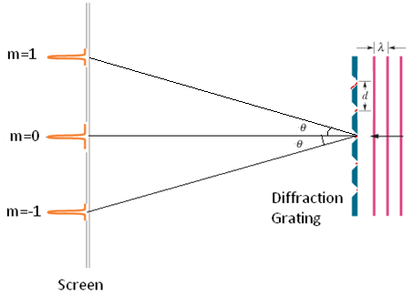
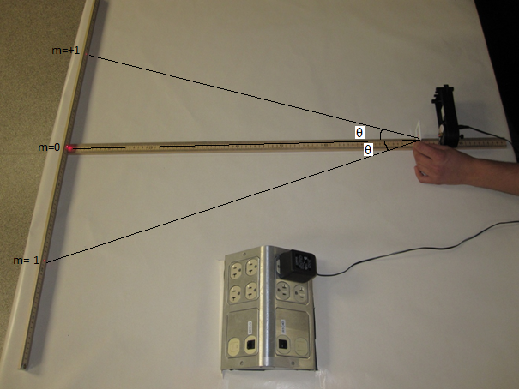
Procedure:
1. Place a meter-stick on the side, parallel to the edge of the lab-table, place the other meter-stick flat, perpendicular to the first meter stick, as shown above.
2. Place the diode-laser on the side on top of the flat-meter stick.
3. Turn on the laser and adjust it until the laser beam strikes the middle of the scale.
4. Hold the diffraction grating (500 lines/mm) in the path of the laser beam and obtain the first order diffraction spots (m=1 and m=-1) on the scale of the meter-stick.
5. Make the necessary measurements and calculate the wavelength.
6. List the accepted value, and find the %Error.
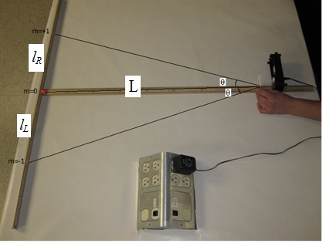

DATA:
d = (1/500) mm = ________mm = ________nm Center spot location = _________

L (cm) | Locations of diffracted R and L spots |  | l_{R} (cm) | l_{L} (cm) | l (cm) | θ | Sin θ | λ= d Sinθ
90
80
70
60
Average λ
Accepted λ
% Error

