**Electromagnetic Induction: Faraday’s Law**             **Name: _______________________**

When a magnet is passed through a coil there is a changing magnetic flux, Φ through the coil which induces an electromotive force, emf, also known as voltage. According to Faraday's law of induction the induced emf, *ξ* is given by; where *B*┴ is the magnetic field perpendicular to the area *A* and *N* is the number of turns in the coil.

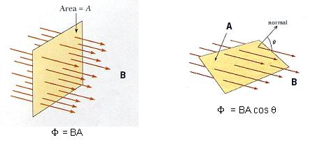

 ****is the magnetic flux for one turn.

**Demo: Inducing emf/Current using magnetic field**Apparatus: Galvanometer, solenoid, banana-plug wires, and horse-shoe magnet.

|  |  |  |
| --- | --- | --- |
| Procedure | Observation | Explanation |
| 1. Magnet placed in the solenoid, not moving |  |  |
| 2. Moving the magnet, out |  |  |
| 3. Moving the magnet, in |  |  |
| 4. Moving the magnet faster VS. slower |  |  |

**Purpose:** Investigate the electromotive force (emf), also known as voltage, induced in a solenoid by a moving magnet.

|  |  |  |
| --- | --- | --- |
|  |  |  |

**Theory:**When a magnet is passed through a coil there is a changing magnetic flux   
through the coil which induces an electromotive force, emf. According to   
Faraday's law of induction the induced emf, *ξ* is given by; where *B*┴ is the   
magnetic field perpendicular to the area *A* and *N* is the number of turns in   
the coil.   
In this activity, a plot of the emf (or Voltage) *versus* time is made and   
the area under the curve represents the magnetic flux.

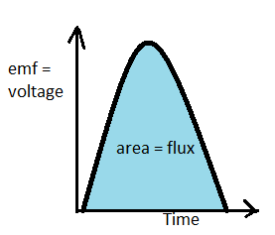

**Apparatus:** Voltage sensor, solenoid (# of turns =540), magnets (bar and horse-shoe), foot-ruler, banana-plug wires (2), and soft-box (to catch the magnet).

**Procedure:**  
1. Place the solenoid vertically on the lab table and connect the solenoid to the voltage sensor using two banana-plug wires. Place the horseshoe magnet inside the solenoid.

2. Open SPARKvue software, pair the voltage sensor, and choose a graph display for Voltage VS. Time.

3. Click “Sampling Options”, lower left corner and do the following:  
a. Increase the sample rate to 200 Hz.  
b. Change the stop condition to “Stop after duration of 3 s”.

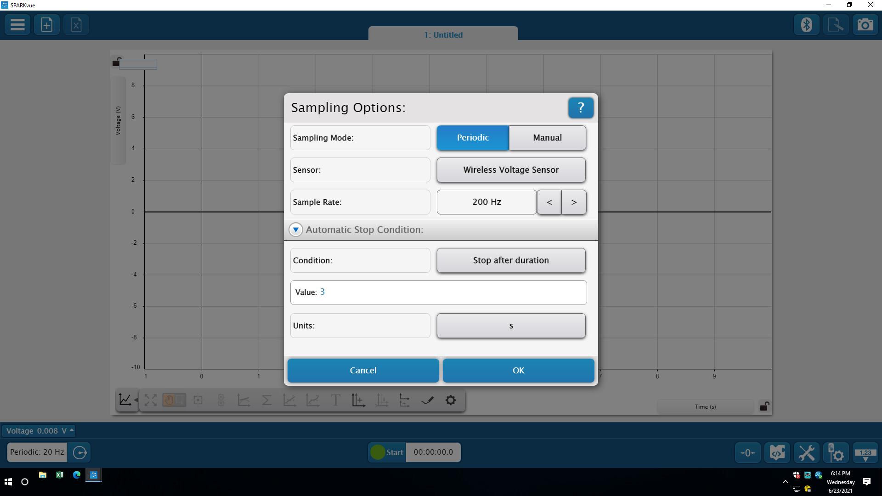

4. Click “Show Hardware setup”, lower right corner, click gear symbol next to wireless voltage sensor, and do the following: Turn on “zero sensor automatically on start”.

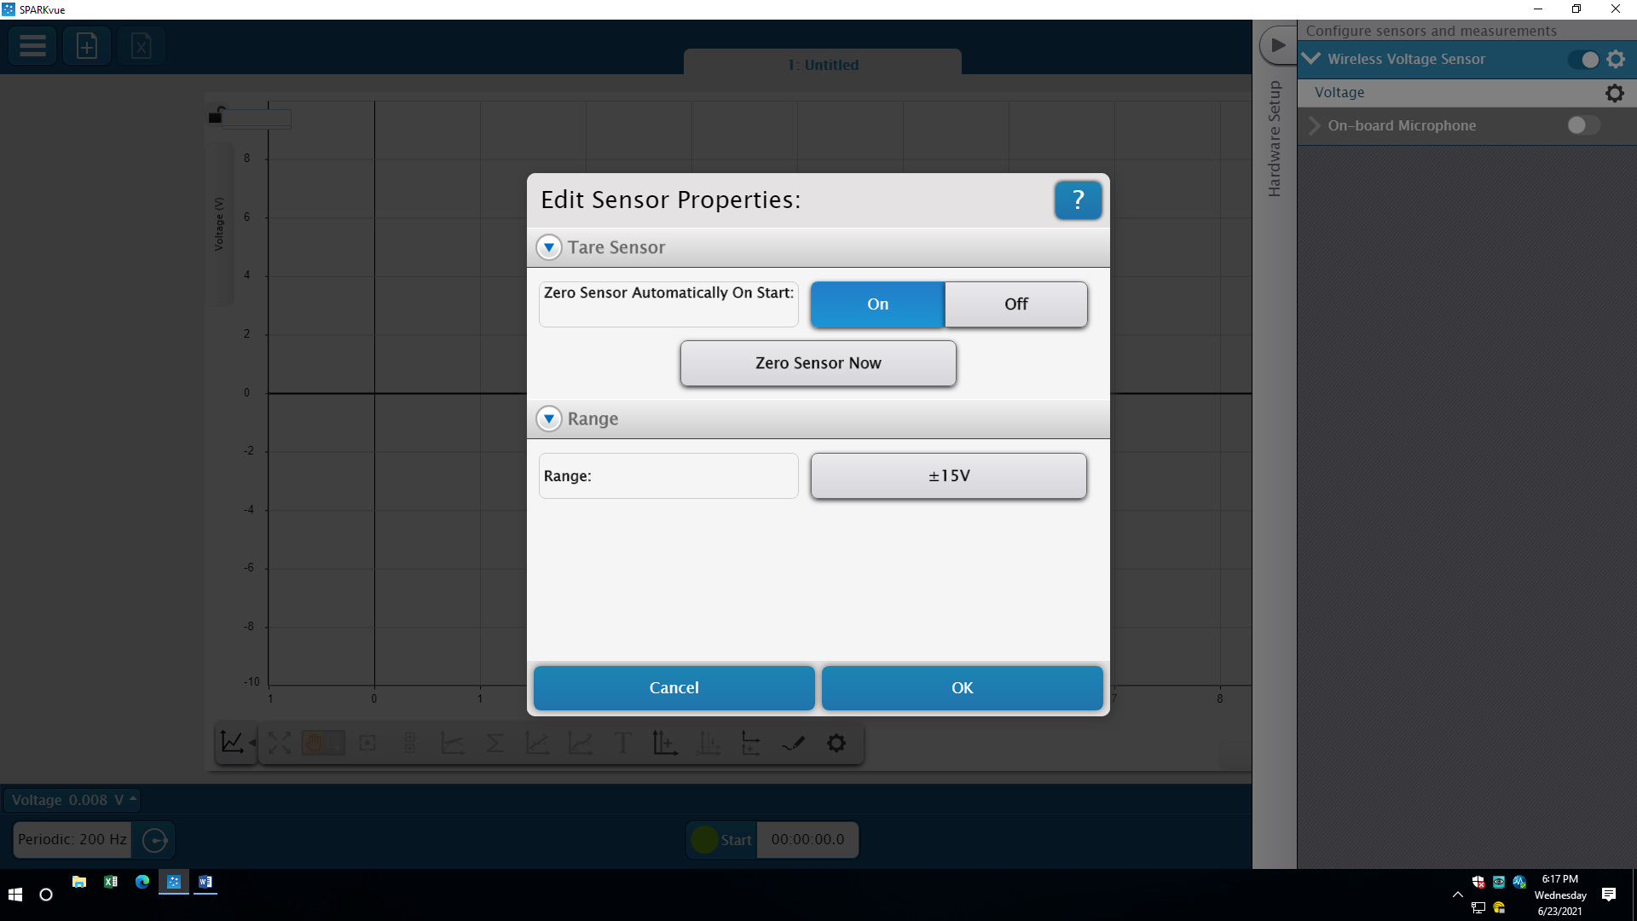

5. Click **Record** and remove the horse-shoe magnet.   
6. If nothing is displayed; stop the data collection, place the other side of the horse-shoe magnet and try Procedure (5) again.  
7. Maximize the graph display, which should look like the following.

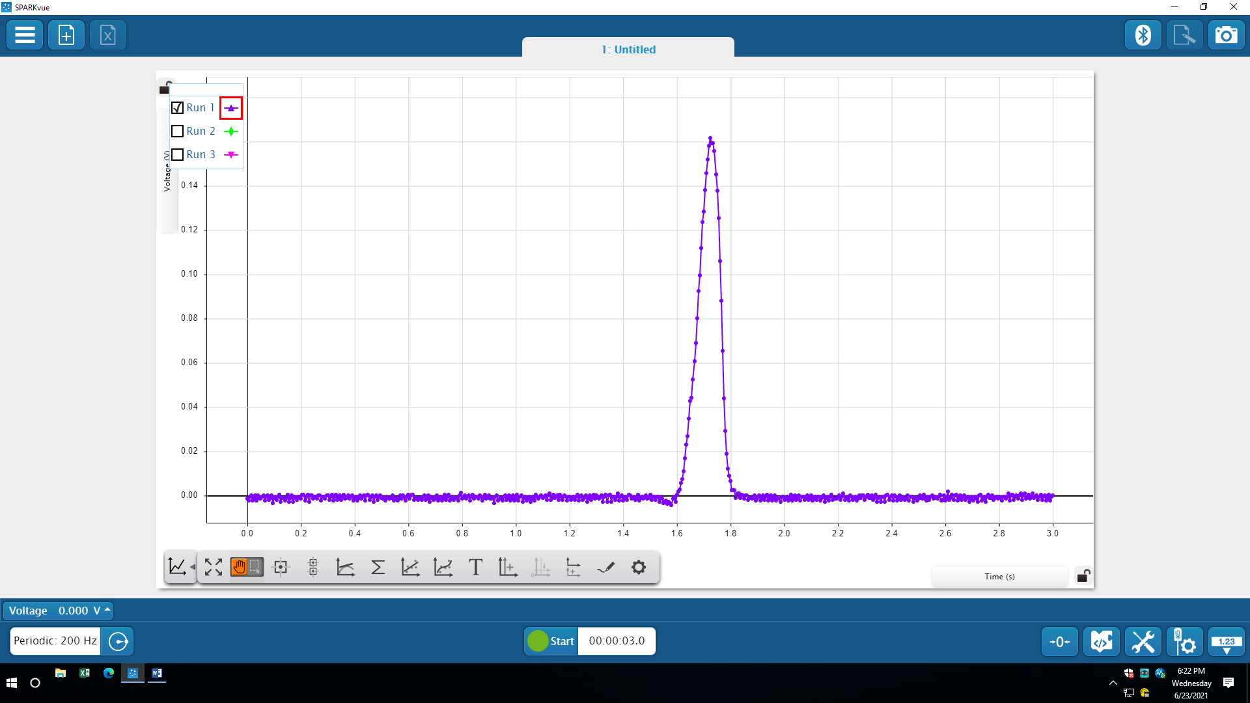

8. Measure the peak value of the induced voltage using the **Show Coordinates Tool** and the magnetic flux (area under the V vs. t graph) using the **Display area under active data tool**.  
Safe a screenshot of the display.   
9. Repeat procedures, for removing the magnet quicker, and complete the data table for the horse-shoe magnet.   
10. Place the soft-box on the floor close to the edge of the table and hold the solenoid vertically above it.  
11. Click **Record** and drop the bar magnet, N-pole down, through the solenoid.   
12. The data collection will stop automatically. You should see two peaks.  
13. Magnetic flux is obtained by finding the area under the V vs. t graph. Safe a screenshot of the display.  
14. After completing the data tables, and answering the questions.

DATA: a. Horse-shoe magnet: Include Units.

|  |  |  |
| --- | --- | --- |
|  | Slow removal | Quick removal |
| Peak value of the induced emf |  |  |
| Magnetic flux  (Area under the V vs. t graph) |  |  |
| Average speed |  |  |

Q1. Why the magnitude of the peak value of the induced emf is higher for the quick removal?

 ___________________________________________________________________

Q2. Is the magnitude of the magnetic flux equal for the two peaks? Explain why.

___________________________________________________________________

___________________________________________________________________

b. Bar magnet: Include Units.

|  |  |  |  |  |
| --- | --- | --- | --- | --- |
| Bar Magnet | Dropping the magnet from closer to the solenoid | | Dropping the magnet from further to the solenoid | |
| First Peak | Second Peak | First Peak | Second Peak |
| Peak value of the induced emf |  |  |  |  |
| Magnetic flux (Area under the V vs. t graph) |  |  |  |  |
| Average speed for the moving magnet |  | |  | |

Q1. Is the magnitude of the magnetic flux equal for the peaks? Explain why.

__________________________________________________________________

__________________________________________________________________

Q2. Why the magnitude of the peak value of the induced emf is higher for dropping from further from the solenoid and for the second peak?  
  
__________________________________________________________________

__________________________________________________________________

Q3. Describe how the display will change if the S-pole is down when the bar magnet is dropped.

____________________________________________________________________

____________________________________________________________________

 Q4. Click Start again and drop the bar magnet, this time S-pole down, through the solenoid. Describe and explain what you see. Does this support your prediction in Q3?  
_____________________________________________________________________  
  
________________________________________________________________________