PHYS 351 Independent Study – Circuit Analysis Name:________________________
Topic: KCL, KVL, and the Node Method
1. Watch this MIT video lecture-2
2. Determine the current through each of the resistances below using the node method.
(V = 12 volt, R₁= 5 ohm, R₂= 8 ohm, R₃= 15 ohm, R₄= 9 ohm, R₅= 10 ohm, and I = 3 A)
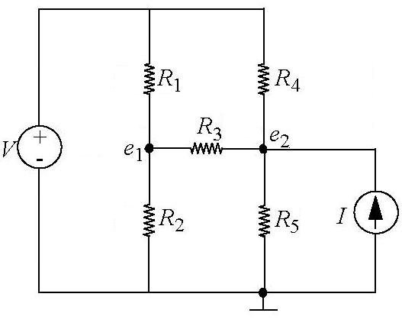
3. Determine the current through each of the resistances below using the node method.
(V = 6 volt, R₁= 3 ohm, R₂= 4 ohm, R₃= 5 ohm, R₄= 6 ohm, R₅= 7 ohm, R₆= 8 ohm, and I = 2 A)