PHYS 321 Interplanar spacing & H-like Spectra Name:________________________
1. For the cubic system, derive expressions for the interplanar spacings for (100), (200), (110), and (111) planes and show that they agree with what is given by the following equation: $d_{hkl}=\frac{a}{\sqrt{h^{2}+k^{2}+l^{2}}}$
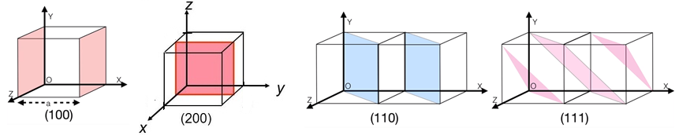

2. Derive the following expression for the wavelength of Hydrogen like spectra.
$$\frac{1}{λ}=RZ^{2}\left(\frac{1}{{n_{f}}^{2}}-\frac{1}{{n_{i}}^{2}}\right)$$

PHYS 321 X-ray Diffraction Name:______________________________
Braggs’s Law | Inter-planar Spacing | Hydrogen Like Spectra  (R= 1.097 x 10⁷ m⁻¹)
$$2d_{hkl}Sinθ=nλ$$ | $$d_{hkl}=\frac{a}{\sqrt{h^{2}+k^{2}+l^{2}}}$$ | $$\frac{1}{λ}=RZ^{2}\left(\frac{1}{{n_{f}}^{2}}-\frac{1}{{n_{i}}^{2}}\right)$$

3. The 2ϴ values in degrees for first order diffraction peaks are given below for a metal with cubic structure, using X-rays from Cu-K_{α} radiation (Z = 29): 44.48, 51.83, 76.35, 92.9, 98.4, 121.87, 144.54, 155.51.
(a) Determine the wavelength of the X-rays used.

(b) Derive an expression for $\frac{{Sin}^{2}θ}{h^{2}+k^{2}+l^{2}}$ .
(c) Complete the table below.

2θ (deg.) | θ (rad) | Sin²θ | Normalize | Clear  Fractions | h²+k²+l² | (hkl) | $$\frac{{Sin}^{2}θ}{h^{2}+k^{2}+l^{2}}$$
44.48
51.83
76.35
92.9
98.4
121.87
144.54
155.51
(d) Determine the crystal structure.
(e) Determine the lattice constant.
(f) Determine the ionic radius.
(g) Identify the metal.

PHYS 321 X-ray Diffraction Name:______________________________
Braggs’s Law | Inter-planar Spacing | Hydrogen Like Spectra  (R= 1.097 x 10⁷ m⁻¹)
$$2d_{hkl}Sinθ=nλ$$ | $$d_{hkl}=\frac{a}{\sqrt{h^{2}+k^{2}+l^{2}}}$$ | $$\frac{1}{λ}=RZ^{2}\left(\frac{1}{{n_{f}}^{2}}-\frac{1}{{n_{i}}^{2}}\right)$$

4. The 2ϴ values in degrees for first order diffraction peaks are given below for a metal with cubic structure, using X-rays from Ag-K_{α} and (Z = 47):
(a) Determine the wavelength of the K_{α} and L_{α} X-rays (need this for (g)).
(b) Derive an expression for $\frac{{Sin}^{2}θ}{h^{2}+k^{2}+l^{2}}$ .
(c) Determine the crystal structure.
(d) Determine the lattice constant.
(e) Determine the ionic radius.
(f) Identify the metal.
(g) At what angle be the first reflection if, instead of K_{α} radiation, L_{α} radiation is used?
2θ (deg.) | θ (rad) | Sin²θ | Normalize | Clear  Fractions | h²+k²+l² | (hkl) | $$\frac{{Sin}^{2}θ}{h^{2}+k^{2}+l^{2}}$$
14.10
19.98
24.54
28.41
31.85
34.98
37.89
40.61

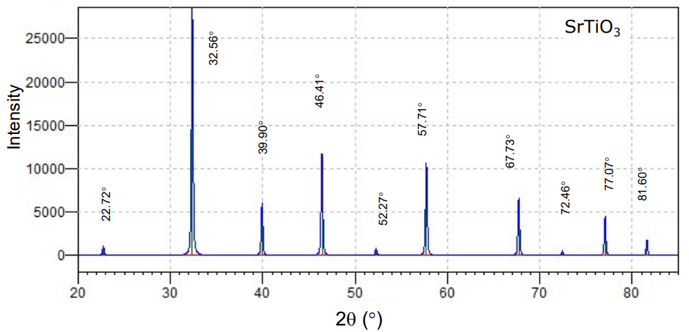
Braggs’s Law | Inter-planar Spacing
$$2d_{hkl}Sinθ=nλ$$ | $$d_{hkl}=\frac{a}{\sqrt{h^{2}+k^{2}+l^{2}}}$$

5. The 2ϴ values in degrees for first order diffraction peaks are given above for SrTiO₃, with cubic structure, using X-rays of wavelength 0.154 nm.
(a) Derive an expression for $\frac{{Sin}^{2}θ}{h^{2}+k^{2}+l^{2}}$

(b) Determine the crystal structure. (c) Determine the lattice constant.
2θ (deg.) | θ (rad) | Sin²θ | Normalize | Clear  Fractions | h²+k²+l² | (hkl) | $$\frac{{Sin}^{2}θ}{h^{2}+k^{2}+l^{2}}$$

