PHYS 321 S 2022 Test #1 Name:________________________
A. The net potential energy between two adjacent ions, E_{N}, may be represented by:
Calculate the equilibrium inter-ionic spacing, r₀ and the bonding energy E₀ in terms of the parameters A, B, and n.

B. Compute the percent ionic character of the inter-atomic bonds for the following compounds: MgO and GaAs. The electronegativity values are given below.
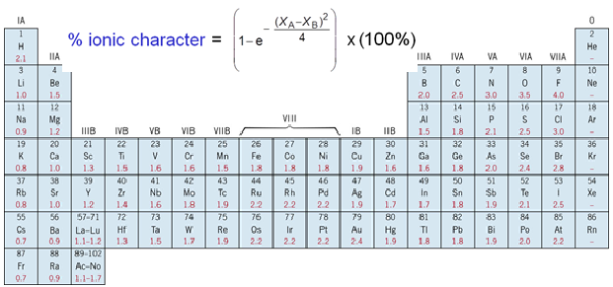

- The unit cell for the face-centered cubic crystal structure is shown below.
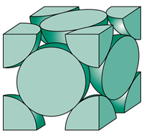
1. Show that the cube edge length, a and the atomic radius, R are
related by: $a=2R\sqrt{2}$

2. Show that the atomic packing factor is 0.74 for FCC.

3a. Calculate the atomic radius of a lead atom, given that Pb has a FCC crystal structure, a density of 11.35 g/cm³, and an atomic weight of 207.2 g/mol.

3b. Calculate the planar density for (110) planes in lead.

D. Determine the density of CaTiO₂. Ionic radius: Ca = 0.100 nm, O = 0.140 nm, and Ti = 0.068 nm. Atomic masses: Ca = 40.08, O = 16, Ti = 47.87
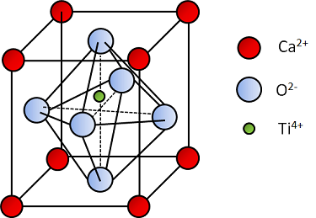

E. 1. What are the indices for the directions shown, A and B within a cubic unit cell?
2. Draw the direction [$\overline{2}10].$
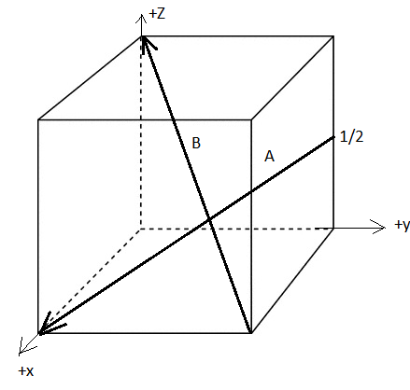

F. 1. Determine the 3-axis indices and then convert them to 4-axis indices for the directions shown.
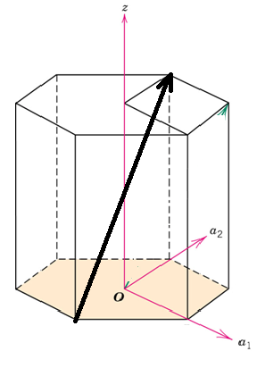
=
=
=
'
w
w
t
v
u
)
v
u
(
+
-
)
'
u
'
v
2
(
3
1
-
)
'
v
'
u
2
(
3
1
-
=
]
uvtw
[
]
'
w
'
v
'
u
[
→

2. Draw the direction [$2\overline{4}26].$
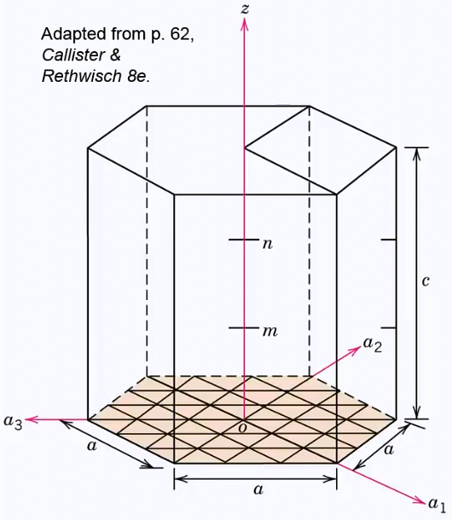

G. What are the Miller indices for the planes shown below?
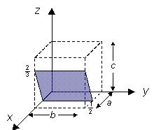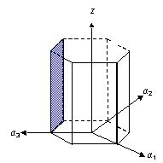
H. Hexagonal Closed Pack Structure
1. Show that the base area of the unit cell for HCP is given by, 6√3R².

2. Show that the atomic packing factor for HCP is 0.74.

3. Magnesium (atomic weight = 24.31) has an HCP unit cell for which the ratio of the lattice parameters c/a is 1.624. If the density of Mg is 1.74 g/cm³, determine the radius of the Mg atom.
