PHYS 321 F 2019 Test #1 Name:\_\_\_\_\_\_\_\_\_\_\_\_\_\_\_\_\_\_\_\_\_\_\_\_

A. Uranium metal can be produced by the reaction of uranium tetrafluoride (UF4) with magnesium (Mg) in a sealed reactor heated to 700ºC. The by-product is magnesium fluoride (MgF2). To ensure that all the magnesium is consumed in the reaction, the reactor is charged with excess UF4, specifically 12% more than the stoichiometric requirement of the reaction. To produce 322 kg of U, how much UF4 and Mg must be introduced into the reactor? Express your answers in kg. (U:238, F:19.0, Mg:24.3)

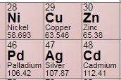

B. Give the electron configurations for: Cu and Cu+

C1. Compute the percent ionic character of the inter-atomic bonds for the following compound: CdTe.  
C2. On the basis of the above result what type of interatomic bonding would you expect in CdTe?

The electronegativity values are given below.  
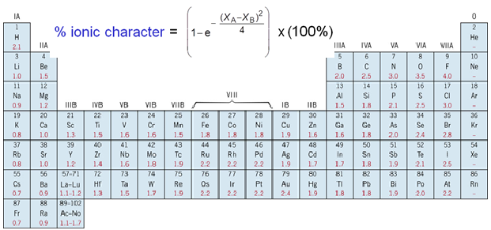

1. The unit cell for the face-centered cubic crystal structure is shown below.

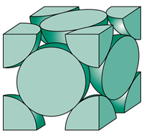

1. Show that the cube edge length, *a* and the atomic radius, R are   
related by:

2. Show that the atomic packing factor is 0.74 for FCC.

3a. Calculate the atomic radius of a copper atom, given that Cu has a FCC crystal structure, a density of 8.94 g/cm3, and an atomic weight of 63.546 g/mol.

3b. Calculate the linear density for [111] direction and planar density for (111) planes in copper.

E. Determine the density of BaTiO3, which forms a perovskite crystal structure, shown below: 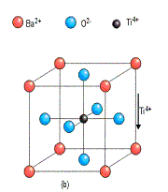

|  |  |  |
| --- | --- | --- |
|  | Ionic Radius (nm) | Atomic mass (g/mol) |
| Ba (Corner) | 0.136 | 137.3 |
| O (Face center) | 0.140 | 16 |
| Ti (Middle) | 0.145 | 47.87 |

F. What are the indices for the directions represented by the vectors (A,B,C,D) that has been drawn within a unit cell?  
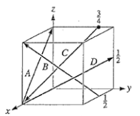

G. Determine the Miller indices for the planes shown (A,B,C) in the following unit cell:

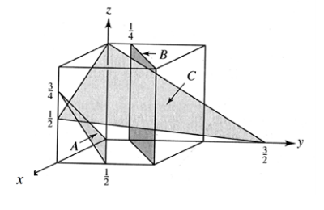

H. What are the Miller indices for the planes shown below?

|  |  |  |
| --- | --- | --- |
| q16-1 | figun_03_p88d.jpg | figun_03_p88e.jpg |

I. S*ketch the following directions:(a)* *(b)* *(c)* 

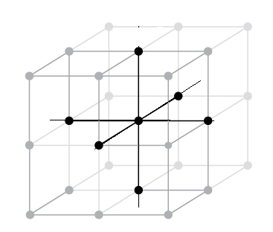

1. *Sketch $\left[1\overline{2}\overline{2}3\right]$ and $[\overline{2}4\overline{2}3]$ direction in a hexagonal unit cell.*

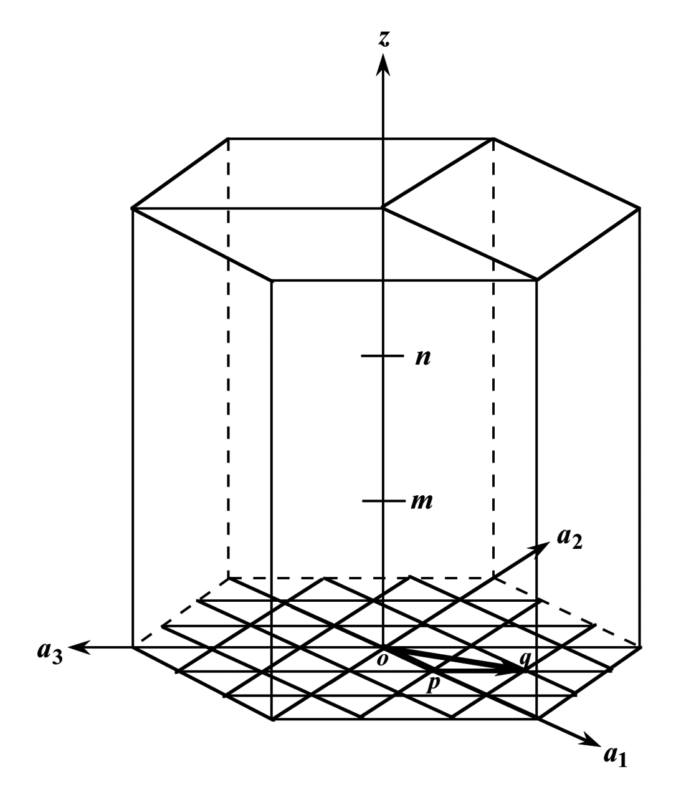

I. S*ketch the following directions:(a)* *(b)* *(c)* 

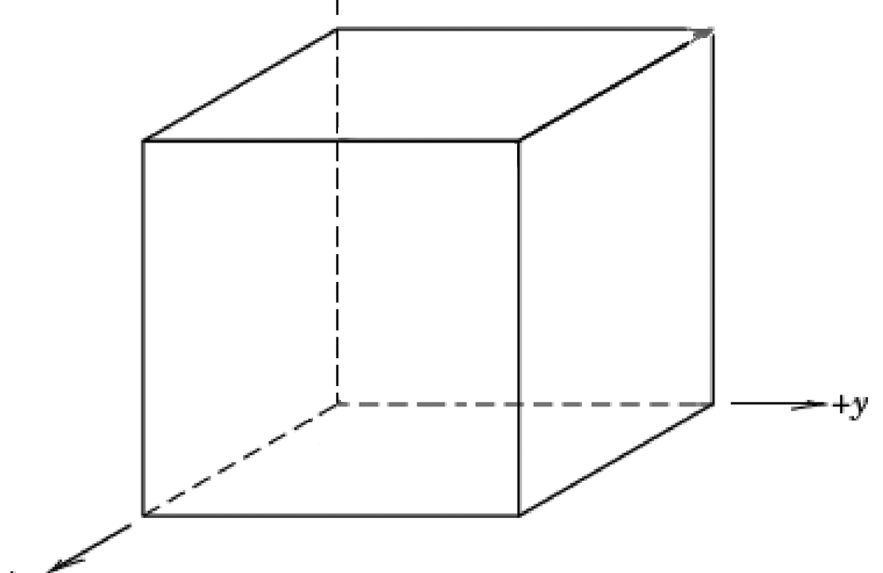

1. *Sketch $\left[1\overline{2}\overline{2}3\right]$ and $[\overline{2}4\overline{2}3]$ direction in a hexagonal unit cell.*

 