PHYS 321 F 2017 Test #1 Name:________________________

A. Uranium metal can be produced by the reaction of uranium tetrafluoride (UF4) with magnesium (Mg) in a sealed reactor heated to 700ºC. The by-product is magnesium fluoride (MgF2). To ensure that all the magnesium is consumed in the reaction, the reactor is charged with excess UF4, specifically 10% more than the stoichiometric requirement of the reaction. To produce 222 kg of U, how much UF4 and Mg must be introduced into the reactor? Express your answers in kg.

B. Compute the percent ionic character of the inter-atomic bonds for the following compounds: TiO2 and CdS. The electronegativity values are given below.  
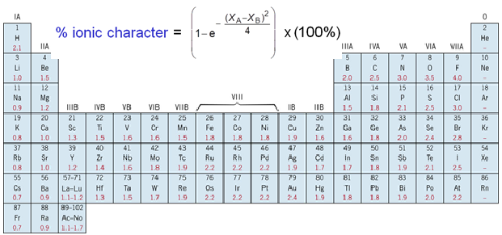

1. The unit cell for the face-centered cubic crystal structure is shown below.

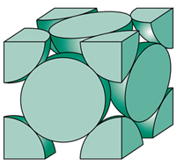

1. Show that the cube edge length, *a* and the atomic radius, R are   
related by:

2. Show that the atomic packing factor is 0.74 for FCC.

3a. Calculate the atomic radius of a lead atom, given that Pb has a FCC crystal structure, a density of 11.35 g/cm3, and an atomic weight of 207.2 g/mol.

3b. Calculate the linear density and planar density for (110) planes in lead.

D. Determine the density of BaTiO3, which forms a perovskite crystal structure, shown below: 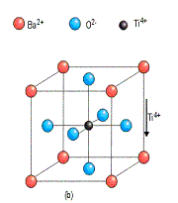

|  |  |  |
| --- | --- | --- |
|  | Ionic Radius (nm) | Atomic mass (g/mol) |
| Ba (Corner) | 0.136 | 137.3 |
| O (Face center) | 0.140 | 16 |
| Ti (Middle) | 0.145 | 47.87 |

E. What are the indices for the directions represented by the vector that has been drawn within a unit cell?  
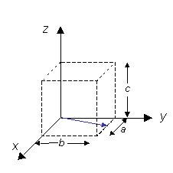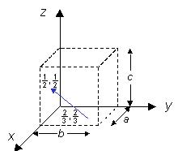

F. Determine the Miller indices for the planes shown in the following unit cell:



G. What are the Miller indices for the planes shown below?   
  
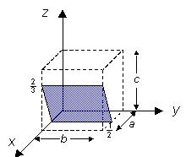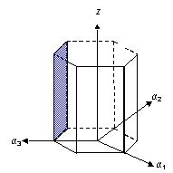

H. *Within a cubic unit cell, sketch the following directions:*

*(a)*, *(b)*, *(c)* , *(d)* .

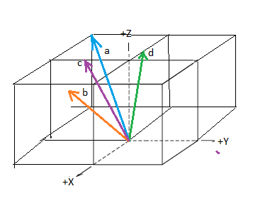

1. *Sketch the $\left[1\overline{2}\overline{2}3\right]$*  *direction in a hexagonal unit cell.*

