PHYS 321 S 2025 Test #2 Name:________________________

|  |  |  |
| --- | --- | --- |
| Braggs’s Law | Inter-planar Spacing | Hydrogen Like Spectra  (R= 1.097 x 107 m-1) |
|  |  |  |

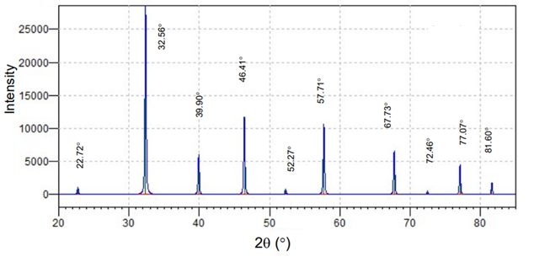  
1. The 2ϴ values in degrees for first order diffraction peaks are given above for strontium titanate, with cubic structure, using X-rays of wavelength 0.154 nm.

(a) Enter the above diffraction angles in the data table below and complete the rest of the columns.

|  |  |  |  |  |  |  |  |
| --- | --- | --- | --- | --- | --- | --- | --- |
| 2θ (deg.) | θ (deg.) | Sin2θ | Normalize | Clear  Fractions | h2+k2+l2 | (hkl) |  |
|  |  |  |  |  |  |  |  |
|  |  |  |  |  |  |  |  |
|  |  |  |  |  |  |  |  |
|  |  |  |  |  |  |  |  |
|  |  |  |  |  |  |  |  |
|  |  |  |  |  |  |  |  |
|  |  |  |  |  |  |  |  |
|  |  |  |  |  |  |  |  |
|  |  |  |  |  |  |  |  |
|  |  |  |  |  |  |  |  |

(b) Derive an expression for $\frac{{Sin}^{2}θ}{h^{2}+k^{2}+l^{2}}$.

(c) Determine the lattice constant.

(d) Calculate the lattice constant using the crystal structure shown below and the density of 5.1 g/cm3, for strontium titanate. Atomic masses: Sr (body center) = 87.62, Ti (corner) = 47.87, O (edge center) = 16.



2. Write down the *ni* and *nf* energy level values for each of the line spectra.

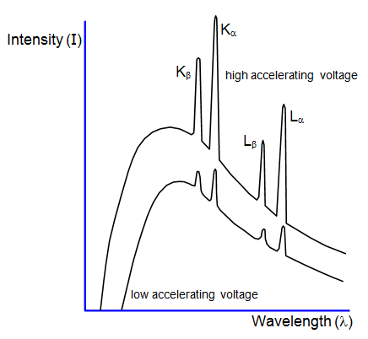

|  |  |  |
| --- | --- | --- |
|  | *ni* | *nf* |
| *Kα* |  |  |
| *Kβ* |  |  |
| *Lα* |  |  |
| *Lβ* |  |  |

|  |  |  |
| --- | --- | --- |
|  |  |  |

3. Calculate the unit cell edge length for an 64.8 wt% V-35.2 wt% Nb alloy. All of the niobium is in solid solution, and, at room temperature the crystal structure for this alloy is BCC. The room-temperature density of Nb is 8.57 g/cm3, and its atomic weight is 92.91 g/mol. The room-temperature density of V is 6.10 g/cm3, and its atomic weight is 50.94 g/mol.

4. Compute the radius r of an impurity atom that will just fit into an FCC tetrahedral site in terms of the atomic radius R of the host atom (without introducing lattice strains).

|  |  |  |
| --- | --- | --- |
|  |  |  |

5.  conductivity of copper is 6.0 × 107 (Ω-m)-1  **V = IR J = I/A E = V/L**

(a) Compute the resistance of a copper wire 3 mm (0.12 in.) in diameter and 2 m (78.7 in.) long. (b) What would be the current flow if the potential drop across the ends of the wire is 0.05 V?   
(c) What is the current density? (d) What is the magnitude of the electric field across the ends of the wire?



6. The following electrical characteristics have been determined for both intrinsic and n-type extrinsic indium phosphide (InP) at room temperature:

|  |  |  |  |
| --- | --- | --- | --- |
|  | ***σ* (Ω -*m*)–1** | ***n* (*m*–3)** | ***p* (*m*–3)** |
| *Intrinsic* | *2.5 × 10-6* | *3.0 × 1013* | *3.0 × 1013* |
| *Extrinsic (n-type)* | *3.6 × 10-5* | *4.5 × 1014* | *2.0 × 1012* |

Calculate electron and hole mobilities.