PHYS 321 Test #2 S2022 Name:______________________________

|  |  |  |
| --- | --- | --- |
| Braggs’s Law | Inter-planar Spacing | Hydrogen Like Spectra  (R= 1.097 x 107 m-1) |
|  |  |  |

1. The voltage across an X-ray tube is 47.0 kV. The tungsten (*Z* = 74) is the target in the X-ray tube. Determine **(a)** the tube's cutoff wavelength **(b)** the wavelength of the *Kα and Lβ* - ray lines emitted by the tungsten target.

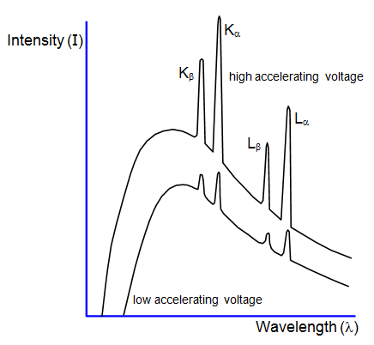

Bragg’s law for X-ray diffraction:



Additional Conditions: BCC: *h+k+l*=even FCC: h,k,l either odd or even

2. The 2ϴ values in degrees for diffraction peaks are given below for a metal with cubic structure, using X-rays of wavelength 0.1542 nm: 37.21, 43.23, 62.86, 75.31, 79.32.  
(a) Derive an expression for $$\frac{{Sin}^{2}θ}{h^{2}+k^{2}+l^{2}}$$

(b) Complete the table below.

(c) Determine the crystal structure.

(d)Determine the lattice constant.

(e) Determine the ionic radius.

|  |  |  |  |  |  |  |  |
| --- | --- | --- | --- | --- | --- | --- | --- |
| 2θ (deg.) | θ | Sin2θ | Normalize | Clear  Fractions | h2+k2+l2 | (hkl) |  |
| 37.21 |  |  |  |  |  |  |  |
| 43.23 |  |  |  |  |  |  |  |
| 62.86 |  |  |  |  |  |  |  |
| 75.31 |  |  |  |  |  |  |  |
| 79.32 |  |  |  |  |  |  |  |

|  |  |  |
| --- | --- | --- |
|  |  | Figure 3 |

3. Silver and palladium both have the FCC crystal structure, and Pd forms a substitutional solid solution for all concentrations at room temperature. Compute the unit cell edge length for a 65 wt% Ag–35 wt% Pd alloy. The room-temperature density of Pd is 12.02 g/cm3, and its atomic weight is 106.4 g/mol. The room-temperature density of Ag is 10.49 g/cm3, and its atomic weight is 107.9 g/mol.

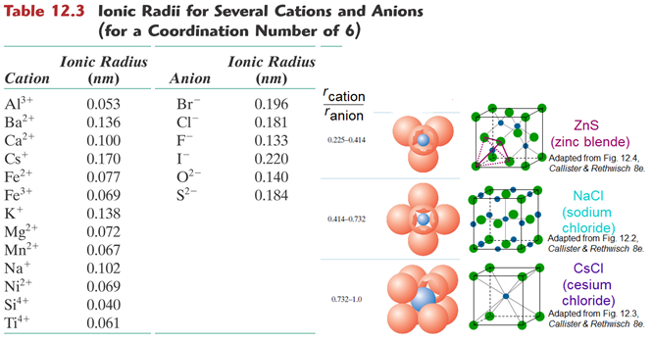

4. On the basis of ionic charge and ionic radii given in Table 12.3, predict crystal structures for the following materials*:*

(a)CsI

(b)NiO

(c)KI

(d)NiS

Justify your selections*.*

 the resistivity of aluminum is 2.7 × 10-8 Ω-m **V = IR J = I/A E = V/L**

5. (a) Compute the resistance of an aluminum wire 5 mm (0.20 in.) in diameter and 5 m (200 in.) in length.

(b) What would be the current flow if the potential drop across the ends of the wire is 0.04 V?

(c) What is the current density?

(d) What is the magnitude of the electric field across the ends of the wire?



6. The following electrical characteristics have been determined for both intrinsic and p-type extrinsic indium phosphide (InP) at room temperature:

|  |  |  |  |
| --- | --- | --- | --- |
|  | **σ (Ω -*m*)–1** | ***n* (*m*–3)** | ***p* (*m*–3)** |
| *Intrinsic* | *2.5 × 10-6* | *3.0 × 1013* | *3.0 × 1013* |
| *Extrinsic (n-type)* | *3.6 × 10-5* | *4.5 × 1014* | *2.0 × 1012* |

*Calculate electron and hole mobilities.*

7. Calculate the Density of CaTiO3.

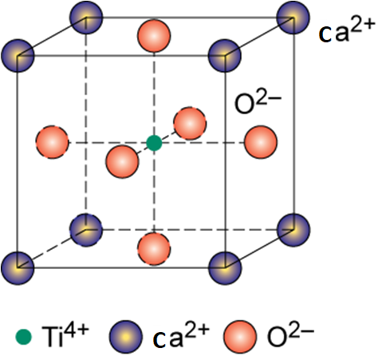

|  |  |  |  |
| --- | --- | --- | --- |
|  | Ti4+ | Ca2+ | O2- |
| Radius | 0.145 nm | 0.100 nm | 0.140 nm |
| Atomic weight | 47.88 g | 40.08 g | 16 g |