PHYS 321 S2025 Test #1 Name:_________________________

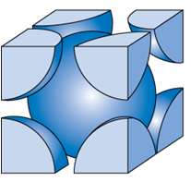

I. Body Centered Cubic Structure

1. How many atoms are inside the cubic unit cell of [BCC](https://www.youtube.com/watch?v=KNgRBqj9FS8)?

2. Show the cube edge length, *a* and the atomic radius, *R* in   
the figure.

3. Show that the cube edge length, *a* and the atomic radius, *R* are   
related by:

4. Calculate the density of iron, Fe, which has a BCC crystal structure. Its atomic radius = 0.126 nm and atomic weight = 55.845 g/mol. (Avogadro’s number = 6.022 x 1023)

5. Calculate the planar density for (110) planes in iron.

II. Hafnium has six naturally occurring isotopes: 0.16% of 174Hf, with an atomic weight of 173.940 amu; 5.26% of 176Hf, with an atomic weight of 175.941 amu; 18.60% of 177Hf, with an atomic weight of 176.943 amu; 27.28% of 178Hf, with an atomic weight of 177.944 amu; 13.62% of 179Hf, with an atomic weight of 178.946 amu;. and 35.08% of 180Hf, with an atomic weight of 179.947 amu. Calculate the average atomic weight of Hf.

III.Net potential energy EN between two adjacent ions is sometimes represented by the expression

……….(I)

in which r is the interionic separation and C, D, and ρ are constants whose values depend on the specific material.

(a) Derive an expression for the bonding energy E0 in terms of the equilibrium interionic separation r0 and the constants D and ρ using the following procedure:

1. Differentiate EN with respect to r and set the resulting expression equal to zero.

2. Solve for C in terms of D, ρ, and r0.

3. Determine the expression for E0 by substitution for C in Equation (I).

(b) Derive another expression forE0 in terms of r0, C, and ρ.

IV. Determine the indices for the directions shown (A and B) in the cubic unit cell.

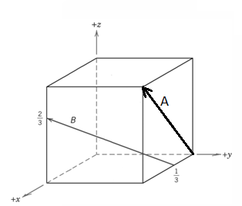

V. Determine the Miller indices for the planes (B and A) shown in the following unit cell:

VI. In one of the cubic cell pictures, choose an origin and XYZ axes and sketch the following directions:

VII. Determine the 3-axis indices and then convert them to 4-axis indices for the directions shown.   
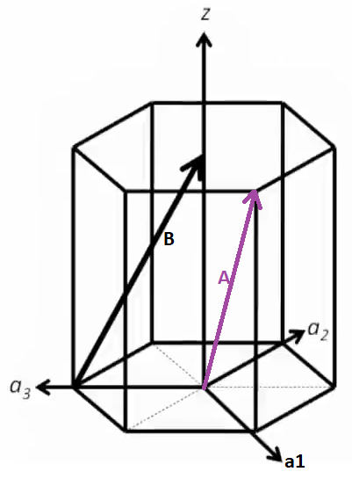







'

*w*

*w*

*t*

*v*

*u*

)

*v*

*u*

(

+

-

)

'

*u*

'

*v*

2

(

3

1

-

)

'

*v*

'

*u*

2

(

3

1

-



]

*uvtww*

[

]

'

*w*

'

*v*

'

*u*

[

→

VIII. Draw the direction [

VIII. Determine the 4-index miller indices for the planes A & B shown below.

