PHYS 321 Study Guide for Final

1. Study the Materials from Test #1 and Test #2.

2. Determine the density of the Superconductor YBa₂Cu₃O₇.
Atomic masses: Y=88.91, Ba=137.3, Cu=63.55, O=16
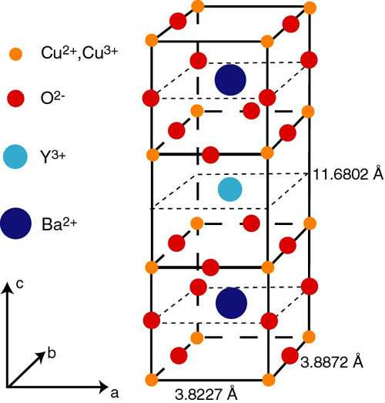

3. Compute the density for nickel at 500°C, given that its room-temperature density is 8.902 g/cm³. Assume that the volume coefficient of thermal expansion, α_{v}, is equal to 3α_{l}.
αl for nickel is 13.3 × 10-6 (°C)-1

4. (a) Explain the two sources of magnetic moments for electrons.
(b) Do all electrons have a net magnetic moment? Why or why not?
(c) Do all atoms have a net magnetic moment? Why or why not?

5. Assume there exists some hypothetical metal that exhibits ferromagnetic behavior and that has (1) a simple cubic crystal structure (Figure 3.3), (2) an atomic radius of 0.125 nm, and (3) a saturation magnetic field of 0.85 tesla. Determine the number of Bohr magnetons per atom for this material. 1 Bohr magneton = 9.27 x 10⁻²⁴ A.m². B = µ₀M. µ₀ = 1.257 x 10⁻⁶ T.m/A.
6. Compute (a) the saturation magnetization and (b) the saturation magnetic field for cobalt, which has a net magnetic moment per atom of 1.72 Bohr magnetons and a density of 8.90 g/cm³.

