PHYS 321 Problem 20.21 Name:___________________________
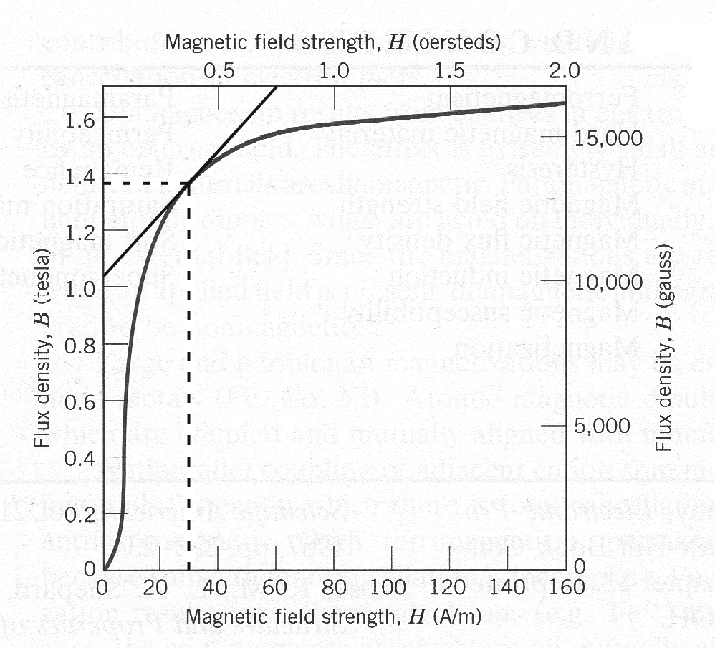
20.21 A bar of an iron–silicon alloy having the B–H behavior shown in the Figure above is inserted within a coil of wire 0.20 m long and having 60 turns, through which passes a current of 0.1 A.
(a) What is the applied magnetic field, H?
(b) What is the B field within this bar?
(c) At this magnetic field,
(i) What is the permeability?
(ii) What is the relative permeability?
(iii) What is the susceptibility?
(iv) What is the magnetization?

