PHYS 321 Study Guide for Final

a.. Materials and problems similar to Test #1.

b. 4.5 For both FCC and BCC crystal structures, there are two different types of interstitial sites. In each case, one site is larger than the other, and is normally occupied by impurity atoms. For FCC, this larger one is located at the center of each edge of the unit cell; it is termed an octahedral interstitial site. On the other hand, with BCC the larger site type is found at 0  positions—that is, lying on {100} faces, and situated midway between two unit cell edges on this face and one-quarter of the distance between the other two unit cell edges; it is termed a tetrahedral interstitial site. For both FCC and BCC crystal structures, compute the radius r of an impurity atom that will just fit into one of these sites in terms of the atomic radius R of the host atom.

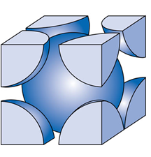

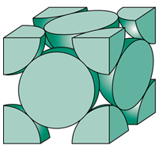

c. Derive the following:  
 

d. Problems in Specification of Composition

4.25 Silver and palladium both have the FCC crystal structure, and Pd forms a substitutional solid solution for all concentrations at room temperature. Compute the unit cell edge length for a 75 wt% Ag–25 wt% Pd alloy. The room-temperature density of Pd is 12.02 g/cm3, and its atomic weight and atomic radius are 106.4 g/mol and 0.138 nm, respectively.

e. 19.D1 *Railroad tracks made of 1025 steel are to be laid during the time of year when the temperature averages 10°C (50°F). If a joint space of 4.6 mm (0.180 in.) is allowed between the standard 11.9-m (39-ft) long rails, what is the hottest possible temperature that can be tolerated without the introduction of thermal stresses?*

[*l* for the 1025 steel [12.0 × 10-6 (C)-1]

f. Understanding of the following:  
1. p-type and n-type semiconductors   
2. n-type semiconductors  
3. Hall effect

g. 18.31 *The following electrical characteristics have been determined for both intrinsic and p-type extrinsic indium phosphide (InP) at room temperature:*

|  |  |  |  |
| --- | --- | --- | --- |
|  | **σ (Ω -*m*)–1** | ***n* (*m*–3)** | ***p* (*m*–3)** |
| *Intrinsic* | *2.5 × 10-6* | *3.0 × 1013* | *3.0 × 1013* |
| *Extrinsic (n-type)* | *3.6 × 10-5* | *4.5 × 1014* | *2.0 × 1012* |

*Calculate electron and hole mobilities.*

h. Types of Magnetism and examples.i. Magnetic storage media and solid-state drives.

<https://www.youtube.com/watch?v=viac3j6MeII>

<https://www.youtube.com/watch?v=AB-JUyQYxIw>

j. Questions from student presentations.