PHYS 321 HW-4 Name:________________________

3.29 *What are the indices for the directions indicated by the two vectors in the sketch below?*

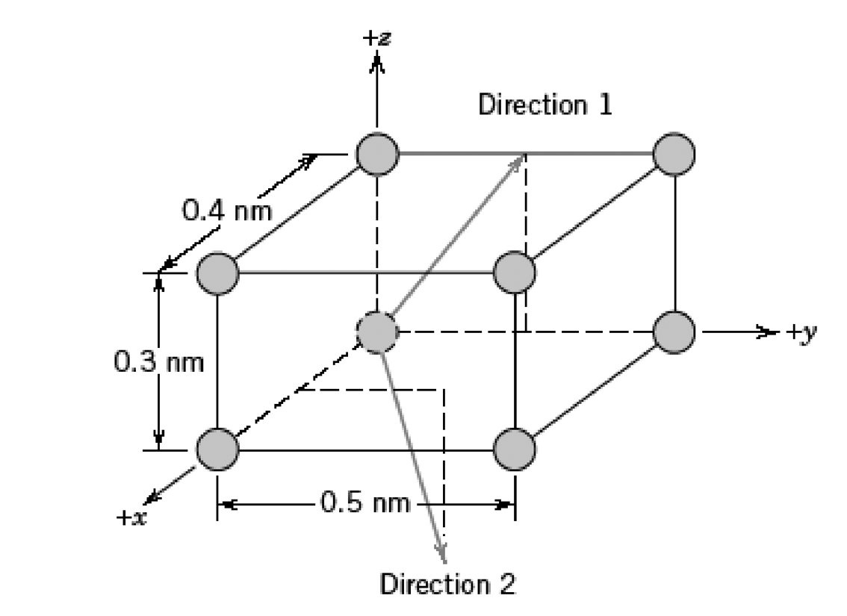

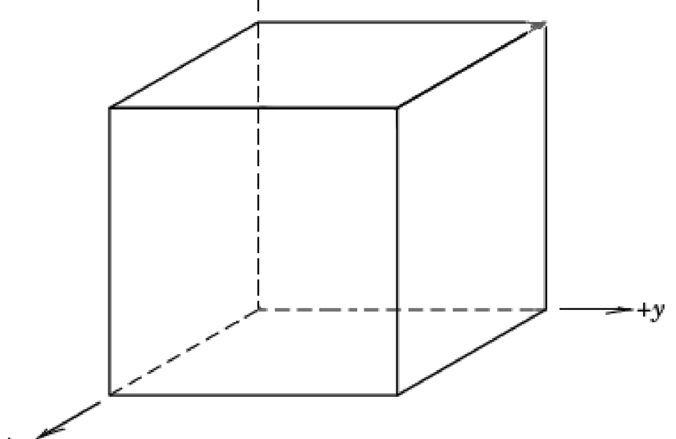

3.30 *Within a cubic unit cell, sketch the following directions:*

*(a)*, *(e)* ,

*(b)*, *(f)* ,

*(c)*, *(g)* ,

*(d)*, *(h)* .

3.36 *Sketch the ,* [ 112¯0 ], and * directions in a hexagonal unit cell.*

