2.15 *For a K+–Cl– ion pair, attractive and repulsive energies EA and ER, respectively, depend on the distance between the ions r, according to*





*For these expressions, energies are expressed in electron volts per K+–Cl– pair, and r is the distance in nanometers. The net energy EN is just the sum of the two expressions above.*

*(a) Superimpose on a single plot EN, ER, and EA versus r up to 1.0 nm.*

*(b) On the basis of this plot, determine (i) the equilibrium spacing r0 between the K+ and Cl– ions, and (ii) the magnitude of the bonding energy E0 between the two ions.*

*(c) Mathematically determine the r0 and E0 values using the solutions to Problem 2.14 and compare these with the graphical results from part (b).*

Solution

(a) Curves of *EA*, *ER*, and *EN* are shown on the plot below.

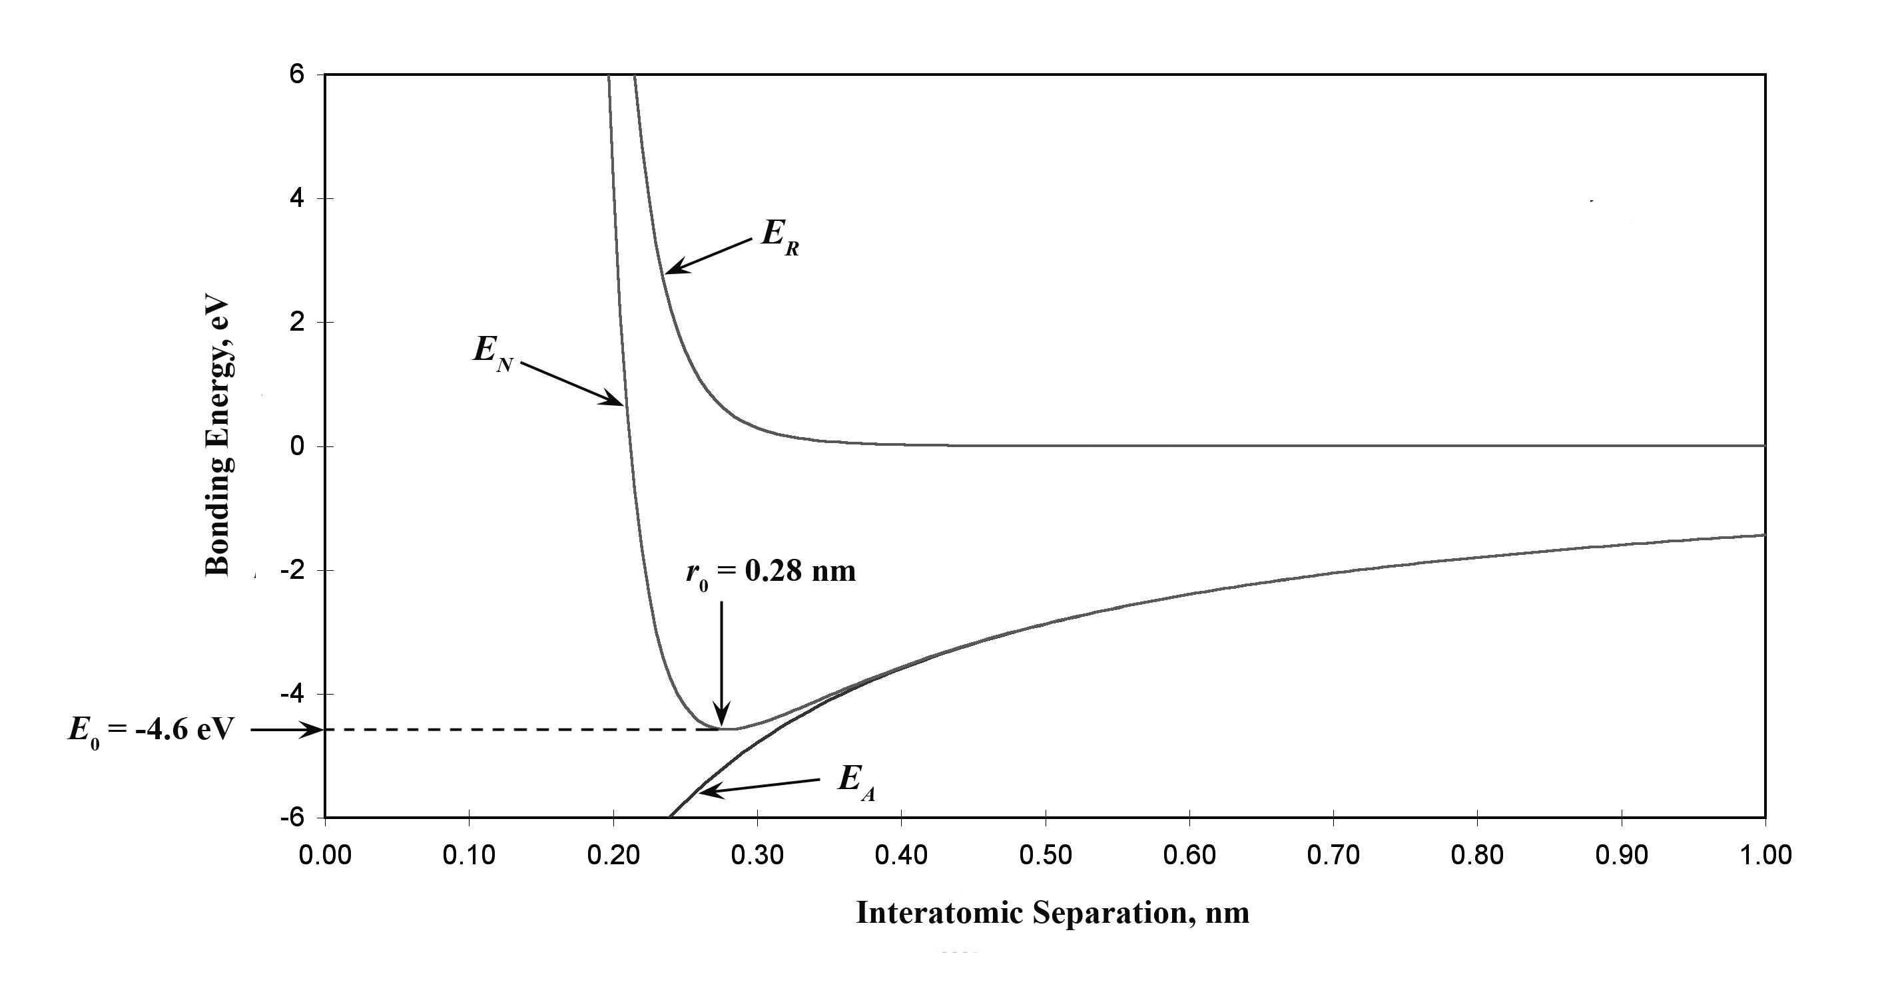

(b) From this plot

*r*0 = 0.28 nm

*E*0 = – 4.6 eV

(c) From Equation 2.11 for *EN*

*A* = 1.436

*B* = 5.86 × 10-6

*n* = 9

Thus,







and





= – 4.57 eV