PHYS 321 In-Class Problem Solving Name:______________________

<http://www.luc.edu/faculty/spavko1/minerals/prelims/rr/rr.htm>

12.2 *Show that the minimum cation-to-anion radius ratio for a coordination number of 4 is 0.225.*

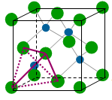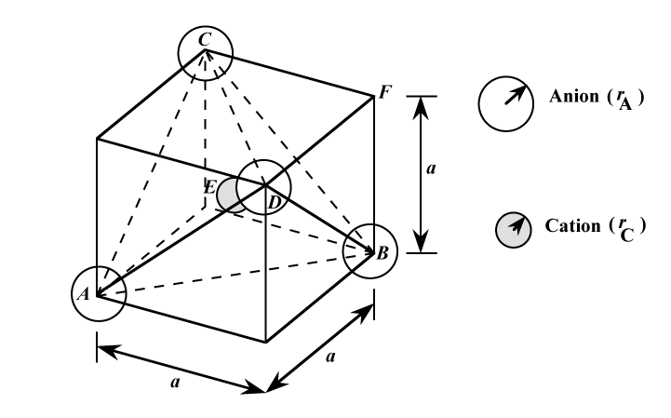

12.27 *Determine the angle between covalent bonds in an tetrahedron.*

