PHYS 321 Problems on Miller indices for plane Name:________________________

3.41 Determine the Miller indices for the planes shown in the following unit cell:

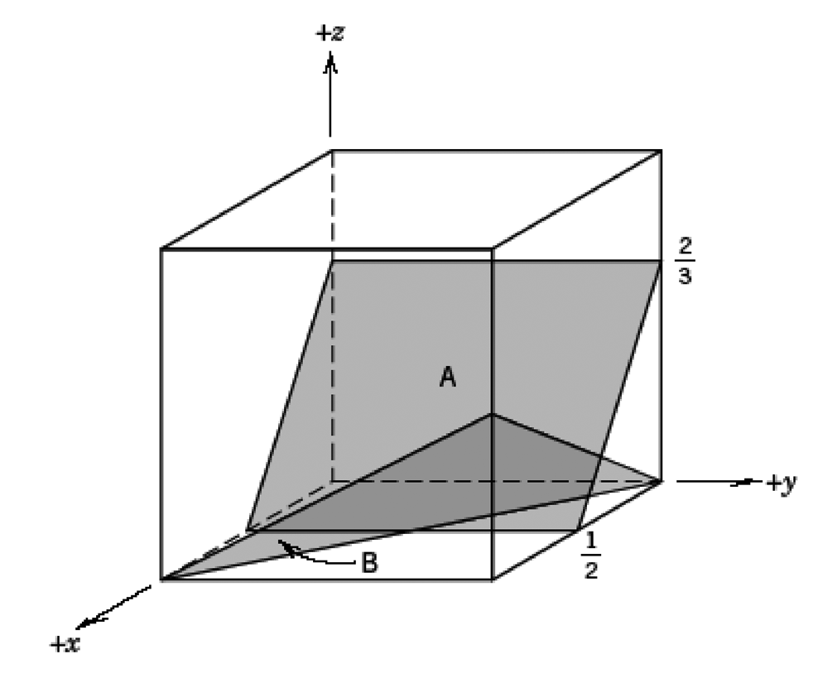

3.42 Determine the Miller indices for the planes shown in the following unit cell:

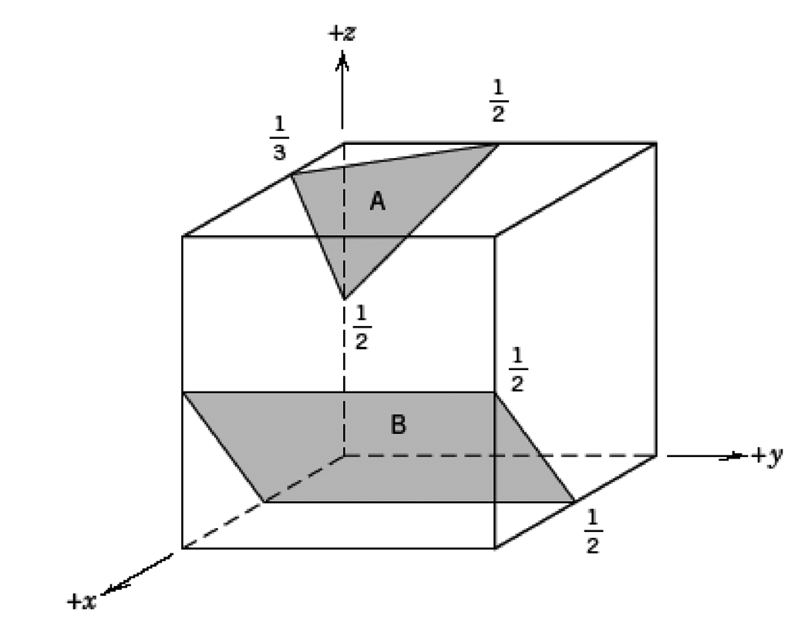

3.54 Determine the Miller indices for the plane shown in the following unit cell:

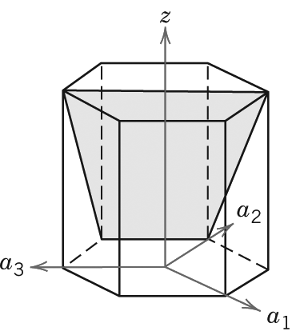

3.40 *Sketch within a cubic unit cell the following planes:*

*(a)*, *(e)*  ,

*(b)*, *(f)*  ,

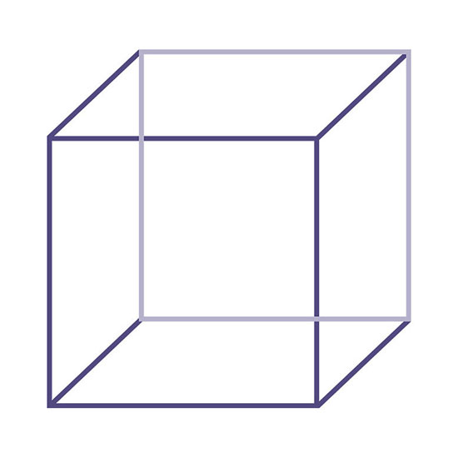

3.51 *Sketch the  and  planes in a hexagonal unit cell.*

