PHYS 321 Alternating Current (ac) Voltage Name:_________________
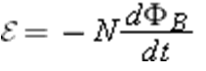
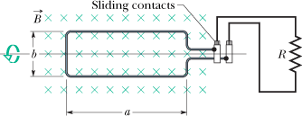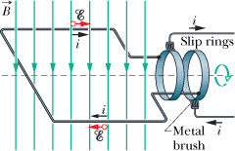
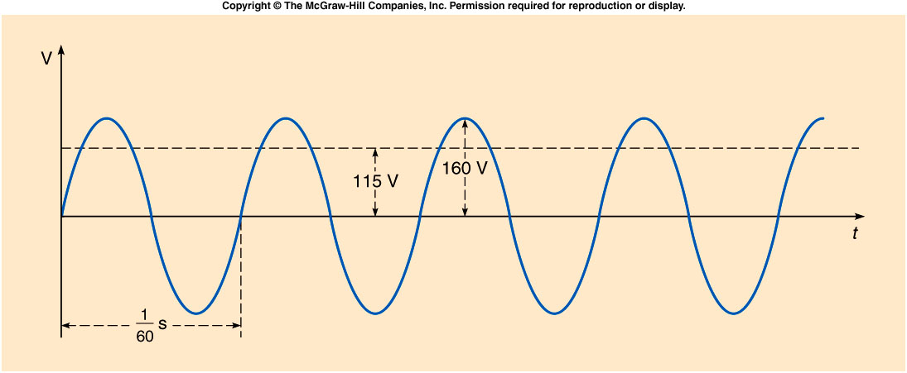
••11 | A rectangular coil of N turns and of length a and width b is rotated at frequency f in a uniform magnetic field , as indicated in Fig. The coil is connected to co-rotating cylinders, against which metal brushes slide to make contact.  (a) Show that the emf induced in the coil is given (as a function of time t) by  (30-0)  This is the principle of the commercial alternating-current generator.  (b) What value of Nab gives an emf with ₀ = 160 V when the loop is rotated at 60.0 rev/s in a uniform magnetic field of 0.500 T?

PHYS 321 Homework on Transformers Name:____________________________
- Write down the ideal-transformer equations.
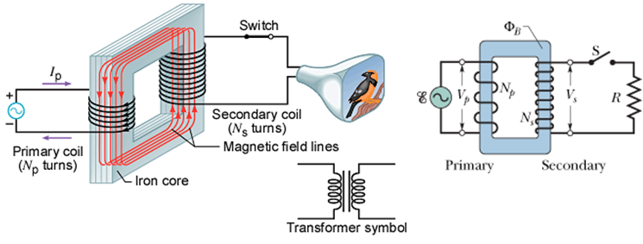
- A transformer has 500 primary turns and 10 secondary turns. (a) If V_{p} is 120 V (rms), what is V_{s} with an open circuit? If the secondary now has a resistive load of 15 Ω, what is the current in the (b) primary and (c) secondary?

- An ac generator provides emf to a resistive load in a remote factory over a two-cable transmission line. At the factory a step-down transformer reduces the voltage from its (rms) transmission value V_{t} to a much lower value that is safe and convenient for use in the factory. The transmission line resistance is 0.30 Ω/cable, and the power of the generator is 250 kW. If V_{t} = 80 kV, what are (a) the voltage decrease ΔV along the transmission line and (b) the rate P_{d} at which energy is dissipated in the line as thermal energy? If V_{t} = 8.0 kV, what are (c) ΔV and (d) P_{d}? If V_{t} = 0.80 kV, what are (e) ΔV and (f) P_{d}?

The Superconductor YBa₂Cu₃O₇
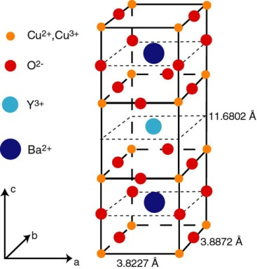
Determine the density.

