PHYS 321 H Spectra Name:______________________
1. Expain the origin of light? https://www.youtube.com/watch?v=7BFM46vJbrI

2. Energy levels of the electron of the hydrogen atom are shown below. Calculate and list the energy values, $E_{n}=-\frac{13.6}{n^{2}}$eV, with the orbitals, shown (not to scale).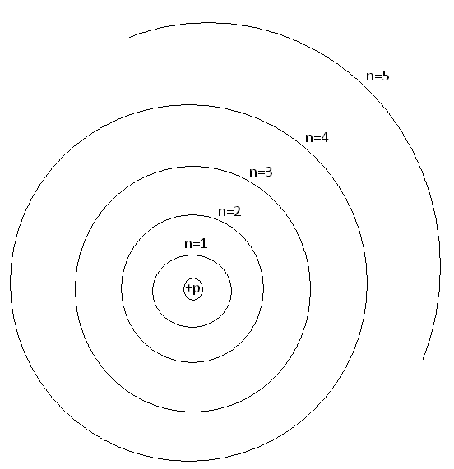
3. Show the transitions of electron for the Lyman (1), Balmer (2), and Paschen (3) series in the above diagram.
4. Calculate the 4 of the highest wavelengths (λ) of the Balmer series.
$∆E=\frac{hc}{λ}$; h = 6.63x10⁻³⁴J.s and c = 3x10⁸m/s. 1eV=1.6x10⁻¹⁹J

