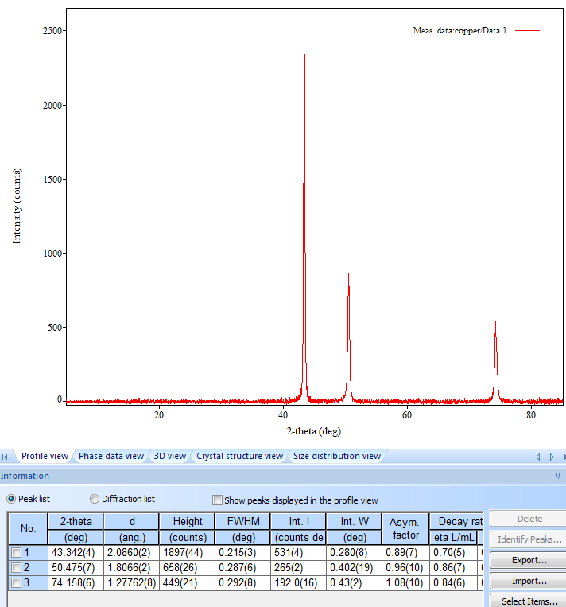
2θ | θ (rad) | sin²θ | normalized | clear fractions | h^2+k^2+l^2 | (hkl) | (〖Sin〗^2 θ)/(h^2+k^2+l^2 )
43.3 | 0.3782 | 0.136353 | 1.00000077 | 3.000002323 | 3 | 111 | 0.045451035
50.5 | 0.4405 | 0.181793 | 1.33324956 | 3.999748691 | 4 | 200 | 0.045448144
74.2 | 0.6472 | 0.363507 | 2.66592772 | 7.997783146 | 8 | 220 | 0.045438405

