PHYS 321 Name:_______________________________
Ohm’s Law and Conductivity:
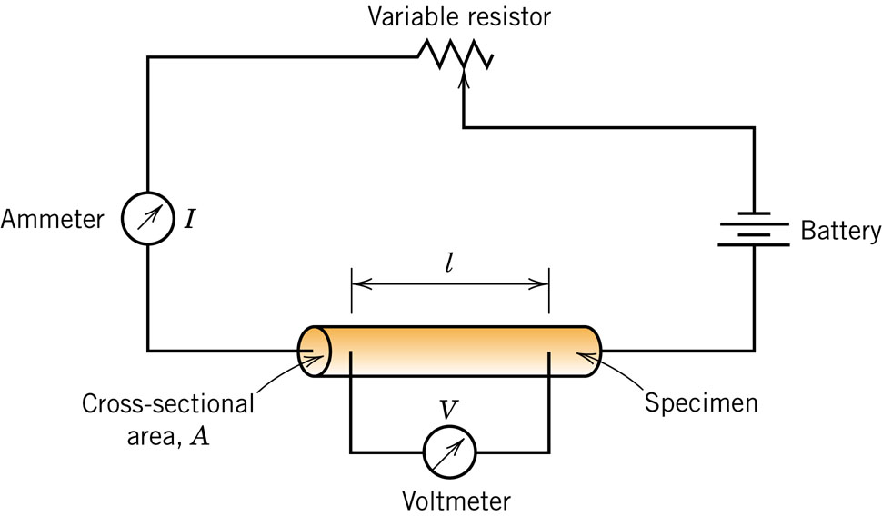
18.1 (a) Compute the electrical conductivity of a 5.1-mm
(0.2-in.) diameter cylindrical silicon specimen 51 mm (2 in.)
long in which a current of 0.1 A passes in an axial direction.
A voltage of 12.5 V is measured across two probes that
are separated by 38 mm (1.5 in.).
(b) Compute the resistance over the entire 51 mm (2 in.)
of the specimen.

18.4 Demonstrate that the two Ohm’s law expressions, V=IR and J=σE, are equivalent.
18.17 A cylindrical metal wire 3 mm (0.12 in.) in diameter is required to carry a current of 12 A with a minimum of 0.01 V drop per foot (300 mm) of wire. Which of the metals and alloys listed in Table 18.1 are possible candidates?

Electron Mobility: $σ=neμ$ $v_{d}=μE$
18.11 At room temperature the electrical conductivity and the electron mobility for copper are 6.0 × 10⁷ (Ω-m)⁻¹ and 0.0030 m²/V-s, respectively. (a) Compute the number of free electrons per cubic meter for copper at room temperature. (b) What is the number of free electrons per copper atom? Assume a density of 8.9 g/cm³.
Electrical Resistivity of Metals:
18.15 Determine the electrical conductivity of a Cu-Ni alloy that has a yield strength of 160 MPa.
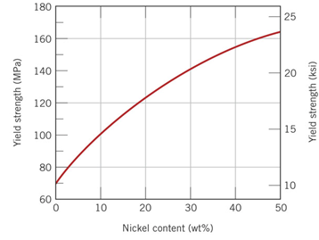 | 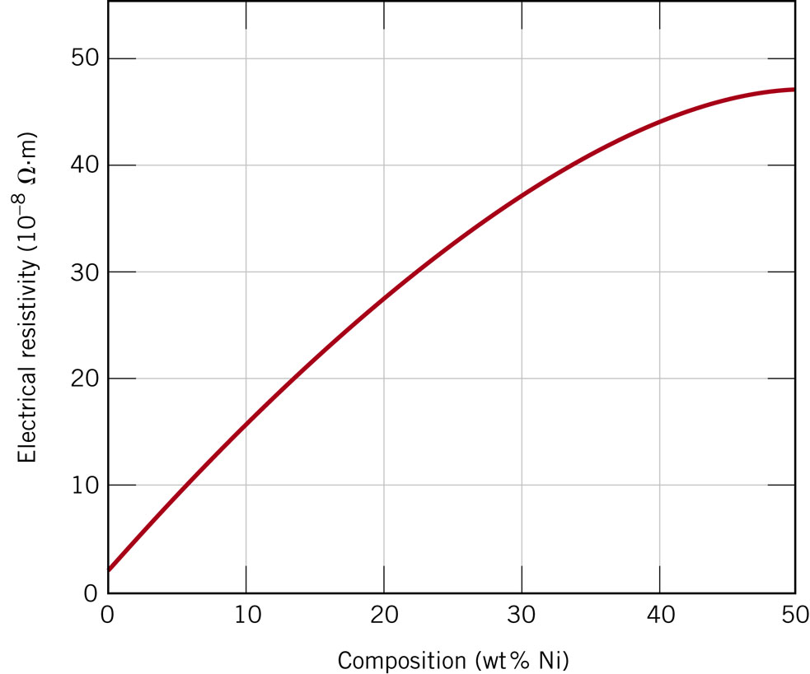

PHYS 321 Intrinsic Semiconduction
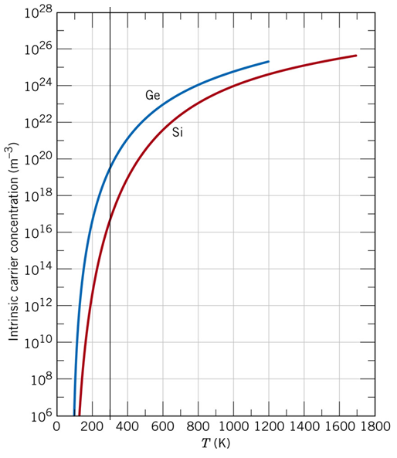
18.18 (a) Using the data presented in Figure 18.16, determine the number of free electrons per atom for intrinsic germanium and silicon at room temperature (298 K). The densities for Ge and Si are 5.32 and 2.33 g/cm³, respectively.
(b) Now explain the difference in these free-electron-per-atom values.

18.21 At room temperature the electrical conductivity of PbS is 25 (Ω.m)–1, whereas the electron and hole mobilities are 0.06 and 0.02 m2/V.s, respectively. Compute the intrinsic carrier concentration for PbS at room temperature.

