PHYS 321 Intrinsic Semiconduction Name:_____________________

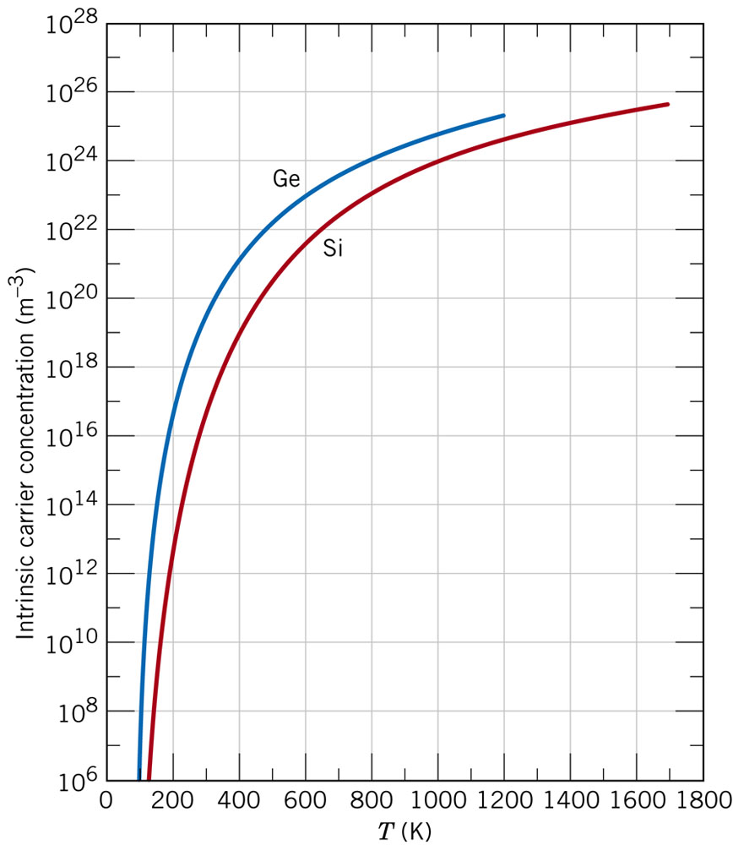
18.18 (a) Using the data presented in Figure 18.16, determine the number of free electrons per atom for intrinsic germanium and silicon at room temperature (298 K). The densities for Ge and Si are 5.32 and 2.33 g/cm³, respectively.
(b) Now explain the difference in these free-electron-per-atom values.

18.21 At room temperature the electrical conductivity of PbTe is 500 (Ω-m)^{–1}, whereas the electron and hole mobilities are 0.16 and 0.075 m²/V-s, respectively. Compute the intrinsic carrier concentration for PbTe at room temperature.

