PHYS 321 Chap-6 Hwk
6.6 Consider a cylindrical titanium wire 3.0 mm (0.12 in.) in diameter and 2.5 × 104 mm (1000 in.) long. Calculate its elongation when a load of 500 N (112 lb_{f}) is applied. Assume that the deformation is totally elastic.
6.7 For a bronze alloy, the stress at which plastic deformation begins is 275 MPa (40,000 psi), and the modulus of elasticity is 115 GPa (16.7 × 10⁶ psi).
(a) What is the maximum load that may be applied to a specimen with a cross-sectional area of 325 mm² (0.5 in.²) without plastic deformation?
(b) If the original specimen length is 115 mm (4.5 in.), what is the maximum length to which it may be stretched without causing plastic deformation?

6.15 A cylindrical specimen of aluminum having a diameter of 19 mm (0.75 in.) and length of 200 mm (8.0 in.) is deformed elastically in tension with a force of 48,800 N (11,000 lb_{f}). Using the data contained in Table 6.1, determine the following:
(a) The amount by which this specimen will elongate in the direction of the applied stress.
(b) The change in diameter of the specimen. Will the diameter increase or decrease?

6.19 Consider a cylindrical specimen of some hypothetical metal alloy that has a diameter of 8.0 mm (0.31 in.). A tensile force of 1000 N (225 lb_{f}) produces an elastic reduction in diameter of 2.8 × 10⁻⁴ mm (1.10 × 10⁻⁵ in.). Compute the modulus of elasticity for this alloy, given that Poisson's ratio is 0.30.

6.23 A cylindrical rod 100 mm long and having a diameter of 10.0 mm is to be deformed using a tensile load of 27,500 N. It must not experience either plastic deformation or a diameter reduction of more than 7.5 × 10⁻³ mm. Of the materials listed as follows, which are possible candidates? Justify your choice(s).
Material | Modulus of Elasticity  (GPa) | Yield Strength  (MPa) | Poisson’s Ratio
Aluminum alloy | 70 | 200 | 0.33
Brass alloy | 101 | 300 | 0.34
Steel alloy | 207 | 400 | 0.30
Titanium alloy | 107 | 650 | 0.34

6.25 Figure 6.21 shows the tensile engineering stress–strain behavior for a steel alloy.
(a) What is the modulus of elasticity?
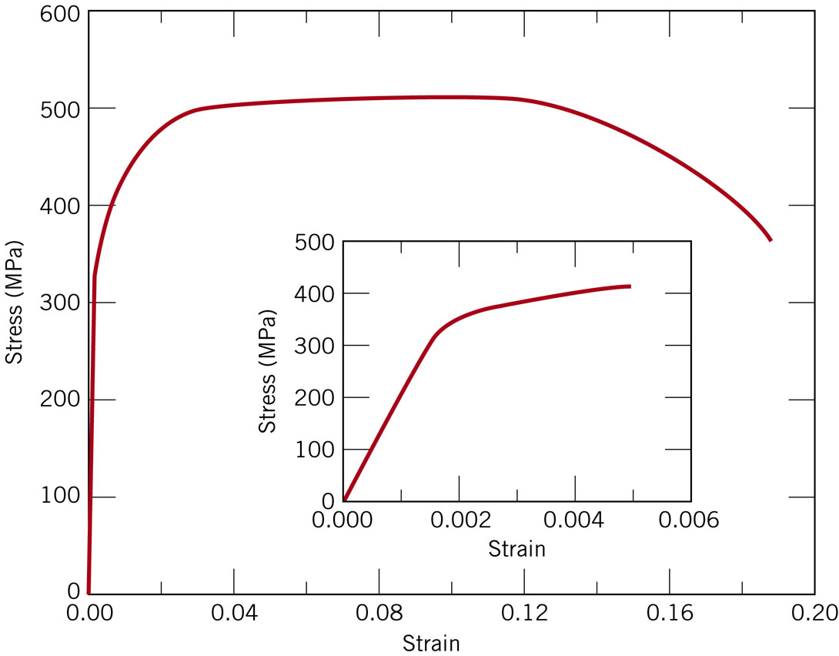
(b) What is the proportional limit?
(c) What is the yield strength at a strain offset of 0.002?
(d) What is the tensile strength?

6.29 A cylindrical specimen of aluminum having a diameter of 0.505 in. (12.8 mm) and a gauge length of 2.000 in. (50.800 mm) is pulled in tension. Use the load–elongation characteristics tabulated below to complete parts (a) through (f).
Load |  | Length
N | lb_{f} | mm | in.
0 | 0 | 50.800 | 2.000
7,330  (a) Plot the data as engineering stress versus engineering strain.  (b) Compute the modulus of elasticity.  (c) Determine the yield strength at a strain offset of 0.002.  (d) Determine the tensile strength of this alloy.  (e) What is the approximate ductility, in percent elongation?  (f) Compute the modulus of resilience. | 1,650 | 50.851 | 2.002
15,100 | 3,400 | 50.902 | 2.004
23,100 | 5,200 | 50.952 | 2.006
30,400 | 6,850 | 51.003 | 2.008
34,400 | 7,750 | 51.054 | 2.010
38,400 | 8,650 | 51.308 | 2.020
41,300 | 9,300 | 51.816 | 2.040
44,800 | 10,100 | 52.832 | 2.080
46,200 | 10,400 | 53.848 | 2.120
47,300 | 10,650 | 54.864 | 2.160
47,500 | 10,700 | 55.880 | 2.200
46,100 | 10,400 | 56.896 | 2.240
44,800 | 10,100 | 57.658 | 2.270
42,600 | 9,600 | 58.420 | 2.300
36,400 | 8,200 | 59.182 | 2.330
Fracture

6.35 A cylindrical metal specimen having an original diameter of 12.8 mm (0.505 in.) and gauge length of 50.80 mm (2.000 in.) is pulled in tension until fracture occurs. The diameter at the point of fracture is 6.60 mm (0.260 in.), and the fractured gauge length is 72.14 mm (2.840 in.). Calculate the ductility in terms of percent reduction in area and percent elongation.

