PHYS 321 BCC & FCC Name:________________________

- The unit cell for the body-centered cubic crystal structure is shown below.
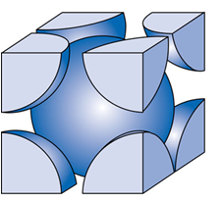
1. Show that the cube edge length, a and the atomic radius, R are
related by: $a=\frac{4R}{\sqrt{3}}$

2. Show that the atomic packing factor is 0.68 for BCC.

- The unit cell for the face-centered cubic crystal structure is shown below.
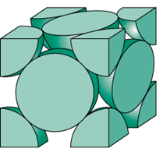
- Find a relationship between the cube edge length, a and
the atomic radius, R

- Find the atomic packing factor for FCC.

