PHYS 315 HWK on Resistors Name:___________________________

a. Ohm’s law: V=IR; b. Power = P = IV= I2R = V2/R

c. When resistors (*R1*, *R2*, *R3*) are connected in series the equivalent resistance (*Rs*) is given by,



d. When resistors (*R1*, *R2*, *R3*) are connected in parallel the equivalent resistance (*Rp*) is given by,



1. Give an explanation for the above equation c.

2. Derive the above equation d.

3. Find the equivalent [resistance](javascript:parent.xlinkeyword('u0028')) between points *A* and *B* for the resistor network shown below. (Ans: 4.67 ohm)

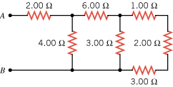

4. In Fig. [27-53](http://edugen.wiley.com/edugen/courses/crs4957/halliday9118/halliday9088c27/halliday9118/halliday9088c27/halliday9088c27xlinks.xform?id=halliday9088c27-fig-0053), *R*1 = 100 *Ω*, *R*2 = *R*3 = 50.0 *Ω*, *R*4 = 75.0 *Ω*, and the ideal battery has emf http://edugen.wiley.com/edugen/courses/crs4957/common/art/glyphs/isomscr/U02130.gif = 6.00 V. (a) What is the equivalent resistance? What is *i* in (b) resistance 1, (c) resistance 2, (d) resistance 3, and (e) resistance 4?

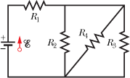

5. In Fig. [27-44](http://edugen.wiley.com/edugen/courses/crs4957/halliday9118/halliday9088c27/halliday9118/halliday9088c27/halliday9088c27xlinks.xform?id=halliday9088c27-fig-0044), the current in resistance 6 is *i*6 = 1.40 A, and the resistances are *R*1 = *R*2 = *R*3 = 2.00 *Ω*, *R*4 = 16.0 *Ω*, *R*5 = 8.00 *Ω*, and *R*6 = 4.00 *Ω*. What is the emf of the ideal battery?

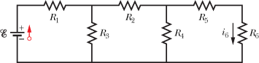

5.