PHYS 315 Circuit Analysis F2018 Study Guide for Final
Final exam format will be similar to past tests. Study the past two tests (Test #1 and Test #2) and the related materials.
1. Node-voltage method.
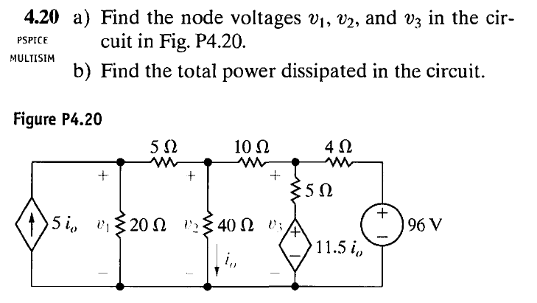

2. Op-Amp https://www.youtube.com/watch?v=yfbQFWp4-So
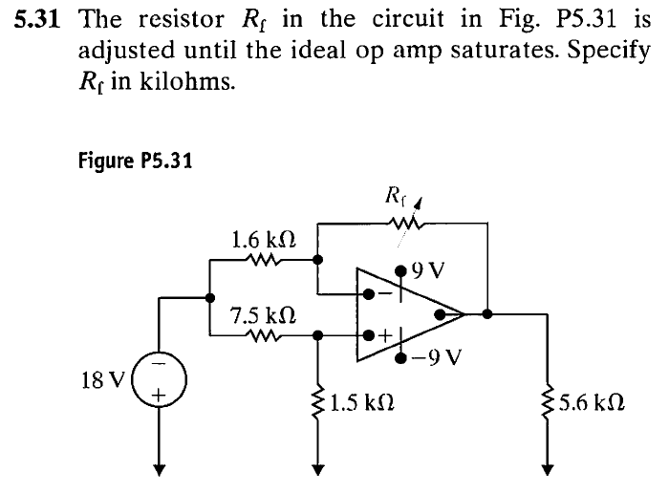

3. Op-Amp: Find V₀ as a function of V_{S} in terms of the resistors shown.
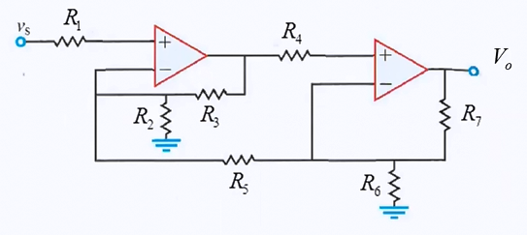

3. Designing and analyzing (BJT) amplifier circuits.
$I_{C}=βI_{B}$ $r_{e}=\frac{26 mV}{I_{C}}$ $Vgain=-\frac{R_{C}}{r_{e}}$ $V_{BE}=0.7 v$
https://www.youtube.com/watch?v=7ukDKVHnac4
1. Explain why the BJT Common Emitter is an inverting amplifier.

2a. Calculate the following DC bias conditions: V_{B}, V_{E}, I_{E}, I_{C}, I_{B}, V_{C}, V_{CE,} Power dissipated in the transistor and the ac voltage gain.
(Assume that the transistor is a Si type, with β=100, $V_{BE}=0.7 v$)
2b. How will you modify the emitter resistance for a gain of 100?.
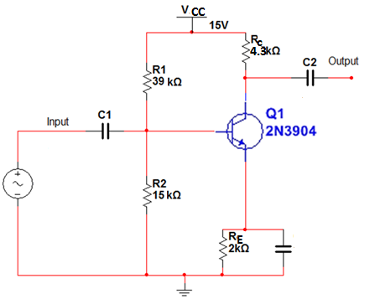

Designing amplifier circuits with BJT and Op=Amp:
$I_{C}=βI_{B}$ $r_{e}=\frac{26 mV}{I_{C}}$ $Vgain=-\frac{R_{C}}{r_{e}}$ $V_{BE}=0.7 v$
3. Design the following two-stage non-inverting amplifier with an overall voltage gain of 400. Use an op-amp for the final (second) stage with a gain of 4 and a Si BJT (β = 100) as the first stage with the following restrictions: I_{c} = 2.0 mA, V_{cc} = 5 V, V_{ce} = 1.4 V, and I_{R2} ≥10I_{B}.

