PHYS 315 S 2017 Practice for Final

a. Ohm’s law: V=IR; b. Power = P = IV= I2R = V2/R

b. Series equivalent resistance (*Rs*) and parallel the equivalent resistance (*Rp*)are given by,

 __________________________________________________________________________________

1. Find the current delivered by the power source and the current through 1.2kΩ resistor.

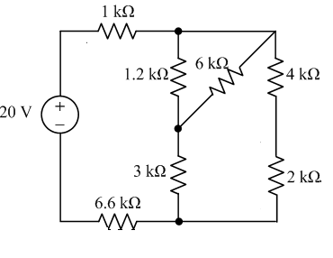

 http://edugen.wiley.com/edugen/courses/crs4957/halliday9118/halliday9088c25/image_n/nt0014-y.gif http://edugen.wiley.com/edugen/courses/crs4957/halliday9118/halliday9088c25/image_n/nt0016-y.gif

2) Find the equivalent capacitance seen by the voltage source. Also find the charge on the 3 µF capacitor.

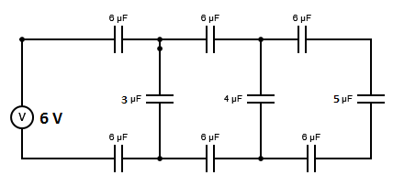

3. Find the current through the 4-Ω resistor, using the node-voltage method.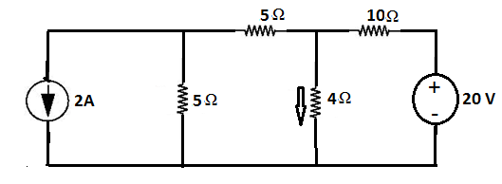

Diodes and Transistors (Si)

1. Determine the value of the load resistor.

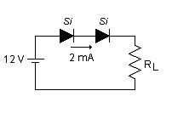

2. What is the current in the circuit, shown below?  
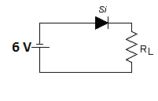

3. Calculate β.

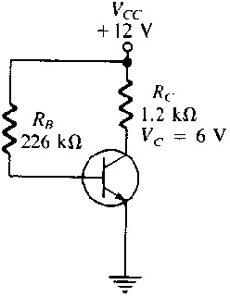

Diodes and Transistors (Si)

4. Calculate the following DC bias conditions: VB, VE, IE, IC, IB, VC, VCE, and the DC and ac gain.   
(Assume that the transistor is a Si type, with β=150)

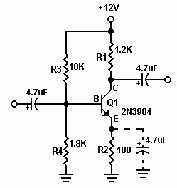

1. Find the gain for the following circuits:

|  |  |
| --- | --- |
| Inverting Amplifier Circuit.  Vin on the left connected to R1 connected to the negative terminal of the opamp connected to R2 connected to Vout and the output of the opamp.  Positive terminal of the opamp tied to ground. | Noninverting Amplifier circuit |
|  |  |

2. Calculate the output voltage if V1 = V2 = 0.15 V.

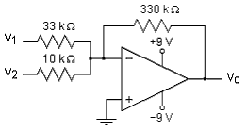

2. Calculate the output voltage if V1 = V2 = 700 mV.

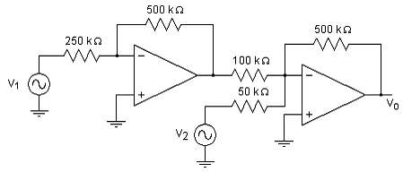

4. The resistor R in the circuit below is adjusted until the ideal op amp saturates. Specify R in kilohms.

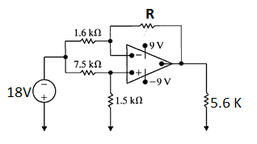

**5.4** Assume that the op amp in the circuit shown is ideal.

a) Find the output voltage when the variable resistor is set to 60 kΩ.

b) How large can *Rx* be before the amplifier saturates?

**Answer:** (a) 4.8 V;

(b) 75 kΩ.

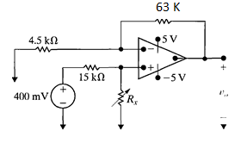

**5.5** a) In the difference amplifier shown,

vb = 4.0 V. What range of values for Va will result in linear operation?

b) Repeat (a) with the 20 kΩ resistor decreased to 8 kΩ.

**Answer:** (a) 2 V < *Va <* 6 V;

(b) 1.2 V < *Va <* 5.2 V.

