PHYS 301 Time Dilation and Length Contraction Name:_____________________________
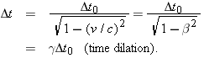 | 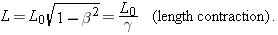
1. The center of our Milky Way galaxy is about 23 000 ly away. (a) To eight significant figures, at what constant speed parameter would you need to travel exactly 23 000 ly (measured in the Galaxy frame) in exactly 30 y (measured in your frame)? (b) Measured in your frame and in light-years, what length of the Galaxy would pass by you during the trip?

2. An airplane whose rest length is 40.0 m is moving at uniform velocity with respect to Earth, at a speed of 630 m/s. (a) By what fraction of its rest length is it shortened to an observer on Earth? (b) How long would it take, according to Earth clocks, for the airplane's clock to fall behind by 1.00 μs?

