PHYS 301 Thompson’s Expt Name:_______________________________

Equations of kinematics & Newton’s 2nd law are given below:

|  |  |  |  |  |
| --- | --- | --- | --- | --- |
| 1. | 2. | 3. | 4. | Newton’s 2nd Law: |
|  |  |  |  | $$\vec{F}=m\vec{a}$$ |

Electric Force: $F_{E}=qE$ Magnetic Force: 

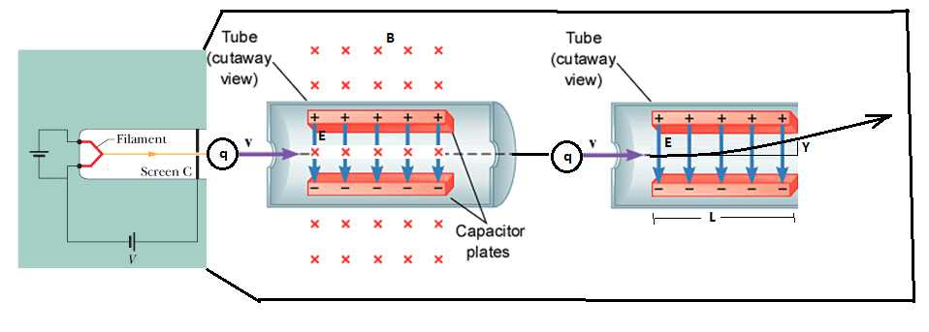

Figure above shows a modern, simplified version of Thomson's experimental apparatus—a *cathode ray tube* (which is like the picture tube in an old type television set). Charged particles (which we now know as electrons) are emitted by a hot filament at the rear of the evacuated tube and are accelerated by an applied potential difference *ν*. After they pass through a slit in screen C, they form a narrow beam. They then pass through a region of crossed http://edugen.wiley.com/edugen/courses/crs4957/halliday9118/halliday9088c28/math/math001.gif and http://edugen.wiley.com/edugen/courses/crs4957/halliday9118/halliday9088c28/math/math002.gif fields, velocity selector. Then they go through a region of electric field, of length L, which deflects the beam, by a vertical amount Y.   
a. Express the velocity, *v* in terms of *E* and *B*.  
b. Show the following:

$\frac{m}{\left|q\right|}=\frac{B^{2}L^{2}}{2YE}$