PHYS 301 Lorentz Transformation Name:______________________________
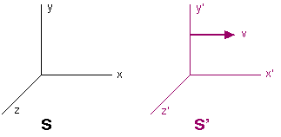
1. Given that $x^{'}= γ(x-vt)$ and $x= γ(x^{'}+vt^{'})$, show the following:
$t^{'}= γ[t-\frac{vx}{c^{2}}]$

