PHYS 301 EM Spectrum Name:____________________________________
Speed of an electromagnetic wave is also given by: c = λf.
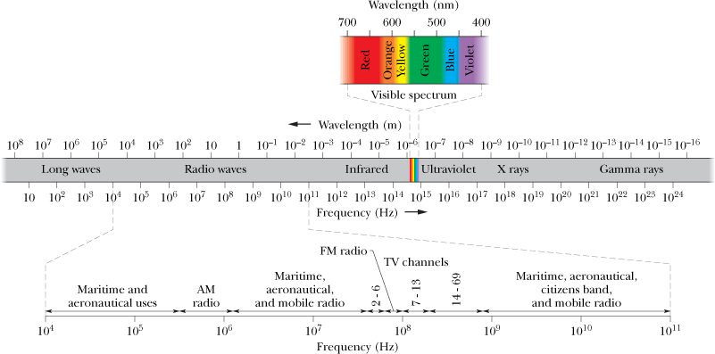

1. Calculate the speed of light to 9 significant figures, using the fundamental constants.

2. A certain helium–neon laser emits red light in a narrow band of wavelengths centered at 632.8 nm and with a “wavelength width” (such as on the scale of Fig. 33-1) of 0.0100 nm. What is the corresponding “frequency width” for the emission?

