PHYS 212 MWF 9-9:50 S08 Study Guide for Test #1 Chapters 18,19, & 2
Test will consist of multiple choice questions, regular questions, derivations, and problems.
- Chapter Reading: Find the answers to the chapter opening puzzlers.
- Laws of Thermodynamics: Zeroth, First, and Second.
- Derivations: You will be asked to derive one of the following:
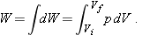
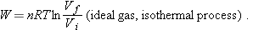
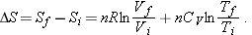
- Problems: Practice WileyPlus assignments. (Equations in parenthesis below will be provided)?
a. Temperature conversion.
b. Thermal expansion (linear & volume).
c. Calorimetry (absorption of heat by solids & liquids) including that of heat of transformation.
d. Solving problems using ideal gas law including that of isothermal and adiabatic processes.
e. Molar specific heats of an ideal gas.
f. Entropy:
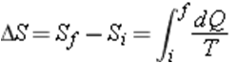
g. Heat engine h. Refrigerator
