PHYS 212 Spring 2012 Test #3 Name:

$i=\frac{dq}{dt}$_____________________________

Power = P = iv = v2/R = i2R Ohm’s law: v = iR

1. Figure below shows four situations in which positive and negative charges move horizontally and gives the rate at which each charge moves. Rank the situations according to the effective current through the regions, greatest first.

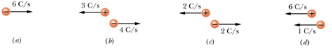

2. A 180 W light bulb is plugged into a standard 120 V outlet. Assume electrical energy costs US$ 0.06/kW · h.   
**(a)** How much does it cost in dollars per year to leave the light turned on one hour every month? **(b)** What is the resistance of the bulb?   
**(c)** What is the current in the bulb?

3. A 4.0 kW heater element from a dryer has a length of 38 cm. If an 8.0 cm section is removed, what power is used by the now shortened element at 120 V?

$V=\frac{kq}{r}$ (*k* = Coulomb’s constant = 9 × 109 N.m2/C2) http://edugen.wiley.com/edugen/courses/crs1650/art/math/halliday8019c24/math118.gif

4. A plastic rod has been bent into a circle of radius *R* = 8 cm. It has a charge *Q*1 = +4 pC uniformly distributed along one-quarter of its circumference and a charge *Q*2 = - 24 pC uniformly distributed along the rest of the circumference. With *V* = 0 at infinity, what is the electric potential at point *P*, on the central axis of the circle at distance *D* = 6 cm from the center?

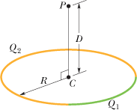

5. What is the electric field in unit vector notation and its magnitude at the point (3http://edugen.wiley.com/edugen/courses/crs1650/art/qb/qu/imgPenta/icirc.gif- 2http://edugen.wiley.com/edugen/courses/crs1650/art/qb/qu/imgPenta/jcirc.gif-http://edugen.wiley.com/edugen/courses/crs1650/art/qb/qu/imgPenta/kcirc.gif) m if the electric potential is given by *V* = 3*xy2z*3, where *V* is in volts and *x*, *y*, and *z* are in meters?

http://edugen.wiley.com/edugen/courses/crs1650/art/math/halliday8019c25/math127.gif http://edugen.wiley.com/edugen/courses/crs1650/art/math/halliday8019c25/math132.gif http://edugen.wiley.com/edugen/courses/crs1650/art/math/halliday8019c25/math133.gif6. Below: *V* = 12 V, *C*1 = *C*4 = 2.0 μF, *C*2 = 4.0 μF, *C*3 = 3.0 μF, *C*5 = 6.0 μF, and *C*6 = 9.0 μF.  
a. What is the equivalent capacitance?  
b. What is the charge on the equivalent capacitance?  
c. What is the charge on capacitor 2?

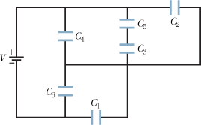

7. Figure below shows a parallel-plate capacitor of plate area *A* = 10.5 cm2 and plate separation 2*d* = 7.12 mm. The left half of the gap is filled with material of dielectric constant *κ*1 = 21.0; the top of the right half is filled with material of dielectric constant *κ*2 = 42.0; the bottom of the right half is filled with material of dielectric constant *κ*3 = 58.0. What is the capacitance? $(ε_{0}=8.85×{10}^{-12} C^{2}/(N.m^{2})$



  
  
  