PHYS 212 Field from Potential

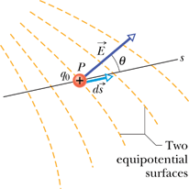





http://edugen.wiley.com/edugen/courses/crs1650/art/math/halliday8019c24/math119.gif

|  |
| --- |
|  |

P35. The electric potential at points in an *xy* plane is given by:  
 *V* = (2.0 V/m2)*x*2 - (3.0 V/m2)*y*2.   
In unit-vector notation, what is the electric field at the point (3.0 m, 2.0 m)?

P37. What is the magnitude of the electric field at the point (3**i** -2**j** +4**k**)m if the electric potential is given by *V* = 2.00*xyz*2, where *V* is in volts and *x*, *y*, and *z* are in meters?