VIBRATING STRING PHYS 201L Name:__________________________
Partner(s):______________________________________________________________
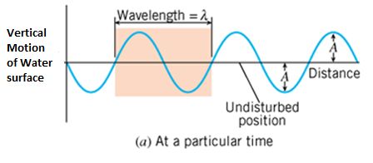 | 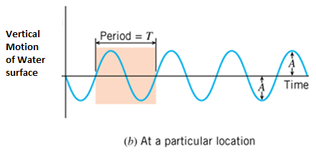

The amplitude, A is the maximum disturbance.

The wavelength, λ is the horizontal length of one cycle of the wave.

The period, T is the time required for one complete up/down cycle of the wave.

The frequency, f is the number of waves per unit time.
$Frequency=\frac{1}{Period}$

Wave Speed = $\frac{Distance}{Time}$ = $\frac{Wavelength}{Period}=Wavelength×\frac{1}{Period}=Wavelength×Frequency$

$$Wave Speed=Wavelength×Frequency$$

In terms of hanging mass, m and acceleration due to gravity, g tension force, F_{T} is given by:
$F_{T}=mg$
In terms of frequency, f and wavelength, λ the wave speed, v is given by:
In terms of tension, T and strings linear density, μ the wave speed, v is given by:
$v=\sqrt{\frac{F_{T}}{μ}}$
Linear Density: Linear density, μ is a property of the string which tells us whether the string is "heavy" or "light". You may know that the four violin strings are not the same. Some are thick and others are thin. The heavy strings are used for low frequency tones and the light ones are for high frequency tones. In this investigation you will determine μ, by measuring the length (without any knots) and mass of the string before attaching it to the string vibrator, to 3 significant figures.
Show that the following equation is correct unit wise, dimensionally correct:
$v=\sqrt{\frac{F_{T}}{μ}}$
DATA: Use SI units
Total length of string = ________________ Total mass of string = _________________
Linear Density = μ = ________________ Acceleration due to gravity = g = 9.8 m/s²
Length of the vibrating string = _________________
Table I: For a particular # of loops, obtain resonance with the highest amplitude by changing the hanging mass. Frequency = f = 60 Hz. If you prefer, use Excel to construct this data table.
# of Loops | Loop length | Wavelength, λ | Hanging mass, m | Tension,  $$F_{T}=mg$$ | Wave Speed, V |  | % Difference
 |  |  |  |  | Using f & λ | Using F_{T} & μ
2
3
4
5
6
Table II: For a particular hanging mass, obtain resonance with the highest amplitude by changing the frequency. Keep the #of loops constant. If you prefer, use Excel to construct this data table.
Hanging Mass (kg) | Loop length | Wavelength, λ | Frequency, f | Tension,  $$F_{T}=mg$$ | Wave Speed, V |  | % Difference
 |  |  |  |  | Using f & λ | Using F_{T} & μ
0.1
0.2
0.3
0.4
0.5

