PHYS 201L TORQUE Name:____________________________
Partner(s):________________________________________________________________
Purpose: To investigate torque by doing the following activities:
a. Finding the center of gravity of a meter stick
b. Measuring an unknown mass
c. Measuring the mass of a meter stick
d. Calculating clockwise and counter-clockwise torques
Apparatus: Meter stick, unknown mass, knife edge clamp, knife edge support, mass-hanger, mass set, lab jack, electronic balance, and string loops.
Theory: Introduction to torque
Think about the everyday activity of opening a door and entering a room, just for a moment.
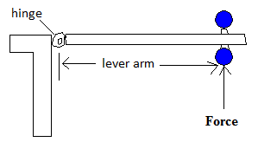 | Q: What do you think you do to the door, when you open it?  A: You apply a torque.
Torque = Lever-arm X Force; Torque is a vector. Torque comes in clockwise and counter clockwise directions. Clockwise direction is the direction in which a mechanical clock turns. The opposite direction is called counter clockwise.
The door knob is kept away from the hinge in order to have a greater lever-arm. Imagine how hard it will be to open, if the knob is kept closer to the hinge.
Lever-arm is the perpendicular distance between the line of action of the force and axis of rotation. Force, F is applied with different directions to a door below. Show the line of action and lever arm for each of the following cases, and rank the torques in descending order.
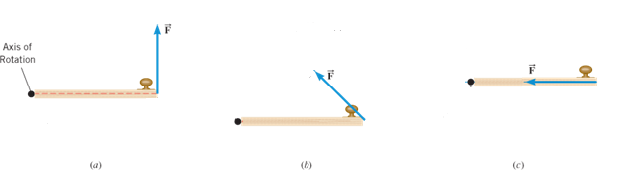
a. Center of gravity of a meter stick:
Mass of the knife-edge clamp = __________ Mass of the meter stick = __________
- Support the meter stick with a knife-edge clamp and obtain balance as shown below.
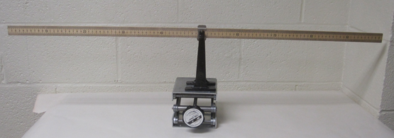
- Read the center of gravity to the tenth of a centimeter.
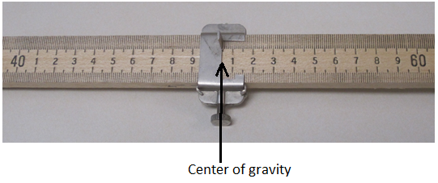
Location of the center of gravity (C.G) = ________ cm

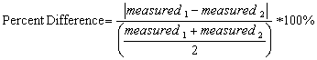
b. Measuring an unknown mass (Meter stick is supported at the center of gravity)
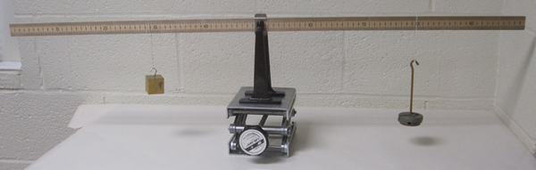
Unknown mass will try to rotate the meter stick counter
clockwise and known mass will try to rotate the meter
stick clockwise. Draw a free-body diagram for the meter stick.
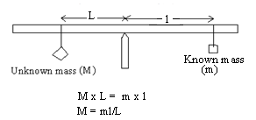
For balance, counterclockwise torque = clockwise torque.
Unknown mass can be determined using the above equation.
DATA for Unknown Mass
Mass of the knife-edge clamp = ________ Mass of the meter stick =_________
Location of the center of gravity (C.G) = ________ cm
Location of the unknown mass = _________ cm _________cm __________cm
Location of the known mass = _________ cm _________cm __________cm
Known mass, m (g) | Lever-arm for known mass, l (cm) | Lever-arm for unknown mass, L (cm) | Unknown mass, M (g) | Normal force at  the support point
200
250
300
Average of the unknown mass, M
Unknown mass measured using electronic balance
% difference
c. Measuring the mass of a meter stick (M)
Now you need to move the support point away from the center of gravity (C.G). This way you get the rotation effect of M, mass of the meter stick. Draw a free-body diagram for the meter stick.
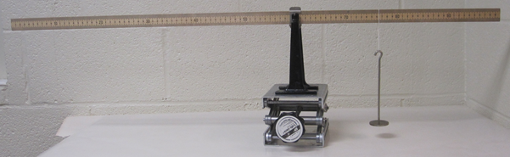
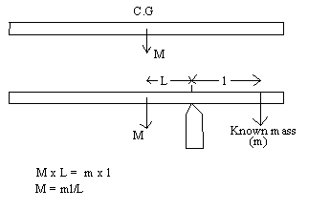

DATA for Mass of Meter Stick
Mass of the knife-edge clamp = ________
Mass of the meter stick =_________
Location of the center of gravity (C.G) = ________ cm.
Location of the support point = ________ cm __________cm _________cm
Location of the known mass = ________ cm __________cm _________cm
Known mass, m (g) | Lever-arm for known mass, l (cm) | Lever-arm for mass of meter stick, L (cm) | Mass of meter stick, M (g) | Normal force at  the support point
50
100
150
Average of the mass of meter stick, M
Mass of meter stick measured using electronic balance
% difference
d) Torques
1. With the meter stick on the support stand at X₀ (center of gravity) suspend a 150-g mass at the 10 cm mark and a 200-g mass at 90 cm mark. Hang a 100-g and adjust its position to obtain static equilibrium.
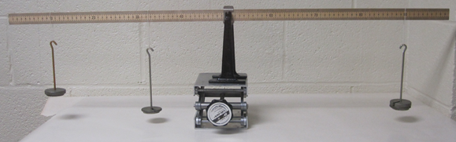
2. Record the location of the 100-g mass.
3. Draw a free-body diagram for the meter stick and identify all the forces acting on it. Use masses as force.
4. What is the normal force at the support point?____________________________
5. Write an equation by balancing the torques about the support point.
6. Calculate the location for the 100-g mass, using the above equation, and compare it with the experimental value.
7. Use the experimental value of the location for the 100-g mass to calculate the counterclockwise and clockwise torques about X₀ and complete the data below.

DATA for Torques (Include units):
Experimental value of the location for the 100-g mass = ___________
Calculated value of the location for the 100-g mass = ___________
% Difference = ___________
Counterclockwise torque about X₀ = _________
Clockwise torque about X₀ = __________
% difference = _________

Conclusion:

