PHYS 201L TORQUE Name:____________________________
Partner(s):________________________________________________________________
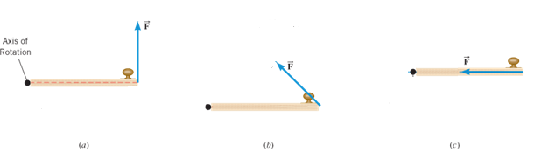
a. Center of gravity of a meter stick:
Mass of the knife-edge clamp = __________ Mass of the meter stick = __________
Location of the center of gravity (C.G) = ________ cm
b. DATA for Unknown Mass
Mass of the knife-edge clamp = ________ Mass of the meter stick =_________
Location of the center of gravity (C.G) = ________ cm
Location of the unknown mass = _________ cm _________cm __________cm
Location of the known mass = _________ cm _________cm __________cm
Known mass, m (g) | Lever-arm for known mass, l (cm) | Lever-arm for unknown mass, L (cm) | Unknown mass, M (g) | Normal force at  the support point
200
250
300
Average of the unknown mass, M
Unknown mass measured using electronic balance
% difference
c. Measuring the mass of a meter stick (M)
Now you need to move the support point away from the center of gravity (C.G). This way you get the rotation effect of M, mass of the meter stick. Draw a free-body diagram for the meter stick.
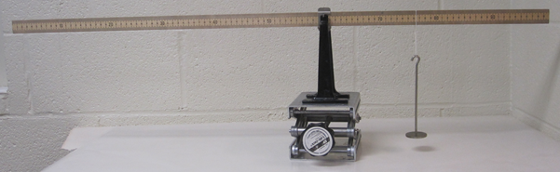
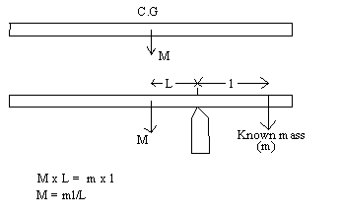

DATA for Mass of Meter Stick
Mass of the knife-edge clamp = ________
Mass of the meter stick =_________
Location of the center of gravity (C.G) = ________ cm.
Location of the support point = ________ cm __________cm _________cm
Location of the known mass = ________ cm __________cm _________cm
Known mass, m (g) | Lever-arm for known mass, l (cm) | Lever-arm for mass of meter stick, L (cm) | Mass of meter stick, M (g) | Normal force at  the support point
50
100
150
Average of the mass of meter stick, M
Mass of meter stick measured using electronic balance
% difference
d) Torques
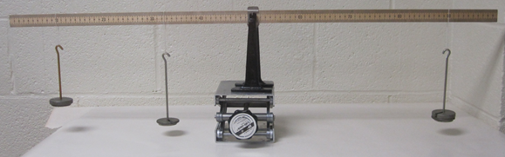
Draw a free-body diagram for the meter stick and identify all the forces acting on it. Use masses as force.
4. What is the normal force at the support point?____________________________
5. Write an equation by balancing the torques about the support point.
DATA for Torques (Include units):
Experimental value of the location for the 100-g mass = ___________
Calculated value of the location for the 100-g mass = ___________
% Difference = ___________
Counterclockwise torque about X₀ = _________
Clockwise torque about X₀ = __________
% difference = _________

