PHYS 201L Rotational Motion Name:_____________________
Partner(s):____________________________Day/Time:________________________
Theory for Measuring Moment of Inertia, I (also known as Rotational Inertia):
Moment of inertia is given by:$I=\sum{mr^{2}}$, where m is the mass of the particle and r is the perpendicular distance of the particle from the axis of rotation.
A hanging mass of 20-g will be used to rotate the system in all the trials. The system could be just the step-pulley, step-pulley with rod, step-pulley with rod & masses, step-pulley with disk, or step-pulley with disk & ring. As the 20-g mass goes down with a linear acceleration (a) the system will rotate with an angular acceleration (α). Linear acceleration is given by, a = rα, where r is the radius of the outer step-pulley. An expression for the rotational inertia (I) is obtained as follows.
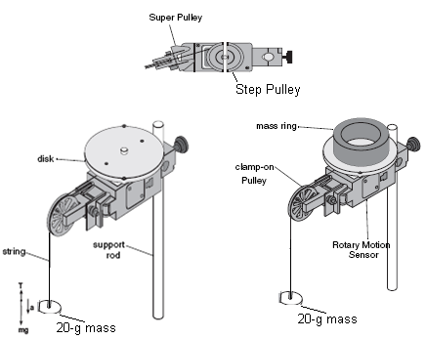
Applying Newton second law for the 20-g mass yields----> mg - T = ma-------(I)
Applying Newton's second law for the rotational motion of the system yields---->
T.r = I α = I (a/r)------(II)
Eliminating T from the above two equations yields--------> I = mr² (g/a - 1).
The hanging mass, m = 20-g and the outer step pulley radius, r = 2.38 cm can be used to re-write I (in g.cm²) as follows.
I = mr² [(g/a) - 1] = 20*2.38²[(g/a) - 1] =113 [(g/a) - 1].
$I=113\left[\frac{g}{a}-1\right]$
A. Rotational Inertia of point masses, rod, disk, and ring
Purpose: Determine the rotational inertias of point masses, and regularly shaped objects: rod, disk, and ring using a Rotary Motion Sensor.
Apparatus: Rotary motion sensor with step pulley (attached at the letter side), super pulley, 2 point masses, rod, gray disk, black ring, vernier caliper, thread, 20-g mass, 600-g electronic balance, lab stand, interface, and PC.
Procedure:
1. Connect the rotary motion sensor to the PASCO 850 interface by inserting the yellow plug into digital channel-1 and the black plug into digital channel-2.
2. Mount the Rotary Sensor onto the lab stand so that the step pulley is on top. Clamp-on the Super Pulley on the end of the sensor (end where the cord is).
3. Cut a piece of thread, about 50cm in length. Tie one end to the top of the step pulley and the other to a 20-g mass and hang it over the super pulley.
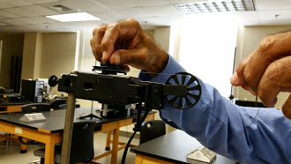
4. Setting up the Interface for data collection:
a. Open PASCO Capstone software from the desktop.
b. Click Hardware Setup under Tools on the left, click on the interface input where the sensor is connected and select Rotary Motion Sensor. Click Hardware Setup again to close it.
c. Double-Click Graph under Displays on the right, click Select Measurement, and select Velocity.
5. Turn the step-pulley clockwise so that the thread winds around the outer groove of the step pulley and hold it.
6. Click "Start" and release the system. Stop the data collection.
7. Using the beginning linear portion of the Velocity VS. Time graph, obtain the acceleration by curve fitting the data.
8. Attach the rod (without the masses) to the step pulley.
9. Repeat procedures 5-7.
10. Insert the two masses; the center of each mass is 5-cm from the center of the rod, and repeat procedures 5-7.
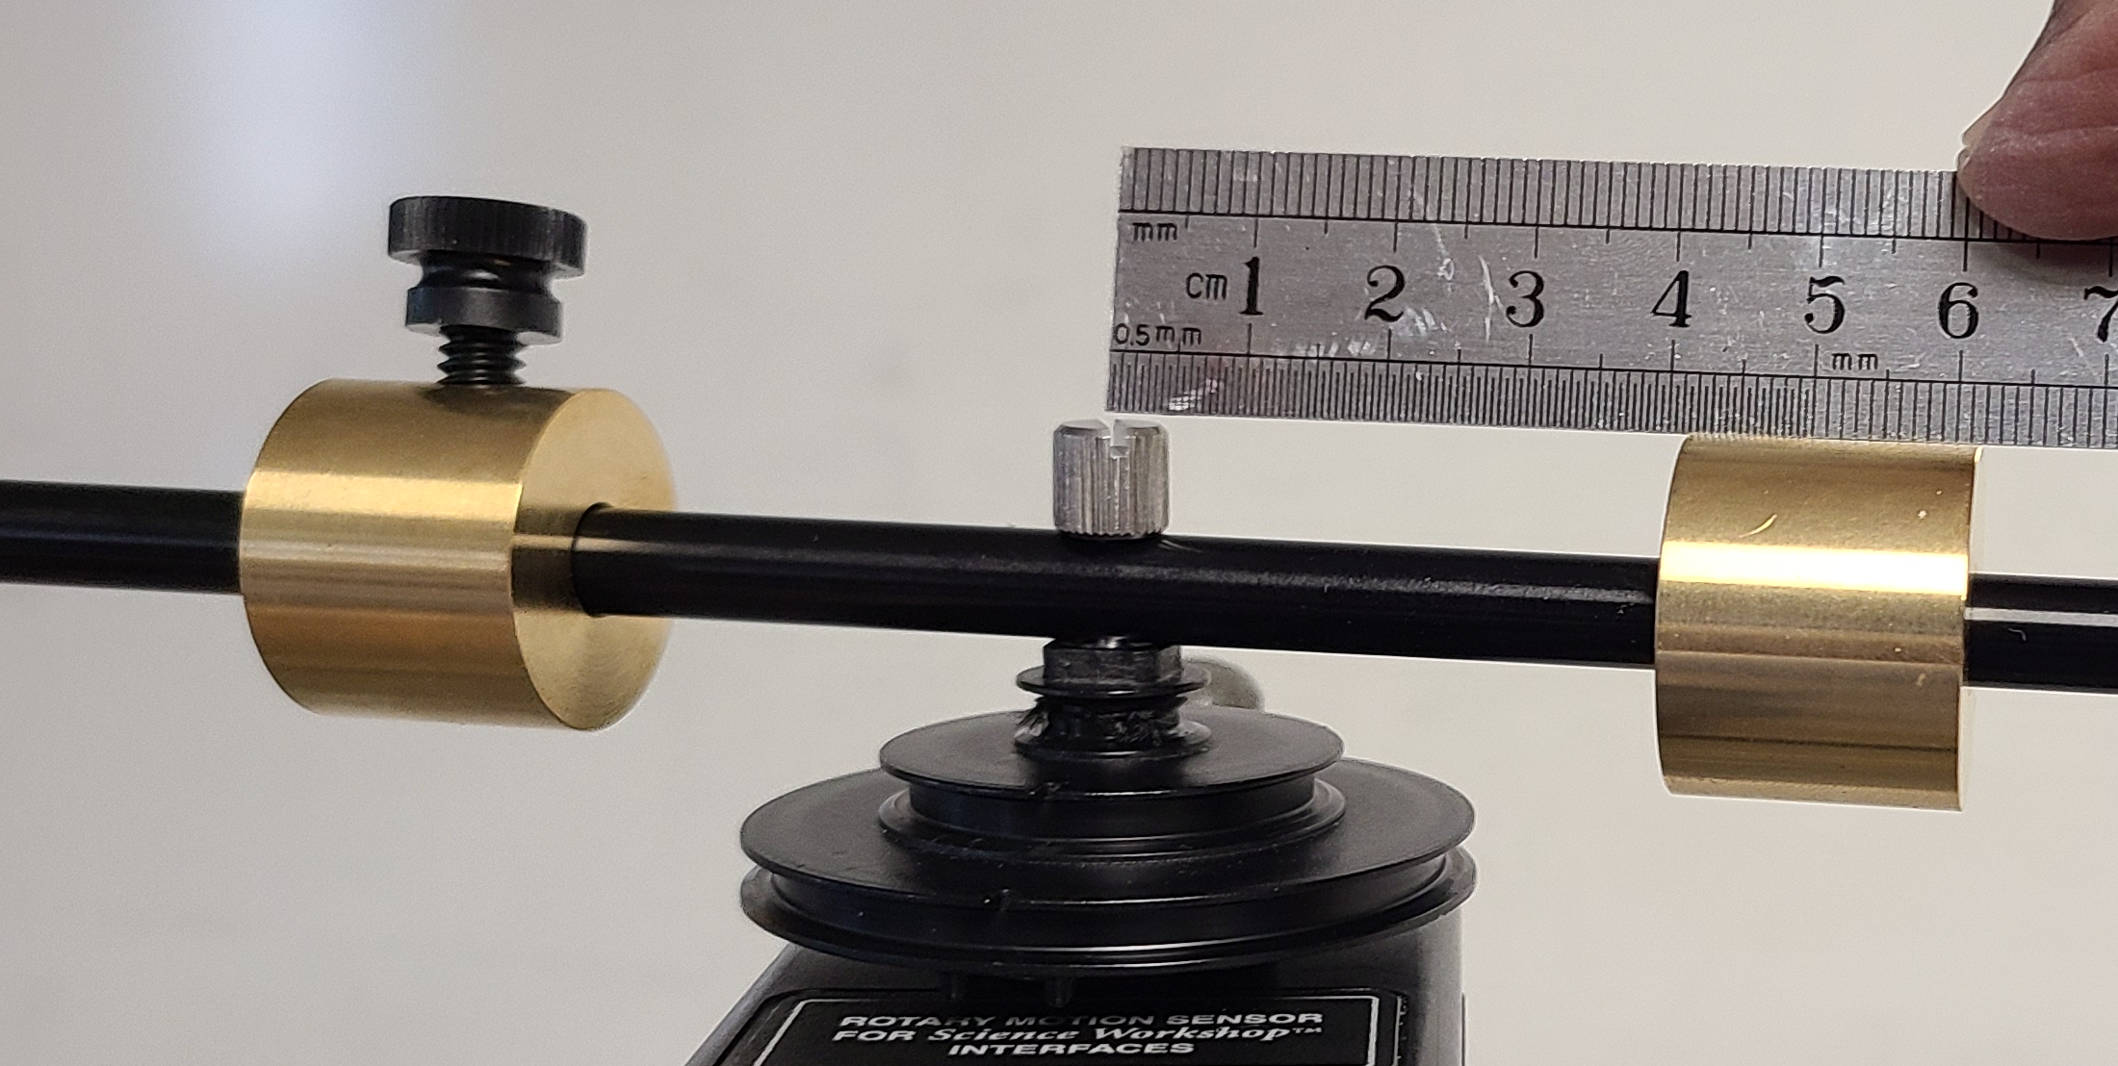
11. Remove the rod and attach the gray disk into the top of the step-pulley.
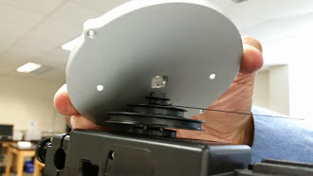
12. Repeat procedures 5-7.
13. Place the black ring on top of the disk, repeat procedures 5-7, and complete the data table.
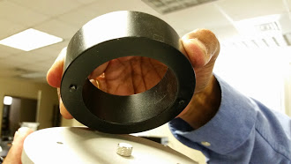 | 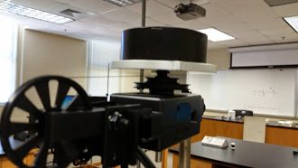
DATA Table A: g = 9.8 m/s² $\%Difference=\frac{\left|Difference\right|}{Average}×100$
 | Acceleration, a (m/s²) | I, Exptal*(g.cm²)  $I=113\left[\frac{g}{a}-1\right]$ | I_{T}, Theory**(g.cm²) | % Difference
Pulley |  |  | XXXXXXXXXXX | XXXXXXX
Pulley & Rod |  |  | XXXXXXXXXXX | XXXXXXX
Pulley, Rod, & Two Masses at 5 cm |  |  | XXXXXXXXXXX | XXXXXXX
Two Masses at 5 cm | XXXXXXXX
Rod | XXXXXXXX
Pulley & Disk |  |  | XXXXXXXXXXX | XXXXXXX
Disk | XXXXXXXX
Pulley, Disk & Ring |  |  | XXXXXXXXXXX | XXXXXXX
Ring | XXXXXXXX
*I, For 2 point masses are obtained by subtracting the Pulley-Rod value from
the Pulley-Rod + Two M’s values.
*I, for the rod is obtained by subtracting the pulley value from the pulley & rod value.
*I, for the disk is obtained by subtracting the pulley value from the pulley & disk value.
** Moment of inertia of point masses: $I=\sum{mr^{2}}$
**I_{T} (rod) = (1/12)mL² **I_{T} (disk) = 0.5 MR²; **I_{T} (Ring) = 0.5 M₁(R₁² +R₂² );
Data for calculating I_{T}:
Mass of a point mass = ________Length of rod = L = ______Mass of rod = m = ______
Mass of the gray disk = M = _______ Mass of black ring = M₁ = ______________
Dimensions of the ring & disk | Diameter (cm) | Radius (cm)
Inside of black ring |  | R₁ =
Outside of black ring |  | R₂ =
Gray disk |  | R =
B. Angular Momentum and Rotational Kinetic Energy
Purpose: Investigate what happens to the angular momentum and rotational kinetic energy when a disk is dropped onto a rotating disk.
Apparatus: Rotary motion sensor with step pulley, gray disks, interface, and PC.
Theory: In this part you will rotate a disk attached to the rotary motion sensor and let the PC collect the data. While the first disk rotates, a second disk will be dropped onto the first disk. The PC will continue to collect the data. From the display the initial and final angular velocities can be obtained. 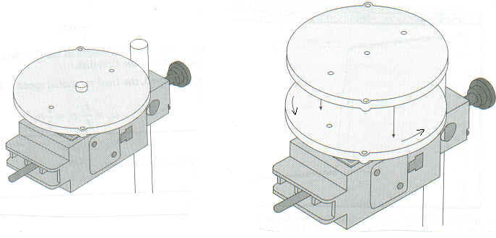
Angular momentum, L is given by:
Rotational kinetic energy, K is given by:
Procedure:
1. The rotary motion sensor is connected to the interface. Remove the black ring. Remove the super pulley and the string from the rotary motion sensor.
2. Setting up the Interface for data collection:
a. Open PASCO Capstone software from the desktop.
b. Click Hardware Setup under Tools on the left, click on the interface input where the sensor is connected and select Rotary Motion Sensor. Click Hardware Setup again to close it.
c. Double-Click Graph under Displays on the right, click Select Measurement, and select Angular Velocity.
3. Spin the gray disk counter-clockwise, then click start.
4. Let the PC collect some data, then drop the second disk onto first disk, and let the PC collect some more data.
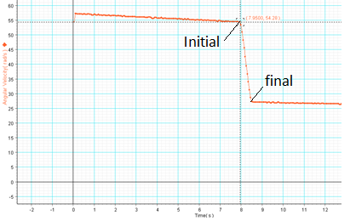
5. To determine the initial and final angular velocities, use the Show coordinates Tool found on tool bar. Drag the pointer to the data entry that was recorded just before the second disk was dropped. The Y coordinate is the angular speed. The final angular speed is found in the same fashion, this time dragging the Smart Tool to the data entry just after the completion of the slowing. Record both angular speeds.
6. Repeat steps 3-5, 2 more times and complete the data table.
7. For one of the trials, calculate the initial and final rotational kinetic energies in SI unit, and see whether the rotational kinetic energy is conserved.
8. Write a conclusion for the last activity, B.
DATA B: (Include units)
Trial | ω_{i} | ω_{f} | Use Data Table A |  | L_{i =} I_{i}ω_{i} | L_{f} = I_{f}ω_{f} | % Difference
 |  |  | I _{i} | I _{f}
1.
2.
3.
Calculation of initial and final rotational kinetic energies (in SI unit) for one trial:

